 This newsletter
Devoted to pet bird
Enthusiasts is
Published monthly by
The Rainbow Feathers
Bird club of Michigan
A 501(c) (3) club

September 2012
Volume 15 Issue 9

Bird Droppings

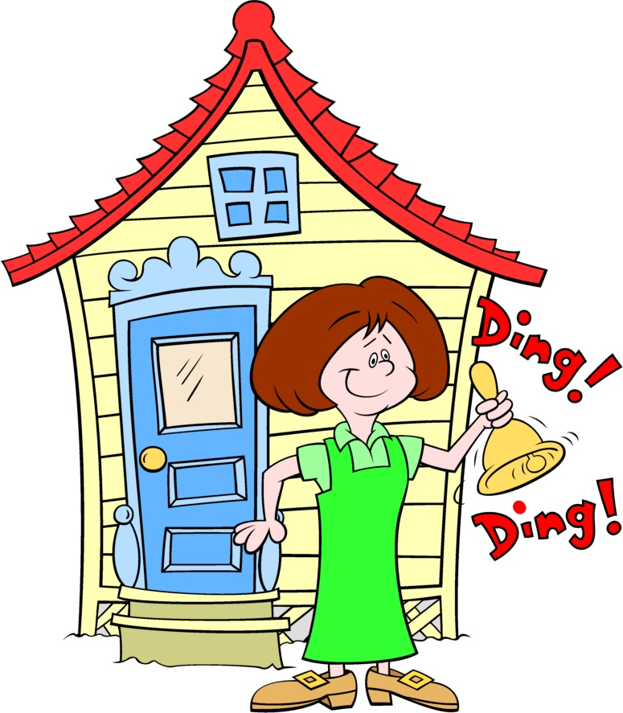

UPCOMING MEETING DATES:
SEPT. – Pet Expo No Meeting
OCT. 28th – Fourth Sunday
NOV. 18th – Third Sunday

RAINBOW FEATHERS BIRD CLUB
Who we are and what we are about
- Non Profit club with members throughout the tri-county area, single bird owners, or just thinking of getting a bird, families, breeders, exhibitors, all are welcome.
- Support scholarships for avian vet students
- Yearly Bird Fair
- Yearly Pet Expo
- Club Library for members
- Grooming available
- Avian rescue/relocation programs
- Monthly meetings with programs of interest to members.
- Monthly newsletter
- Periodic Service projects
- Field Trips
- Educational Programs upon request
- Make-it-take-it workshops
And more…….
Come join us and have your feathers preened by other Pet Bird Enthusiasts

Rainbow Feathers Bird Club Elected Officers:
President – Dave Carol 734-422-5981
Email – sweettweeters@comcast.net
Vice President – Steve Plafchan 734-513-0030
Email – splafchan@twmi.rr.com

Secretary – Marie Keehl 734-262-2098
Email –mariekeehl@ymail.com
Treasurer and Membership Secretary – Tammy Carol 734-422-5981
Email – sweettweeters@comcast.net

Board of Trustees –
Mary Perva 517-618-7008
Stan Johnson 248-746-0520
Email- mailto:mmisterjay@comcast.net
Henry Jedrzejek-734-427-3187
E-mail bigduke@comcast.net

ALL HEALTHY AND CLIPPED BIRDS ARE ALWAYS WELCOME TO ACCOMPANY THEIR HUMAN COMPANIONS TO THE MONTHLY MEETINGS. WE MEET AT THE UNITED METHODIST CHURCH, 6443 MERRIMAN ROAD BETWEEN FORD AND WARREN IN GARDEN CITY. MEETINGS START AT 2:00 PM.
Anyone interested in becoming a member please contact Tammy Carol @ 734-422-5981 or by e-mail sweettweeters@comcast.net

Steve Plafchan is now doing the newsletter. All ads and articles will be due the 1st of the month for publishing in the current month’s newsletter. Please send all items to him at 11021 Henry Ruff, Livonia, MI 48150 or email them to him at splafchan@twmi.rr.com

Everyone is encouraged to submit articles for the newsletter – this is YOUR newsletter.

Articles and/or pictures copied from other publications must be accompanied with written permission from original publication and author; this needs to be provided to the editor along with the article and/or picture.

Editor reserves the right to approve and/or edit any articles submitted prior to publication.

Ads will be run free for members having a one-time sale (baby birds, etc.). Those wishing to run ads multiple times or for a business must purchase a business membership.

BIRD CLUB ETIQUETTE

- Ask owner’s permission to handle/feed bird(s) and remember to return bird to the owner.
- Wash hands prior/after bird handling.
- When bringing companion birds to club meetings, only bring birds that you have had vet checked and in your possession for at least 30 days.
- Clean up after yourself and your bird(s) before you leave.

CLUB WELFARE

Please contact Jean Jedrzejek at 734-427-3187 or e-mail her at bigduke@comcast.net if you know of any club member who is in the hospital or has lost a loved one.
.

Monthly snack list

We have decided to stop soliciting for snack volunteers for our meetings and make the format a potluck venue. The reasoning for this is twofold; there have been very few members signing up for snacks and many members just bring dishes and desserts without signing up. So from now on our meetings will be a potluck fair, YUM!!

From the prez:
What a busy weekend the Labor Day Weekend was and all my plans for a relaxing weekend went down the tubes. First we had the bird rescue in Hamtramck and that was a little more than fishy if you ask me. Six of us went ready for anything and never made into the house. She had boxed up the fifteen remaining birds, (all budgies) but maintained that the Cockatiels had all been stolen. When we transferred the Budgies to proper carriers we found that one had died somehow in the box so we came home with fourteen. One of these poor little guys had a hurt leg and the other is severely splayed legged. All appear to be in good shape but are having a tiny bit of a hard time adjusting to being caged for the first time in their lives and having clipped wings. I would like to thank Tammy, Alison, Annette, Janet and Steve for coming along even if it turned out to be a little anticlimactic.
I would also like to thank Bev, Brent and Ken for accompanying Steve and me to the Great Lakes State Fair to try and sell tickets and promote the All American Pet expo. It was a long but good day and we sold 33 tickets to add to those we have already sold so things are coming along. Now about the picnic; was it not a simply beautiful day, we had great food and great fun. I would like to thank Mary Perva and Bev Sholar for getting great prizes and organizing the games they were a blast. I now realize that I am not as coordinated as I thought I was but that seemed to be a running theme for a lot of the games I played. Fun was had by all fantastic job guys. Now September is shaping up to be another busy month with the Highland Hey Days on the 8th and 9th, the Finch and Canary Clubs Bird Fair on the 8th (we are splitting up for those two events). The Walled Lake Pet Awareness Day on the 16th and the All American Family Pet Expo on the 21st, 22nd and 23rd we do not have a free weekend in September at all. I am not worried about these events because wherever we go we make an impression a very good impression so let’s show up and be ready to have some fun. Once again I have to say YOU GUYS ROCK!!!!!!!!!
Until Next Time,
Your Prez,
Dave


Voice of the
Veep

Wow, what a month is was for our club in August; between the fairs, pet adoption events and educational shows we barely had a chance to catch our breath. The first thing I feel I must convey to everybody is thank you so much for all the assistance we received. I truly believe that without the help from all of the club members I would have collapsed from exhaustion. However our jam packed schedule is not over. As of the time I’m writing this column (early September) there are about ten days of events yet to do this month.
It’s Pet Expo time! The Pet Expo is this month I hope that everyone who intended to bring their birds to the event has signed up with Tammy because there will not be any birds allowed through the front door during the expo. All club members who want to bring a bird with them have to come to the vendor’s entrance at the rear of the expo center. To all of our newer members that have never been to an event like this allow me to say; “It’s a blast.” Don’t feel you must bring your companion bird with you to join us at the expo; there is plenty to do even if your bird isn’t with you. We need help watching the parrots that are there, assistance taking and printing souvenir photographs, helping with meeting and greeting the people enjoying the expo, cleaning duties and any other issues that may occur. All of these needs don’t preclude the fact that you will enjoy yourself tremendously.
The picnic last month was a blast; I must give kudos to everybody that brought something to share, what a feast we had! Complements must also be extended to Mary and Beverly for the great job they did on the games. From the games themselves, the execution, coronation and prizes they did an awesome job. There was no attendance sheet at the picnic so unfortunately we have absolutely no idea how many of us were in attendance. My personal gut feeling is that this was the largest gathering ever for a picnic. There were no hamburgers or hotdogs left and very little in the way of side dishes and goodies. There is one more small detail that must be mentioned; when the games committee coordinator tells you not to leave your cell phone or shoe in your scavenger hunt bag, heed her advice. One of our members threw his cell phone in the trash after the hunt and didn’t realize it until after the pavilion trash cans were emptied by the city. Oops! I don’t want to embarrass this fool so his name is being withheld by request.
P.S. (His initials are Steve the V.P.) ☺
Your Veep
Steve

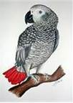
Tales from Buster Brown

I am owned by a nine and one-half year old African Gray named Buster Brown. My family is always asking about the latest “Buster” story so I wanted to share some of them with the club.
Buster is the first I have had the pleasure of sharing my life with and I had always believed that parrots just repeated what they heard. Buster has taught me otherwise; this amazing creature not only understands the words but knows that words have meanings and outcomes. He knows that “good morning” and “bon jour “are said in the morning, and that “night night and sweet dreams” is said when I put the cover on his cage. He knows that choice is the difference between stepping up and getting a towel wrapped around him to make him do what is needed.
With so many stories it is difficult for me to know where to start so I will start with the cleaning of his cage. He has become more territorial of his cage as he has gotten older; when he bites or pokes he knows that he will hear from me “That’s not nice, you are mean or be gentle boy.” As I was cleaning perches he tried to bite my hand. As I removed the grate he tried to bite my hand again. This was new behavior for him and he also asked me “What’s up?” I told him I was cleaning his cage. He then started saying things like “You are mean Buster Brown that is not nice, you go back and what are you doing?” Next I heard “What’s up?” I told him I was taking a break from my attack bird, he looked at me and said “S**t”; I must not have been working fast enough for him. (Thank goodness this is the only bad word I use.) Since this day when ever his cage is being cleaned he is on the play stand in the study. To be fair after I had finished he said “I’m so sorry.”
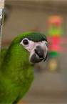
We had visitors from out of town staying with us and Buster kept asking them “Do you want to watch TV, let’s watch TV.” The next thing I know they bought Buster his own 15 inch flat screen TV and mounted it behind his cage. Buster now watches TV and comments all day long.
We lived in Texas and friends of ours taught him to say (in a Texan accent) many things including “Help, help get me out of here” because they thought it would be funny. Well one day Buster was outside on our deck by my neighbor’s fence while I was inside the house making dinner. Suddenly the police were swarming all around my house; my neighbor had called 911 telling them someone was in trouble inside my home. Of course Buster wouldn’t say a word when the police were here. That phrase might not have been the best thing to teach him. ☺
Linda Brown

Ramblings from
Rambo

Hi gang, my name is Rambo I’m a 191/2 year old male Hans Macaw. Last month I attended my first meeting and had a wonderful time meeting everybody. My companion human, Michael, told me I was very well behaved and enjoyed snacking on some almonds a lady I had never met before offered me. I took them from her nice and gentle and didn’t try to bite her. For me this is quite unusual because I normally won’t allow anyone to get close to me let alone feed me. I was having so much fun I even allowed a young girl to have me step up on her hand. I didn’t lunge or snap at her and even let her put her finger next to my feet. She was very special because I have never let any stranger get this close to me before.
The food at the meeting was great I even snuck a few bites for myself when my human wasn’t looking. It was a lot of fun seeing all the different bird species at the meeting; I especially enjoyed meeting the Toucan. I never knew a bird could have such a big beak!
There is other news I want to share with everybody; I recently received a new house full of new toys and it’s HUGE! Well maybe not huge but it’s taller and it has an apartment down below. There is enough room for me to have a buddy and for Michael to store food and stuff below.
Everybody at the meeting was so friendly and got along with each other and all the other parrots treated me and each other with the same respect. I look forward to seeing all of you again.
Rambo

Editor’s Note:
Linda and Michael are new members to our club and I want to thank them for the entertainingly wonderful stories. As a person that is owned by an African Gray I know she has many more tales to tell and we’re all looking forward to hearing them.
I also want to thank Michael for his entertaining story from his Hans Macaw Rambo. I’m sure I speak for all the loyal readers of Bird Droppings when I say we look forward to Rambo’s next adventure.
Also I must apologize to Michael because this is the second story submitted by him. The first one was turned into a bird toy by Pookie and was chewed into itty bitty pieces rendering it unreadable.
Thanks
Steve

PET EXPO
Well it’s finally here the Pet Expo in Novi has arrived; the dates and hours are:
Friday, September 21st, 11am - 8pm
Saturday, September 22nd, 10am - 8pm Sunday, September 23rd, 11am-6pm
A new company has taken over the operation of the pet expo this year. So we are not sure what the policy is going to be on how many free vendor badges will be allotted to us. The club will be getting parking passes for you if you have signed up to work. If you are scheduled to work and have to pay an admission to enter or park your car keep your receipts and the club will refund your admission and parking fees. YOU MUST HAVE YOUR RECEIPTS! Entrance to the expo as a club member means you plan on working at least three hours at our booth. If you intend to shop and look around plan on arriving early or staying over after your scheduled work times please.
We do know that no birds will be allowed through the front door; if your bird is going to attend we must get you a pass to enter in the rear doors.
If you signed up to work and haven’t heard any details feel free to call Tammy 734-422-5981 or Steve 734-513-0030 for last minute information
For those of you who want to look around at the Expo, you can come early or stay after your scheduled time. The schedule will be as follows; Set-up is Thursday 9am-6pm, we will be arriving at 9am to set up. Friday’s show schedule 11am – Noon, Noon-3pm, 3pm-6pm, 6pm-8pm, Saturday’s schedule is 10am - noon noon-3pm, 3pm-6pm and 6pm to 8pm. Sunday’s schedule is 11am-1pm, 1-3pm and 3-6pm, and after it closes we will be needing help to clear out our space.
Tammy
Quality by Mother Nature
Original Corn Bean Mix®: Noodles-n-Nuts®
Rainforest Rice Puddin®: Pollypasta®
Kung Fu Yum®
For Birds of all Sizes 
The Industry Pioneer of Quality Broad Natural Low Fat Nutrition®
All at a Cost Less than Seed
Because Crazy Corn® expands and seed is 60% waste! We’ve made it easy to prevent the most common cause of bird death- malnutrition from a seed diet. Cook ahead monthly, freeze baggies, keep some in the fridge to serve instantly. Superior breeding, lustrous feathering. Self-weans chicks. Shining health. Generous chunky fruits, veggies, whole grains, exciting herbs, pastas, beans, legumes, melon seeds, nuts, and more! Ecstatic birds! 1-800-BIRD YUM
in California (818) 503-4YUM. Fax (818) 765-4895
SPECIAL BREEDER PRICING


Out and About with
Pookie

These past two months have been very hectic for us; between the fairs, festivals and educational shows Sparky, JB and I have barely had enough time for ourselves. I don’t’ know if any of you saw the video posted on the internet but it was a complete travesty. The interviewer showed up on the second day of the Pet Fest, the one day I had to take off, to interview Sparky, JB, Angel, Binky and Mr. Finnegan. What happens; well that camera hog Steve stole the entire interview. Yes, JB and Sparky did manage to snatch a few cameos but there was Steve out front blabbing away. If you simply listened to him you would get the impression that it was him and the other companion humans that the guests were coming to visit. It wasn’t; there wasn’t one single Pet Fest attendee that was there to see our companion humans. They were there to see me, and the rest of the feathered members. There was not one single person in the crowd that was fawning over us that wanted to hold Steve, Dave, Beverly or Charles. No they wanted to hold us the birds. The visitors to our booth wanted pictures with of me and the other feathered members sitting on their hands, arms and laps; we were the stars not our companion humans. But when media people show up with video cameras and microphones who jumps out in front? That publicity hog Steve, that’s who. The sad thing is this wasn’t an isolated incident; the same problem occurred at the Heritage Festival in Ypsilanti, at the State Fair in Novi and at the Hey Days in Highland. I’d be willing to bet that there wasn’t one single child that wanted a picture of themselves with Steve sitting on their laps. In fact I’d be willing to say that if he tried to sit on an eight year old child’s lap he’d probably get arrested; at the very least the parents of the child would have him arrested.
One thing is for certain and all of the feathered members agree to this assessment, this has to change. The Pet Expo is just a few days away and if we, the feathered members and stars of the show don’t attain top billing and the recognition that is deserved by us there will be a revolt. We are making our contingency plans aimed at thwarting our humans from trying to claim the spotlight.
Stand tall and face forward to support your right to be recognized my feathered friends. We are the stars of the Rainbow Feathers booth; we are the ones that draw the crowd. We must fight for our right to be appreciated!
Chirps and Squawks
Pookie


Bits from Baby

Howdy all my feathered and non-feathered friends. Duke told me I missed a good time at our club picnic in August. The food was like a royal banquet. You name it and they had it there! Maybe it was better I had to stay home so I would not eat too much and have a relapse. I’m doing well and don’t want to miss any of the programs we have coming up.
September is the busiest month this year with seven events. There are two multiple day events, starting Sept. 8th Tammy and Duke were in Livonia at the Society of Canary and Finch Breeders Bird Fair while the rest of the gang were at The Highland Hey Days on Sept. 8th and 9th. On Sept.12th we did a Senior Education Program at the Lourdes Nursing Home in Waterford and Sept. 16th The Walled Lake Pet Awareness Day at the Historic Lakefront District. Then the Grand Daddy of them all! For three days from Sept. 21st thru the 23rd the Pet Expo, at the Suburban Collection Showplace in Novi. This one even I get to have fun with the GANG. LETS PARTY! On Sept. 28th we’ll be doing a Senior Educational Program at Canterbury on the Lake in Waterford and the next day Adopt -Your-Pet- Meet-Your-Vet at the Veterinary Care Specialists in Milford.
Then on Oct.6th What Do You Geek? At the Highland Township Public Library in Highland. There will be other groups and people showing off their interests, hobbies and passions.
The Feather and Non-feather members always do a GREAT JOB AT EVERY EVENT.

Till next we meet in October at the Meeting,
Till we meet again, God Bless.
Your friend Baby, >< >< >< >< ><>< >< >< >< ><>< >< ><
>< >< >< >< ><>< >< >< >< >< >< >< ><


RESCUE UPDATE
The adoption side of our rescue was fairly active this month. There were four adoptions; Two African Grays, Keekee and Crystal, Two Cockatiels and Ernie a Mexican Red Head Amazon. They all went to their new homes with cages, toys, and food thanks to the generosity of you, our club members.
The rescue side has been very active also. I can’t divulge what birds are in the rescue right now, however I will say if you are interested in adopting a larger bird contact a member of the board to find out what is available we just might have that special bird you’ve been waiting for.
We don’t normally talk about recent rescues but this one should be mentioned. If you didn’t see the story on the television news: there was a home in Hamtramck with an unknown number of Parakeets and Cockatiels free flighted in the house. The owner had passed away and the Granddaughter was overwhelmed with birds. The rangers recruited extra help and arrived with nets and carriers in hand to rescue the birds. Well the owner claimed that the home was broken into and all the Cockatiels were stolen; all the rescue crew was able to retrieve was fourteen Parakeets already in a box. The owner would not allow the rescue crew into or even near the home. We were met in the back alley where the Budgies were surrendered. To say there was something fishy in this situation is being polite.
All I can say is that we tried; the rescue rangers want to thank Tammy, Janet, Allison and Annett for their help.



BIRTHDAY GREETINGS to:

CHUCK JAMIESON OCT. 1
TAYNA O'CONNOR OCT. 1
EDITH RIOJAS OCT. 7
ANGELA KEENAN OCT. 9
NADA JURISICH-FONTANA OCT.11
ISABEL FONTANA OCT. 11
JEFFERY PASEK OCT. 12
BRIGETTE FELIX OCT. 15
JOSEPH GREENWOOD OCT.17
STEVE PLAFCHAN OCT. 17
JAN HARTZ OCT. 21
OLIVIA OCT. 23
BARRY SCHOENFELNER OCT. 24
CAMILLE JOHNSON OCT. 26
FAITH GREENWOOD OCT.30
SHARON SCHOENFELNER OCT. 31
CAROL STAMM OCT. 31

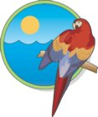

Avast ye Mates

CAPTAINS CORNER

Greetings to everyone feathered and non-feathered I hope all is going well for all of you. As you know we have just done two big events The Pet Fest and The Ypsilanti Heritage Festival. I must say they were great fun but there is STILL one thing that gets to me worse than an itch I cannot scratch, misidentification.
What is it with people that they constantly get what we are wrong! I mean is it so difficult to ask what we are instead of making an insanely wrong guess. For example I was called of all things a Toucan not once but about four times. Do I remotely look like anything that would go on a cereal box? Do I need a beak job or something? How can you confuse me with a Toucan it just boggles the mind. Then Sparky lit up like a Fourth of July fire work when someone referred to her as a Starling, the nerve. All through these events people got it wrong I wanted to say that I was a goat and see how far that got. The other thing that made all of us see red was the question. “Are these Parrots?” What do you think we are Canadian Geese, Canaries, hey how about Loon’s because we think most of the people were loony anyway? I have to congratulate Sparky and J.B. on holding their composure when they were told they looked like Pigeons. How much ruder can someone get? They were lucky both of them didn’t give them an “I’LL GIVE YOU PIGEON COMEUPPANCE.” I know I would have! Anyway, we are coming up to some other big events so to the attending public can I ask one small favor of you? Please get it right so you don’t have to get Gibb slapped up the back of your heads! Don’t know what that is watch NCIS to find out.

Cheers
Captain Morgan



There have been many, to be nice I will call them honest mistakes, but you will see them as what they really are. I’ll just leave it at that. Here are some of the things that have been put on paper that will make you laugh and shake your head in disbelief.
- One person was looking for a Cockotool. Is that a bird that looks more like a Swiss Army Knife?
- A Macall. Is that something you can do with your Mac Computer?
- Maybe you would like a Macow. Is that the cows that supply beef for McDonalds?
- Or a Latino Cockatiel is more your liking. Do they come from south of the border?
- Could anybody find me a Sunned Connor? I won’t even go there!
- Hey, what about a Peed Cockatiel? EEEWWW!!!
- What about a White Capped Penious, anybody, it got awful quiet out there.
- Could you imagine a Molecan Cockatoo? That image is just wrong!
- Since voting is around the corner let’s find an Elected Parrot. He’s got my vote.
- How about an Electric Parrot, absolutely shocking!
- Sir I am still looking for your Red Butted Parakeet?
- No I don’t have a Princess of Whales Parakeet, will any other royalty do?
- You want a cannery that sings, sounds more like a job for a real estate agent.
- Finally, you say you are looking for an Amazine Parrot in my book I think they all are amazing!!!
Yes these are some of the things that have actually made it on paper and I’ll bet there will be a whole lot more to come. Remember it is our job to educate them to the proper names of these parrots. Just don’t let them see you laugh, OK.

Upcoming Events

Sept 12th Senior Educational Program
Lourdes Nursing Home
2300 Watkins Lake Road
Waterford, MI 48328
1:30 PM Set-up
2:30 PM Show

Sept. 16th Walled Lake Pet Awareness
Day at Walled Lake’s Historic Lakefront District
Ferland Street at E. Walled Lake Dr.
11:00 AM to 4:00 PM
We will be setting up our pop-up before the event .
Set-up starts at 9:00 AM
PET EXPO
Sept. 21st 11am to 8pm
Sept. 22nd 10am to 8pm
Sept.23rd 11am to 6pm
Suburban Collection Showplace
46100 Grand River
Novi, MI 48374
We will be setting up on Thursday Sept. 20th most likely around 9:00 am. Please remember no birds will be allowed through the front door.

Sept. 28th Senior educational program
Canterbury on the Lake
5601 Hatchery
Waterford, MI 48329
2:00 PM Set-up
3:00 PM Show

Sept. 29th Adopt -Your-Pet
Meet-Your-Vet
Veterinary Care Specialists
205 Rowe Road
Milford, MI 48380
10AM to 2PM

Oct. 6th What Do You Geek?
Highland Township Public Library
444 Beach Farm Circle
Highland, MI 48357
11AM to 3PM
10AM set-up
This will be similar to an outdoor event but will be inside their conference center room. There will be other groups and people showing off their interests, hobbies and passions.

Oct. 14th Eisenhower Center
3200 East Eisenhower Parkway
Ann Arbor, MI 48108
11:30 AM Set-up
12:30 PM Show

Oct. 22nd Senior Educational Program
American House
25250 Eureka Rd.
Taylor, MI 48180
1:30 PM Set-up
2:00 PM Show

***NOTE******NOTE******NOTE***

There has been some confusion from the loyal readers of Bird Droppings as to which events they are allowed to bring their own bird(s) to. As a point of reference and for future information please we want everyone to be aware that when you see the line:

***Our Club Has a Booth at This Event***
following or “Educational Show” preceding an event listing it means we are attending the event in an official capacity representing our club and rescue. At these events all club members are welcomed to bring their feathered companions with them. Also please note that our space is very limited at some of these events but don’t let this stop you from joining us, we will find a way for you and your birdie buddy to fit in and enjoy the fun.

****NOTE*****NOTE*****NOTE****

*CANCELATION CONFUSION *

A few of our scheduled events have been canceled at the last minute by the group staging the event. If you do not regularly participate in the shows but plan on attending please call Steve (734-513-0030) to make sure the event is still a go. Recent cancellations that have occurred at the last minute are: the Fall for Novi Pet Adoption Fair, and the Allen Park Animal Shelter Pet Adoption Fair.



RESCUE RANGERS



Now there have been many famous Sam’s we have Sam Cooke, Sam Jones, Sam Addams, Yosemite Sam and Sam Sam the Baker Man but this Sam was a little less famous in fact he was not famous at all. This Sam resided in the city of Wyandotte and had belonged to the gentleman’s father. Now this Sam was not abused tortured or neglected in fact he had a good life but things had started to change for this guy. His owner had received an upgrade at his job (promotion to say it the old fashioned way) and would be traveling more and could not spend the time he needed to with Sam. He wanted Sam to be loved and cared for, what is that, oh what is Sam? Sorry. Sam is an Orange winged Amazon, now on with the story. As I said he just wanted Sam to find a good home where he would be loved and cared for and he knew the Rangers were the right men for the job. So after loading his spacious cage into the Rescue Mobile and then Sam himself they were off to the foster home. Now Sam would never leave his foster home (imagine that a failed foster parent, now where have I heard this before?) and be sassy and happy. So Sam was happy, his former pet parent was happy, the new pet parent was happy and the Rangers were happy. Boy, that’s a lot of happy people to end this happy story, but there were still more birds that need a happy ending and they would not stop until they all had one for they are the RESCUE RANGERS!!!!!!!!

Stay tuned for our next thrillingly exciting adventure Déjà vu Times 3 in Canton.




Establishing Control with Nurturing Guidance
By Liz Wilson, CVT
Nurturing guidance is a training concept developed by Sally Blanchard, and it is critical to enjoying cohabitation with a parrot. Without it, a parrot is often unclear as to his position within his human flock. Genetically an exotic bird is a wild animal, whether domestic-bred or not, and he understands little about cohabiting with people. With patient teaching and guidance, he can learn how to be a good companion. Nurturing guidance is established by teaching and using basic commands. By setting these parameters, a parrot will have a better understanding of what is expected of it.
The first command is “Up,” which means step onto my hand. The second command is “Down,” which means step off my hand onto an inanimate object (like a perch). This is not a directional command. Onto the hand is up, off the hand is down. Teaching these commands requires a neutral room and a neutral perch. Ideally, the bird should have no experience with either the location or perch. This minimizes distractions and maximizes learning. Lessons should be short and upbeat, held once or twice a day for 10-15 minutes. Make sure you are relaxed before you begin, and smile and be patient. Under NO circumstance is aggression acceptable. Training a parrot is like teaching nursery school. You must keep your student involved or it won’t learn. Sessions should be fun, not boring or frightening. Simply put, behavior modification uses positive reinforcement for good behaviors and no reinforcement for bad behaviors. Instead, misbehaviors are ignored.
If the parrot follows a command, smile and praise the bird. If it doesn’t, ignore the transgression and repeat the command, pushing gently at his legs with the side of your hand. If you don’t expect him to behave, he won’t. Under NO CIRCUMSTANCE is aggression allowed with parrots. If approached with respect and love, parrots learn quickly and happily. Aggression begets aggression and is absolutely unacceptable. Experienced parrot behavior consultants agree that allowing a parrot to shoulder is asking for trouble. In this position, you cannot see a bird’s body language, so you don’t know if he’s getting frightened or upset. You also can’t anticipate and prevent a bite—and you DON’T want to be bitten in the face. If you follow these guidelines and use these commands clearly and consistently, life with your parrot should improve immensely.
This article reprinted with permission from Zupreem®

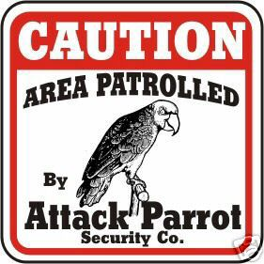



BITE ME BIRD TOYS
Tony & Edie Riojas
4593 Howell Rd, Otter Lake, MI 48464
1-810-793-2093
bitemebirdtoys.com

NORTH BRANCH ANIMAL HOSPITAL
Frederick B. Shulak, D.V.M.
17630 Twelve Mile Road * Southfield, MI 48076
248-557-7773

ROOSE ANIMAL HOSPITAL
Kevin Roose, D.V.M. * Karen Knight, D.V.M.
509 W. Ann Arbor Trail * Plymouth, MI 48170
734-451-2870

SPECIALTY PET SUPPLIES, INC.
1449 W. Ann Arbor Road * Plymouth, MI 48170
734-453-6930
Fax: 734-453-7127
M-F 10-7:30 * Sat 10-6 * Sun 12-4

WARREN WOODS VETERINARY HOSPITAL
29157 Schoenherr * Warren, MI 48314
586-751-3350

OAKLAND VETERINARY EMERGENCY GROUP
1400 Telegraph Rd * Bloomfield Hills, MI 48302
248-334-6877

Free discount card Open 7-Days available to club members Ask about our birdie day spa treatment

DISCOUNT PET & SUPPLIES
Specializing in Exotic Birds & Cages
1623 Middlebelt Rd. Livonia, MI 48154
734-513-6060
http://www.discountpetandsupplies.com/

SOUTHGATE ANIMAL HOSPITAL
Keith Cook, D.V.M. * Elieen Cook, D.V.M.
13697 Dix-Toledo Rd* Southgate, MI 48195
734-284-9122

ANIMAL EMERGENCY CENTER
24360 Novi Road * Novi, MI 48375
248-348-1788
265 E. 2nd St. * Rochester, MI 48307
248-651-1788
Both Locations are open 24 hours a Day
7 Days a Week
www.theanimalemergencycenter.com

MUGSHOTS and MOUSE PADS
Species specific coffee mugs, mouse pads and other parrot
paraphernalia
Cheryl Hitter
734-422-2804
*Put your pet’s picture on a mug or mouse pad*

Custom sizes up to 25” x 38” •
Square or Rectangle cuts
PayPal plus Shipping available • Priced for 100 sheets
White cover weight paper • Fresh clean cage everyday
Call or email us for your custom size
248.438.6572
littlemancageliners@yahoo.com
Visit us on
Facebook and Blogger!
little-man-cage-liners.blogspot.com

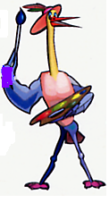
MURALS
AND OTHER
CREATIONS
BY MARY KAY PERVA
734-207-0489

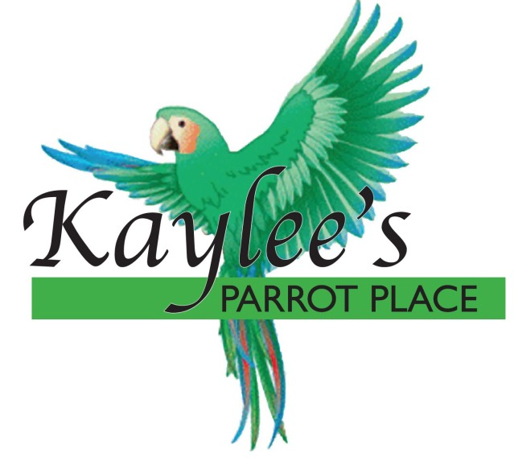
“Baby Parrots Raised in a Home for a Home”
Specializing in Macaws, Greys,
Amazons, and others.
Cages and Food at reasonable prices.
Contact Kaylee at 734-301-0486
www.kayleesparrotplace.com

UV LIGHTING, HEATERS, VITIMINS AND OTHER SUPPLIES for your BIRDS, FISH and REPTILES

VISIT OUR WEBSITE AT
zoomed.com

Veterinary Care Specialists
205 Rowe Road
Milford, MI 48380
248-684-0468
Open 24 Hours A Day 7 Days A Week

