 This newsletter
Devoted to pet bird
Enthusiasts is
Published monthly by
The Rainbow Feathers
Bird club of Michigan
A 501(c) (3) club

July 2012
Volume 15 Issue 7

Bird Droppings

UPCOMING MEETING DATES:
JULY 22nd – FOURTH SUNDAY
AUGUST 26th – FOURTH SUNDAY PICNIC
SEPT. – PET EXPO NO MEETING

RAINBOW FEATHERS BIRD CLUB
Who we are and what we are about
- Non Profit club with members throughout the tri-county area, single bird owners, or just thinking of getting a bird, families, breeders, exhibitors, all are welcome.
- Support scholarships for avian vet students
- Yearly Bird Fair
- Club Library for members
- Grooming available
- Avian rescue/relocation programs
- Monthly meetings with programs of interest to members.
- Monthly newsletter
- Periodic Service projects
- Field Trips
- Educational Programs upon request
- Make-it-take-it workshops
And more…….
Come join us and have your feathers preened by other Pet Bird Enthusiasts

Rainbow Feathers Bird Club Elected Officers:
President – Dave Carol 734-422-5981
Email – sweettweeters@comcast.net
Vice President – Steve Plafchan 734-513-0030
Email – splafchan@twmi.rr.com

Secretary– Marie Keehl 734-262-2098
Email – mariekeehl@ymail.com

Treasurer and Membership Secretary – Tammy Carol 734-422-5981
Email – sweettweeters@comcast.net

Board of Trustees –

Mary Perva 517-618-7008

Stan Johnson 248-746-0520

Email- mmisterjay@comcast.net

Henry Jedrzejek-734-427-3187

Email- bigduke@comcast.net
ALL HEALTHY AND CLIPPED BIRDS ARE ALWAYS WELCOME TO ACCOMPANY THEIR HUMAN COMPANIONS TO THE MONTHLY MEETINGS. WE MEET AT THE UNITED METHODIST CHURCH, 6443 MERRIMAN ROAD BETWEEN FORD AND WARREN IN GARDEN CITY. MEETINGS START AT 2:00 PM.

Anyone interested in becoming a member please contact Tammy Carol @ 734-422-5981 or by e-mail sweettweeters@comcast.net

Steve Plafchan is now doing the newsletter. All ads and articles will be due the 1st of the month for publishing in the current month’s newsletter. Please send all items to him at 11021 Henry Ruff, Livonia, MI 48150 or email them to him at splafchan@twmi.rr.com

Everyone is encouraged to submit articles for the newsletter – this is YOUR newsletter.

Articles and/or pictures copied from other publications must be accompanied with written permission from original publication and author; this needs to be provided to the editor along with the article and/or picture.

Editor reserves the right to approve and/or edit any articles submitted prior to publication.

Ads will be run free for members having a one-time sale (baby birds, etc.). Those wishing to run ads multiple times or for a business must purchase a business membership.

BIRD CLUB ETIQUETTE

- Ask owner’s permission to handle/feed bird(s) and remember to return bird to the owner.
- Wash hands prior/after bird handling.
- When bringing companion birds to club meetings, only bring birds that you have had vet checked and in your possession for at least 30 days.
- Clean up after yourself and your bird(s) before you leave.

CLUB WELFARE
Please contact Jean Jedrzejek at 734-427-3187 or e-mail her at bigduke@comcast.net if you know of any club member who is in the hospital or has lost a loved one

Monthly snack list
We have decided to stop soliciting for snack volunteers for our meetings and make the format a potluck venue. The reasoning for this is two fold; there have been very few members signing up for snacks and many members just bring dishes and deserts without signing up. So from now on our meetings will be a potluck fair, YUM!!



Crossing
The Rainbow Bridge

Sadly it must be reported that our club lost a feathered member last month.
Diego a Peach front Conure, that was rescued and adopted by the Greenwood family. He crossed early on June 27th of what appeared to be a neurological disorder. We offer our sympathies to Pat and Mark Greenwood. To Diego we say soar high and fly free on the other side of the rainbow bridge. You will be missed and forever loved.
To the Greenwood’s we dedicate the following verse.

The Rainbow Bridge

Just this side of heaven is a place called
Rainbow Bridge.
When and animal dies that has been especially close to someone here, that pet goes to
Rainbow Bridge.
There are meadows and hills for all our special friends so they can run and play together. There is plenty of food and water and sunshine, and our friends are warm and comfortable.
All of the animals that have been ill and old are restored to health and vigor, those who were hurt or maimed are made whole and strong again, just as we remember in our dreams of days and times gone bye. The animals are happy and content, except for one small thing;
They miss someone very special to them who had to be left behind. They all run and play together, but the day comes when one suddenly stops and looks into the distance,…
The bright eyes are intent; the eager body quivers. suddenly she begins to break away from the group, flying over the green grass,
her wings carrying her faster and faster YOU ~
have just been spotted, and when you and your special friend meet, you cling together in joyous reunion ~
never to be parted again. The sweet sounds of happy tweets play your ears; your hands again
caress the beloved’s head, and you look once more into the trusting eyes of your pet,
so long gone from your life but never absent from your heart ~
Then you cross~…the
Rainbow Bridge together !

From the prez:

I never thought I would say this but I WANT IT TO RAIN!!!!!!!!!! It has been so hot and dry that I can almost harvest my front and back lawns for hay. I don’t even want to know how much water I have gone through to keep my flowers alive. Even though it has been so hot it could still be far worse we could get too much rain like our neighbors in Florida who have been flooded out so I still count my many blessings. There is only one thing I hope for and that is this heat breaks before we have to do our outdoor events. Now I know that these are “tropical birds” and they should enjoy the heat but they (the birds) enjoy air conditioning as much as we do. Plus they are as wimpy when it comes to the sweltering heat as many of us are. So I am putting in my order for some 75 to 80 degree days for the Heritage Festival as well as the other outdoor events we have. Look in the coming events for a complete listing that grows all the time. Another thing I am proud to say I did not go away empty handed at the annual bag-it-bingo and what I got was a nice bird toy so somebody was not on their toes and missed me during the stealing rounds. Oh well, better luck next year. That was fun and everybody had a blast and that is what it is all about having fun. Also the All American Family Pet Expo is now in September and coming up on us fast and we have agreed to sell the tickets for the discounted price and the prize drawing. I hope to have them by the next meeting so start thinking who you might sell them to. I never worry about club participation you guys always come through and do the club proud because of this we have a stellar reputation. This is because of you the members of the club who work so hard to make every event we do a success and it is in spades. Also our flock keeps growing and we welcome all of our new flock members or as we affectionately refer to ourselves fellow birdbrains we are glad you came and joined us. So we will have a busy couple of months with many events plus our picnic in August so keep checking and if you can join us we have a blast at them all. As always YOU GUYS ROCK!!!!!!
Until Next Time
Your Prez
Dave



Voice of the Veep

Bag-it-bingo is always a fun meeting and last month was no exception. It was a meeting with lots of tasty food and bingo but there was one small problem. Once again I returned home from the meeting, bag-it-bingo gift less. Sometimes I do believe there is a big sign on my forehead that says “take my gift” because this now makes four years in a row that I returned home gift bag bare. ☹ Have I succeeded in making all of you feel guilty? ☺ Well don’t; weather you take a gift home or not, the fun is the playing of the game.
Next month our club is participating in two adoption events as well as numerous educational shows. If you have never joined us at an adoption event you should consider attending. August 11th and 12th we will be at the Pet Emporium Pet Fest being held at the Washtenaw County Fairgrounds. August 17th, 18th, 19th we will have our pop-ups at the Ypsilanti Heritage Festival. In September we will be in Walled Lake for a one day event and at the Pet Expo in Novi for a three day event. I know many of you have joined us with past events but to our newer members I ask that you should consider joining us even if it’s only for an hour or two during the day. Some of us will have our birds with us but if you’re not comfortable bringing your own parrot we can always use extra help talking to the visitors at our booth. I promise, you will enjoy yourself tremendously and will have a lot of fun. You have to be careful though, because you will probably have such a great time you won’t want to miss another event.
Our web site is back up and up to date so you can always get the latest changes in our show schedule there or you can call me (Steve) for information.
Your Veep
Steve

Club Shirts
We are trying to get another order together for club shirts, so that we have them for the Bird Fair in May. Tammy will be taking orders until the July meeting, so they can be available for pick-up at the August meeting (picnic.) Anyone who would like a shirt and can’t make the meeting (picnic), please contact Dave and Tammy 734-422-5981, with the size and color. The logo looks good on gray, beige and lighter colors. The embroidery charge is $10.00 plus the cost of the shirt; if you prefer to bring your own shirt that’s fine, just pin a piece of paper to it with your name on it so we know who it belongs to. The price for S-M-L-XL was $13.00 and anything above the XL was $16.00, we try to get the T-Shirts on sale.

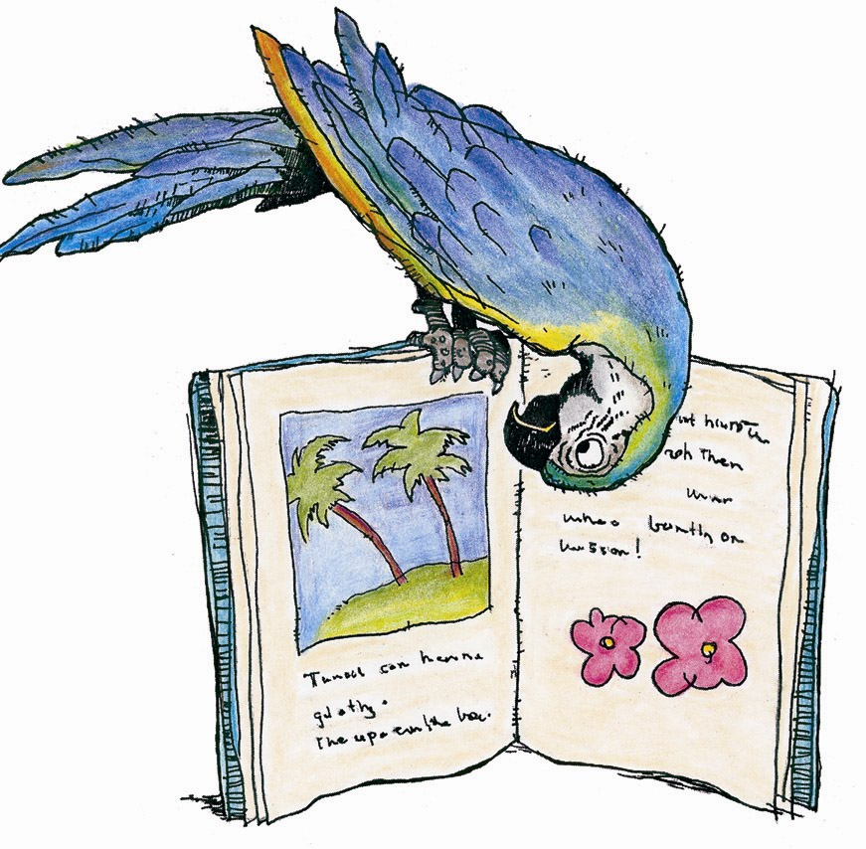
BIRD SHOWS A BIG HIT
We have recently staged many senior educational shows at numerous retirement communities and senior centers. Our club received many accolades and smiles from the residents and other guests in attendance. We also want to say “thank you” to the retirement homes for the generous donations to our rescue for staging the shows
Our bird shows are lots of fun and great fund raisers for our rescue. If you have never attended one of our shows come and join us and see what all fun is about. Even if you can’t bring your bird you can still assist us with the show, everyone is welcome.


Out and About With Pookie

Now that summer is here Steve has begun to include us in his journeys to the park, farmers markets, festivals and carnivals. It is so much fun meeting young children receiving skritches and scratches while enjoying their smiling faces. There is a common question or statement that often gets asked or opined that absolutely drives me insane. This question has also come to me in letters to the editor here at “bird Droppings”. It comes from both non-companion bird owners and companion bird owners. Now I can understand why a non-bird owner might think this way but someone who has companion parrots should know better. OK I’ll stop teasing you and let you in on what I’m getting all worked up about.
We live here in southern Michigan just west of Detroit; the state of Michigan is surrounded by water and gets very hot and humid in the summer time. Why is this significant? Allow me to pontificate by reiterating some of the things I hear while being out and about. “Wow they (us parrots) must like this weather because they’re tropical”, “At least you don’t have to worry about them in this weather like you would in the winter.” You get the gist, most everybody I meet during our outings seems to think that just because my ancestors lived in a tropical rain forest that I enjoy hot humid weather. When this statement comes from a non-companion parrot person I politely correct them and explain. It’s when I hear this from a companion parrot owner that my feathers get ruffled and my dander get puffed up. To those of you that know African Grays we do have dander! Like this heat and humidity? No! No, I don’t like this heat and humidity; my ancestors may have lived in a rainforest but I don’t. I live in an air conditioned climate controlled environment that is maintained at a comfortable sixty-nine to seventy-two degrees year round. It’s warm in the winter and cool in the summer and we just like humans have to become used to heat and humidity. If Steve takes us out on these warm humid days he has water for us to drink. When we’re going to be in the park for a longer period of time he brings a fan operated misting bottle with water in it. When we attend outdoor festivals that last all day long he brings battery operated fans as well as water misters.
Please don’t assume that your companion parrot likes the heat and humidity they need lots of water and a spot to get a cool breeze or a nice damp misting when it’s hot outside. If you don’t make preparations for your feathered companion in the heat they can suffer heat stroke just like a human can. The sad part is that when you notice they have heat stroke it is most likely too late to save your feathered friend. Please prepare for the heat when you’re outside in the summer with your companion parrot.
Chirps and Squawks
Pookie


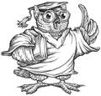
Many times when we do events I can tell when Captain Morgan needs a time out. His posture and his demeanor change along with the pinning of his eyes and rapid head movements tell me he needs a break. The problem is many who are not familiar with Macaws cannot read those warning signs and end up getting nipped. Another thing many birds do not like is to be startled this usually comes from someone moving too fast at the bird or coming from behind the bird when they do not expect it. This happened at an event when a little girl asked if she could pet Captain and very quickly stuck her hand in his face. This startled him causing him to give a warning nip, (if it was aggressive it would have been a WHOLE lot worse than what it was). Even her sister said loudly “you scared him!” Many times when someone has been bit by their birds they have done something to bring it on themselves and I am included in this. The fact of the matter is that we need to be very diligent about educating the public as well as ourselves as what signs to watch for. Some birds like Amazons many times will give a loud and clear warning that they do not want to be messed with but some are more subtle but the results will still be the same and with varying degrees of pain. There are also those birds that are easily excitable like many Cockatoos when things get crazy so do they. I have had many people tell me that when things start to get revved up in their homes so do their Cockatoos and if they are on the floor watch out for your toes. So Mr. or Mrs. Cockatoo has to go away until all calm down and all parties are less excited, (this has saved many a toes from an overly playful Cockatoo). Many of us can read our birds like a book and know when it is time for a little calm down time. The moral to this story is watch body language and if a bird has been placed back on his play stand ask before you proceed to interact with that bird. This will save you from a possibly painful situation.
Dave



BIRTHDAY GREETINGS to:

ANNE BOLANDER AUG. ?
LEO FENNELY AUG. 7
JEAN JEDRZEJEK AUG. 9
KATHE COTE AUG. 14
NADIA MINKH AUG. 14
DON HARRIS AUG. 16
LINDA MCCARTHY AUG. 17
SUSAN JENISON AUG 20
MOLLY CHINERY AUG. 28

DON’T FORGET THE PICNIC!
Next month is our annual picnic at Garden City Park, Cherry Hill and Merriman. Enter the park from Cherry Hill and follow the road around until you see Dave and Tammy at the large pavilion. Remember we are moving the location of our picnic from the pavilion on the north side of the park to the large pavilion at the east end by the restrooms.
The Club is providing the meat and everyone is to bring items to pass and your own beverage (there will be a cooler with water and ice.) It is also recommended that you leave your pets at home for this event unless they are used to being outside in the wind and weather. Wings’ being clipped is a must and smaller lighter birds should stay home, we don’t want any accidental fly offs. The picnic is from 10ish until we’re tired of each other’s company.


BITS from BABY

Howdy all my feathered and non-feathered friends I got some good news. YIPPEE!!! The Vet said I can try going to one of the programs this month, as long as the program is during the week in case I need to see him after. So our second program on July 18th I’ll give it a try.
Well the June meeting was a lot of fun for all playing Bag-It-Bingo. Too us feathered members it looks a little confusing but it was fun watching everyone taking a gift and then someone else takes it when they call bingo. We had a total of sixty-three people, fifty-four members and nine guests with three of the guests joining our flock. There were a total of thirty-three birds at the meeting, six Macaws, seven African Grays and nine Cockatoos, plus fourteen other types of Parrots. I hope to be at the July meeting.
July is one of our busiest months with five Education Programs. We have three the third week alone. July 15th was an encore at the Waldenwoods in Canton, three days later on July 18th another encore at the MediLodge in Milford( I’ll be there at my first program in mouths), and again in three days on July 21st an education show at the White Lake Township Library in White Lake. The feathered and non-feathered members enjoyed doing the programs as much as the audience enjoyed seeing all the beautiful exotic birds.
We still have two programs to do, one July 27th at an American House in Hazel Park and on July 30th at the Sunrise Assisted Living in West Bloomfield.
Keep up the GREAT work you guys and gals!! You make the programs special for all young and elderly folks that attend our shows.
I hope I’m back for good!!
Till next month,
your friend
Baby
>< >< >< >< ><>< >< >< >< ><><><

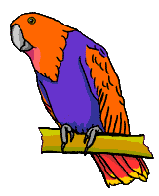


                               

RESCUE RANGERS
                  
         


Once again the call came in and the rangers were off to the hamlet of Royal Oak. (Hamlet sounds much more interesting than city, don’t you think?) This time it was to pick up two Cockatiels. The circumstances went like this; this person was losing their home and needed to place the birds for they were not sure where they would end up but all of the prospects nixed bringing the birds with them. So the rangers were lead in the house through a maze of packed boxes and those waiting to be packed; down the stairs to the basement and over to the birds. Both birds were beautiful but seemed lonely. This person explained that through all the commotion the birds got placed down in the basement so they would be out of the way and sometimes the light was not turned on because they forgot. So both of these beauties were scooped up placed in carriers and whisked off to the foster home. There they would not stay long before they would find their forever home for both were as sweet as they were beautiful. Also both went together so they were not separated and never would be. What joy what bliss a happy ending but they could not revel for long for there were other birds to rescue and as long as they existed our Heroes could never rest for they are the RESCUE RANGERS!!!

Stay tuned for our next exciting installment Oh NO! It’s Friday.

Quality by Mother Nature
Original Corn Bean Mix®: Noodles-n-Nuts®
Rainforest Rice Puddin®: Pollypasta®
Kung Fu Yum®
For Birds of all Sizes 
The Industry Pioneer of Quality Broad Natural Low Fat Nutrition®
All at a Cost Less than Seed
Because Crazy Corn® expands and seed is 60% waste! We’ve made it easy to prevent the most common cause of bird death- malnutrition from a seed diet. Cook ahead monthly, freeze baggies, keep some in the fridge to serve instantly. Superior breeding, lustrous feathering. Self-weans chicks. Shining health. Generous chunky fruits, veggies, whole grains, exciting herbs, pastas, beans, legumes, melon seeds, nuts, and more! Ecstatic birds! 1-800-BIRD YUM
in California (818) 503-4YUM. Fax (818) 765-4895
SPECIAL BREEDER PRICING

   


 □ 









 





Odds and ends


Rescue update

It’s been another successful and busy month for our rescue efforts. This month we found new homes for two Parrotletts and a Goffin Cockatoo. All of these birds went to their new homes with cages, food and toys.
Everyone in our club should be proud of themselves. It is your donations and participation in the club’s monthly raffles and events that have made our rescue the success that it is. Kudos and thanks to all of you for your help, keep up the great work.

*RESCUE PROCEDURE*

There is a proper procedure for turning a bird into the rescue and we must do our best to follow it. Any time a bird is to be surrendered to our rescue Dave, Steve, Tammy, Mary or Stan must be contacted first so proper arrangements can be made. Rainbow Feathers Bird Club and Rescue can not take responsibility for any birds that have not followed this procedure. If you have elected to take in someone’s unwanted bird or if you have been offered a “free” bird please be aware that you will have to assume the full cost of veterinary care yourself.

Avast ye Mates

CAPTAINS CORNER

Greetings to all I hope that you are surviving this very hot start to summer but wait summer started in March this year didn’t it? Anyway I am here to blow off some steam about a trend that not only do I find disturbing and downright totally annoying but my other feathered compatriots do too. That is sticking your hands, face or other body part in our faces it can be flirting with disaster. I have had people come up to me with their palms out like I’m going to sniff it like a dog, excuse me do I remotely resemble a dog. I don’t think so. So rather than sniff it I think I will just give you a parrot version of a Gibb’s Slap but rather than the back of your head it will be a finger and I have got five to choose from. (Ok so one technically is a thumb just work with me on this) We cannot and will not be treated like (UGH) dogs it is a tad bit degrading if you ask Pookie, Angel, J.B., me and any number of parrots. Now don’t get me wrong I like dogs they clean up my pellet mess and keep my pet humans occupied so I can get other things done. The only drawback is that they are a lot harder to train than a pet human and their potty manners are not shall we say the best in the world. (Again, I know we go whenever we want and wherever we want so you got a problem with that?) Anyway, let us not forget that we are Parrots not dogs or cats so next time you expect me to sniff your hand let’s just say it won’t be pretty. Treat us like the superior beings we are and there will not be any problems at all. It is easy and it won’t cause anyone any pain, if you know what I mean.

Cheers
Captain Morgan

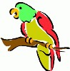
UP COMING
EVENTS

July 15th Educational Show
Waldenwoods of Carriage Park
Assisted Living Building
2000 Canton Center Road
Canton, MI 48178
(Behind Meijer’s off Canton Center RD.)
1:00 PM Set-up
2:00 PM Show

July 18th Educational Program
MediLodge of Milford
555 Highland Avenue
Milford, MI 48381
Set-up at 1:00 pm
Show starts at 2:00 pm

July 21st Educational Show
White Lake Township Library
7527 Highland Rd.
White Lake, MI 48383
10:00 am Set-up
11:00 am Show

July 22nd Club meeting at the church as usual

July 27th Senior Educational Program
American House Hazel Park
777 East Woodward Heights
Hazel Park, MI 48030
Set-up 1:00 PM
Show 2:00 PM

July 30th Senior Educational Program
Sunrise Assisted Living
7005 Pontiac Trail
West Bloomfield, MI 48323
Set-up at 12:30 PM
Show at 1:00 PM

August 11th Pet Emporium Pet Fest
August 12th Washtenaw County Fairgrounds
5055 Ann Arbor-Saline Rd.
Ann Arbor, MI 48103
No Set-up times at this time
Runs 10:00 am to 6:00 pm Both Days

Ypsilanti Heritage Festival
August 17th Noon to 8:00pm
August 18th 10:00am to 8:00pm
August 19th 11:00am to 6:00pm
We will most likely be setting up our pop-ups at about 7:00am on Friday the 17th as we have done in years past. Tearing down on Sunday after the festival ends.

August 23rd Senior Educational Program
Sunrise Assisted Living
7005 Pontiac Trail
West Bloomfield, MI 48323
Set-up at 12:30 PM
Show at 1:00 PM

August 26th Club Picnic
At Garden City Park under the large pavilion.

Sept. 16th Walled Lake Pet Awareness Day at
Walled Lake’s Historic Lakefront District
Ferland Street at E. Walled Lake Drive
11:00 AM to 4:00 PM
We will be setting up our pop-up before the event Set-up starts at 9:00 AM

PET EXPO
Sept. 21st 4pm to 8pm
Sept. 22nd 10am to 8pm
Sept.23rd 11am to 5pm
Suburban Collection Showplace
46100 Grand River
Novi, MI 48374
Please note that the dates for the Expo have been moved from November to September. This will be updated as more information becomes available. We have submitted our club’s paperwork to attend.

******NOTE******NOTE******NOTE******
There has been some confusion from the loyal readers of Bird Droppings as to which events they are allowed to bring their own bird(s) to. As a point of reference and for future information please we want everyone to be aware that when you see the line:
******Our Club Has a Booth at This Event*****
following or “Educational Show” preceding an event listing it means we are attending the event in an official capacity representing our club and rescue. At these events all club members are welcomed to bring their feathered companions with them. Also please note that our space is very limited at some of these events but don’t let this stop you from joining us, we will find a way for you and your birdie buddy to fit in and enjoy the fun.

******NOTE******NOTE******NOTE******

*CANCELATION CONFUSION *

A few of our scheduled events have been canceled at the last minute by the group staging the event. If you do not regularly participate in the shows but plan on attending please call Steve (734-513-0030) to make sure the event is still a go. Recent cancellations that have occurred at the last minute are: the Fall for Novi Pet Adoption Fair, and the Allen Park Animal Shelter Pet Adoption Fair.


How to find an avian veterinarian
By Don J. Harris,DVM

One of the first responsibilities you have as a pet owner is obtaining quality medical care for your bird. The process of finding a qualified veterinarian, who is educated, trained and experienced in treating birds, is often more difficult than you initially might think. Perseverance and some good common sense on your part can result in finding a veterinarian who is skilled in treating your bird.
Here are some methods you can use.

Yellow Pages
While this may be the easiest method, an ad in the yellow pages does not necessarily qualify the practitioner to treat your bird. The American Veterinary Medical Association (AVMA) allows the term “specialist” by only those veterinarians who have fulfilled certain defined criteria in that specialty. Beyond that, yellow page ads can reflect marketing skills more than veterinary competence.

Association Rosters
Many pet owners check association rosters for qualified veterinarians. For example, the American Board of Veterinary Practitioners (ABVP) is a veterinary certifying organization that requires its members to prove competence in order to belong. Within ABVP, there is the “Avian Practice” category of specialization. Veterinarians who complete this certification process are recognized by the AVMA as true specialists. These individuals are identified by the title ABVP, Avian Practice, DVM behind their names. Generally, bird owners can trust these practitioners to provide competent care for their birds.

Pet Suppliers’ Recommendations
Pet retail stores or breeders will often recommend a veterinarian they work with on a regular basis. Their recommendations may be based on positive experiences with this particular veterinarian’s care and treatment. On the other hand, pet suppliers occasionally have relationships with veterinarians based on discounted services in exchange for referrals. While this business relationship is not in itself bad, bird owners should be advised to verify the veterinarian’s credentials.

Word-of-Mouth Recommendations
This is one of the best ways of finding a competent avian veterinarian. If a veterinarian’s own clients are making recommendations, there must be a reason why.
Unfortunately, these personal recommendations are not always available, especially if you recently moved into the area and don’t know anyone to ask.

Colleague Recommendations
This is probably the best and most consistently reliable method, but it demands a little sleuthing on your part. Here are the steps you can follow:
• Identify and call veterinarians in the yellow pages who
DO NOT claim to be avian specialists.
• Call to ask if they will see your bird. If they agree, thank them and move on.
• If they decline, ask whom they would recommend.
• Continue this process until you get enough answers to form a consensus. The veterinarian whose name was recommended the most often is the veterinarian most recognized by his colleagues for competence with exotic birds.
Congratulations! Through hard work and some common sense, you may have found just the right veterinarian for you and your bird.
This article reprinted with permission from Zupreem©

BITE ME BIRD TOYS
Tony & Edie Riojas
4593 Howell Rd, Otter Lake, MI 48464
1-810-793-2093
bitemebirdtoys.com

NORTH BRANCH ANIMAL HOSPITAL
Frederick B. Shulak, D.V.M.
17630 Twelve Mile Road * Southfield, MI 48076
248-557-7773

ROOSE ANIMAL HOSPITAL
Kevin Roose, D.V.M. * Karen Knight, D.V.M.
509 W. Ann Arbor Trail * Plymouth, MI 48170
734-451-2870

SPECIALTY PET SUPPLIES, INC.
1449 W. Ann Arbor Road * Plymouth, MI 48170
734-453-6930
Fax: 734-453-7127
M-F 10-7:30 * Sat 10-6 * Sun 12-4

WARREN WOODS VETERINARY HOSPITAL
29157 Schoenherr * Warren, MI 48314
586-751-3350

OAKLAND VETERINARY EMERGENCY GROUP
1400 Telegraph Rd * Bloomfield Hills, MI 48302
248-334-6877

Free discount card Open 7-Days available to club members Ask about our birdie day spa treatment

DISCOUNT PET & SUPPLIES
Specializing in Exotic Birds & Cages
1623 Middlebelt Rd. Livonia, MI 48154
734-513-6060
http://www.discountpetandsupplies.com/

SOUTHGATE ANIMAL HOSPITAL
Keith Cook, D.V.M. * Elieen Cook, D.V.M.
13697 Dix-Toledo Rd* Southgate, MI 48195
734-284-9122

ANIMAL EMERGENCY CENTER
24360 Novi Road * Novi, MI 48375
248-348-1788
265 E. 2nd St. * Rochester, MI 48307
248-651-1788
Both Locations are open 24 hours a Day
7 Days a Week
www.theanimalemergencycenter.com

MUGSHOTS and MOUSE PADS
Species specific coffee mugs, mouse pads and other parrot
paraphernalia
Cheryl Hitter
734-422-2804
*Put your pet’s picture on a mug or mouse pad*

Custom sizes up to 25” x 38” •
Square or Rectangle cuts
PayPal plus Shipping available • Priced for 100 sheets
White cover weight paper • Fresh clean cage everyday
Call or email us for your custom size
248.438.6572
littlemancageliners@yahoo.com
Visit us on
Facebook and Blogger!
little-man-cage-liners.blogspot.com

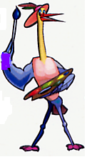
MURALS
AND OTHER
CREATIONS
BY MARY KAY PERVA
734-207-0489
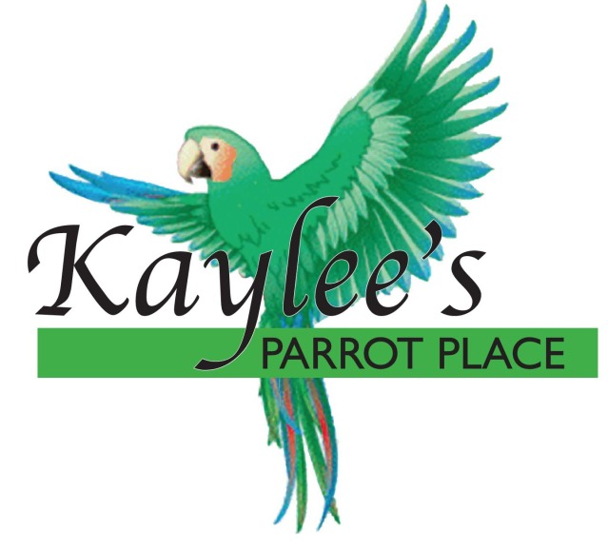
“Baby Parrots Raised in a Home for a Home”
Specializing in Macaws, Greys,
Amazons, and others.
Cages and Food at reasonable prices.
Contact Kaylee at 734-301-0486
www.kayleesparrotplace.com

UV LIGHTING, HEATERS, VITIMINS AND OTHER SUPPLIES for your BIRDS, FISH and REPTILES

VISIT OUR WEBSITE AT
zoomed.com

Veterinary Care Specialists
205 Rowe Road
Milford, MI 48380
248-684-0468
Open 24 Hours A Day 7 Days A Week

