 This newsletter
Devoted to pet bird Enthusiasts is published monthly by
Rainbow Feathers Bird
Club of Michigan
A 501(c) (3) club

November 2016
Volume 19 Issue 11

Bird Droppings

UPCOMING MEETING DATES:
NOV. 11th 12th 13th Pet Expo
NOVEMBER-PET EXPO NO MEETING
DECEMBER 18th – THIRD SUNDAY
JANUARY 22nd – FOURTH SUNDAY

RAINBOW FEATHERS BIRD CLUB
Who we are and what we are about
- Non Profit club with members throughout the tri-county area, single bird owners, or just thinking of getting a bird, families, breeders, exhibitors, all are welcome.
- Support scholarships for avian vet students
- Yearly Bird Fair
- Club Library for members
- Grooming available
- Avian rescue/relocation programs
- Monthly meetings with programs of interest to members.
- Monthly newsletter
- Periodic Service projects
- Field Trips
- Educational Programs upon request
- Make-it-take-it workshops
And more…….
Come join us and have your feathers preened by other Pet Bird Enthusiasts

Rainbow Feathers Bird Club Elected Officers: President – Dave Carol 734-422-5981
Email – sweettweeters@comcast.net
Vice President – Steve Plafchan 734-513-0030
Email – splafchan@twmi.rr.com

Secretary – Kathe Cote 313-728-2211

Email – gardenfrog1967@yahoo.com
Treasurer and Membership Secretary – Tammy Carol 734-422-5981
Email – sweettweeters@comcast.net

Board of Trustees –

Mary Perva – 517-672-9528

Email- maryperva@rocketmail.com
Susan Dixon 248-330-6938
Email – susanhdixon@hotmail.com
Henry Jedrzejek-734-427-3187
Email – bigduke@comcast.net
ALL HEALTHY AND CLIPPED BIRDS ARE ALWAYS WELCOME TO ACCOMPANY THEIR HUMAN COMPANIONS TO THE MONTHLY MEETINGS. WE MEET AT THE UNITED METHODIST CHURCH, 6443 MERRIMAN ROAD BETWEEN FORD AND WARREN IN GARDEN CITY. MEETINGS START AT 2:00 PM.

Anyone interested in becoming a member please contact Tammy Carol @ 734-422-5981 or by e-mail sweettweeters@comcast.net

Steve Plafchan is now doing the newsletter. All ads and articles will be due the 1st of the month for publishing in the current month’s newsletter. Please send all items to him at 11021 Henry Ruff, Livonia, MI 48150 or email them to him at splafchan@twmi.rr.com

Everyone is encouraged to submit articles for the newsletter – this is YOUR newsletter.

Articles and/or pictures copied from other publications must be accompanied with written permission from original publication and author; this needs to be provided to the editor along with the article and/or picture.

Editor reserves the right to approve and/or edit any articles submitted prior to publication.

Ads will be run free for members having a one-time sale (baby birds, etc.). Those wishing to run ads multiple times or for a business must purchase a business membership.

BIRD CLUB ETIQUETTE

- Ask owner’s permission to handle/feed bird(s) and remember to return bird to the owner.
- Wash hands prior/after bird handling.
- When bringing companion birds to club meetings, only bring birds that you have had vet checked and in your possession for at least 30 days.
- Clean up after yourself and
your bird(s) before you leave.

Monthly Potluck
Early last year, we stopped soliciting volunteers to bring food to our meetings. Instead, it was agreed that the format be a potluck venue. We ask that “Everyone”, please join in and contribute a main dish, veggie, salad, or dessert. Our meetings will be a potluck fair enjoyed by one and all.

CLUB WELFARE
Please contact Jean Jedrzejek at 734-427-3187 or e-mail her at bigduke@comcast.net if you know of any club member who is in the hospital or has lost a loved one.



Crossing
The Rainbow Bridge

Sadly, we must report yet another loss of another feathered club member; Merlin a Red Lorrie that has shared a room with Tammy and Dave for many years crossed over.
FAREWELL
Merlin

From the prez:

Do you not love this crazy weather it has been so un-fall like but I am not complaining it could stay like this all winter but I know the cold stuff is coming. I am also amazed how fast this year has gone we are now heading fast into the holiday season Thanksgiving and Christmas, sorry for the reminder. Every year I find myself thinking about the things I am thankful for things that have touched my life and people who I have met no matter how brief, that have impacted my life. It can be with a kind word, a gesture, a surprise donation or a hearty thank you for being there for these magnificent animals. It is the reaction at a program that elicits a spontaneous hug or the endless thank you for giving them such a wonderful program. It is seeing the people’s faces at the events as they get to hold a parrot or a child’s look of wonder as they see a rainbow of colors. It is also the look of total shock, and then laughter as Captain Morgan lets out one of his legendary screams. Most important it is being involved with such an incredible group of people, yes you the members of Rainbow Feathers. Your generosity, your commitment and your passion for these incredible creatures no matter how big or small it is that family feeling and just being able to come together and have such a good time no matter what we do. Believe me it not only comes across at the meeting but at all the events we do, people notice how much fun we are having and what as one person put it a “cohesive group” we are. Well there was that one stuffed shirt that felt we weren’t mature enough for her but oh well stuffy we certainly aint! By the time you get this the Novi Pet Expo will be over and I know it will be a success because of you and what fantastic people you are. I am thankful for each and every one of you and what you bring to the club and rescue. So I wish you all a very happy and Blessed Thanksgiving and as always, YOU GUYS ROCK!!!!!
Until Next Time
Your Prez
Dave

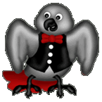
Voice of the Veep

My first duty in the column this month is to apologize for the tardiness of our November newsletter. Due to the date change of the Pet Expo and obligations I was committed to for teaching some classes at the Tech Center for Ford I missed the normal deadline for my column and the newsletter. Hopefully I will be back on schedule and have the December newsletter out on time.
See you at the Dec. Meeting
Your Veep
Steve


From the many events and phone calls we participate in we always get some really interesting comments and observations and you know I can’t resist putting them in the newsletter so I hope you enjoy these little gems.

A woman at Guardians for Animals Pet Expo said this to me. I am so glad that these parrots will end up back in the wild. I asked where did you get that idea. She said she heard me say we rehabilitated them and sent them home. To which I said no we send them to their new homes with new owners. She seemed very disappointed and thought we would do the right thing. I told her that was the right thing they would never survive in their native habitats because of human imprinting. She left very disappointed.

At the same event one guy exclaimed “I really thought those were Pigeons on his shoulder they don’t look like parrots from a distance”!

Another woman at the event said when I told her Princess the Indian Ringneck and Kiwi Rose the Mustache were both Parakeets she looked at me and said “Please don’t lie to me I don’t think they’re even in the parrot family”.

One older gentleman went from Tammy to Steve to me asking “how much?” meaning what are you charging for each bird. I guess the first two not for sale answers were not convincing enough.

Phone calls are fun too:
One woman who had seen us at last year’s Novi Pet Expo and this year’s Guardians for Animals Pet Expo made this rather dumbfounding declaration. After seeing you at two events now I was thinking of joining your club but your group is not mature enough for me. I say thank you we don’t do stuffy to well!

This one was like the classic Who’s on First routine from Abbot and Costello.
This woman calls and says; I see your having a bird fair at the Suburban Collection Showplace. I say no it’s a pet expo. To which she says but there will be birds there right so it’s a bird fair. I say again no it is a pet expo. She says but there will be birds there so IT IS a bird fair. I say no it is not just birds she interrupts and says yes I know there will be toys, cages and food there as well I have been to bird fairs and I do know what they are all about. I finally say and also dogs, and cats up for adoption as well as all sorts of pet products and different shows going on not just birds. She finally says “well I’m not going to waste my time” you said it was a bird fair that birds will be there and hung up. I ran for the aspirin thinking and the pet expo is coming up here we go again!!!



BIRTHDAY GREETINGS to:

CHERYL BRATCHER DEC. 1
LINDA WAGNER DEC. 3
CAROL BURGESS-KRZESOWIAK DEC.5
JEREMY EAMES DEC. 7
PATRICK BONSE DEC. 13
LINNEA NICHOLSON-FARIS DEC.13
ANNETTE BALLARD DEC. 14
ELIZABETH GLADSON DEC. 17

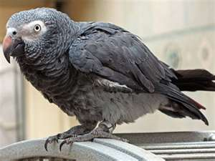

Quality by Mother Nature
Original Corn Bean Mix®: Noodles-n-Nuts®
Rainforest Rice Puddin®: Pollypasta®
Kung Fu Yum®
For Birds of all Sizes 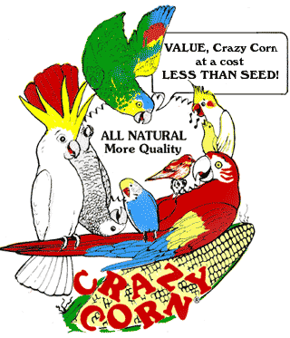
The Industry Pioneer of Quality Broad Natural Low Fat Nutrition®
All at a Cost Less than Seed
Because Crazy Corn® expands and seed is 60% waste! We’ve made it easy to prevent the most common cause of bird death- malnutrition from a seed diet. Cook ahead monthly, freeze baggies, keep some in the fridge to serve instantly. Superior breeding, lustrous feathering. Self-weans chicks. Shining health. Generous chunky fruits, veggies, whole grains, exciting herbs, pastas, beans, legumes, melon seeds, nuts, and more! Ecstatic birds! 1-800-BIRD YUM
in California (818) 503-4YUM. Fax (818) 765-4895
SPECIAL BREEDER PRICING

I’m Sick.....
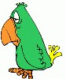
I’m sick can I give this to my birds? That is one of the most asked questions I get at this time of year hands down. Now as we all know rule of thumb is that if you are sick you stay home and avoid groups of people so you do not spread what you have or pick up a secondary infection. This is just common sense but what about your birds; can you give them your cold or flu? In most cases we can not share illnesses with our feathered kids, (except for a couple the main one being Psittacosis or Parrot Fever in humans). This however doesn’t mean that you shouldn’t be more careful around your birds. When ever I get sick I limit face time with my birds which means I do not do my normal snuggling and cuddling just as a safety measure and I constantly wash my hands. I just do not like to take chances with my bird’s health and I know we are all that way. Another thing that has everybody concerned is the Swine Flu they have had turkeys that have contracted this virus but exotics have not. So remember if you do get sick stay home and take care of yourself even if it means missing church or even a bird club meeting. We want you healthy, happy and your birds too.

Dave

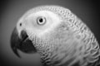
Out and About with Pookie

The editor’s desk at “Bird Droppings” has received numerous inquiries about the cold weather during the winter months. Questions such as; 1) Is it safe to give your companion bird a bath in the winter? 2) Is it safe to take your companion in the car when it’s cold outside? 3) Should I operate a humidifier in my house during the cold months? 4) If I’m ill or have a cold can my companion bird catch it from me? These are but a few of the cold weather questions that have been submitted over the past few months. We will do our best to give everyone some clarity on these inquiries.
First we (companion parrots) cannot catch the flu or the common cold from our human companions. However; if your human companion has a cold or the flu they will most likely be greatly irritated by the dust, dander and loose feathers in our cages while they are under the weather. With most humans it is pretty easy to tell when they are not feeling well, they tend to lie about wrapped in blankets to keep warm while clutching a box of Kleenex® for security.
If your home has a forced air furnace you need to inform your companion human to ensure the humidifier is functioning correctly and is free of any molds or mildew. If the humidifier has an evaporator element it should be cleaned or replaced prior to use during the cold months. A properly operating humidifier will insure there is moisture in the air and helps prevent excessively dry skin and will help us keep all of our feathers in tip top shape. A home with hot water or steam heat (generally recognized because they utilize wall or baseboard registers) doesn’t have a humidifier because the heat is moister than a forced air furnace. Tell your human to pay attention to their own skin; if it’s dry and itchy and they find they are using a lot of lotion and moisturizing cream tell them you have itchy skin also. One of the easiest solutions is increase the number of showers and baths that you take and make sure you preen your feathers dry; don’t use a hair dryer! A hair dryer will dry out your skin and might cause you to get the itchies.
You companion human needs to observe common sense when it comes to taking you in a car when it’s cold outside. Make sure the automobile is started and warmed up before you are put onto the car. Tell your human that if it’s too chilly for them to drive without a jacket it’s too cold for your carrier to not be wrapped in a towel for warmth.
Therefore, everybody remember moisture is your friend when it’s cold outside but you have to stay dry and warm when venturing fourth to the outside when it’s cold.

Chirps and Squawks
Pookie
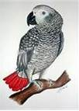


It started out like any other phone call this woman was asking for advice about her African Gray but the advice she needed left me laughing and I’m sure you will too. She was having a 4th birthday party for her daughter and there were between 12 and 15 children there as well; all 4 and 5 years old. They were playing games and things began to get loud and the excitement level was reaching a very high level. As the kids got ramped up so did the Gray and he began making all sorts of amusing sounds and talking away like there was no tomorrow. When all of a sudden he let his freak flag fly and came out with some very colorful language much to the horror of this woman and her husband. The kids all began to say the bird said a bad word and began laughing which encouraged the bird even more. Finally, the bird was put in his night-night cage in another room away from the party but the damage was done. She wanted to know how to stop the bird from ever saying those words again. I told her you can minimize this by not reacting when he says them and he may not say them for a while but unfortunately he has them and will say them again at some time, usually when you don’t want him to. She was not happy but they needed to turn down the TV when movies with that sort of language are on. Can you imagine when the other parents ask how was the party and their kids say the bird said #*!& and %$*& I would love to see the look on their faces. Also I bet they don’t ever go to a party at that house again! Ah birds gotta love em!

Rambling with Rambo
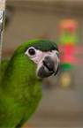
Really not much to say these past few months. Daddy has been busy with other things. So I have not been getting much attention. And we have missed many Educational show.
The past few, Daddy was not paying attention to the show dates.
But on the good side of things. The Guardians For Animals show was really good. We had lots of fun. The first day we took that friend of Daddy’s Lisa. The second day, we took a new friend of his. This was Miss Karen. She is looking to become a Rainbow Feathers member. She want another bird after the holidays. Her other one died a few months back. This is a really nice person. She helped all day. Then she helped pack everything at the end of the day. And naturally, she loved Yours Truly. Well how could anyone help but love me, and all the other Macaws. Remember the Macaws are the stars of the event.
Captain Morgan dressed up for the pet costume contest. Naturally, Dave wore his pirate outfit.
We all had a good time this year. I was not as stressed out as last year. Yes last year I was a bad little bird. Last year I bit daddy many times. This year I was much better. I was nice to everyone.
In a couple of weeks, we are going to the big Pet Expo in Novi, Michigan. We plan on being there all 3 days. Miss Karen will be there on Sunday. She is bringing a friend with her. That is great. That will be another person to enjoy the day with.
Daddy is hoping to bring a new friend of his one of the days. Listen you, don’t take any attention from me. He is my Daddy. I don’t like sharing him.
Well everyone, I hope to see many of you there. And oh yes. The October meeting was great. There were many people we have been missing, lots of food, and the usual fun. Packo got carsick again. Then he barked all over the back of daddy’s white shirt. Poor Packo. He has not been feeling well since the meeting. So he may not write his column this month.
Though Daddy had those mean people cut my nails, and file my beak, I still had a good time at the October meeting. I am so much better there. I don’t mind if Packo wants daddy’s attention. He is still a little nervous with all the noise
That is all I have to say this month.
As always, Remember,
Have Fun, (try to) Be Good,
and Never Forget,
Macaws Rule.
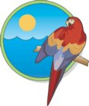
Rambo

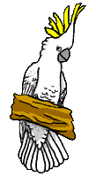
Bits from Baby

HOWDY to all my feathered and non-feathered friends, this is your roving reporter Baby with the latest and greatest news.
October was the last busiest month this year. We still have three more Senior Programs in November and one in December to do and then we can rest up for next year.
We also have The Pet Expo at the Suburban Collection Showplace in Novi from Nov.11th thru the 13th. That is one of the shows I get to attend with all the other fathered and non-feathered members. I like to call it THE GREATEST SHOW ON EARTH! I hope to see you guys there to have one great party and meet a lot of nice people that come to visit our group!!
The October meeting was great with fifty people, there were forty-five club members and five guests of which two joined our flock. There were six African Grays, Eight Cockatoos, and seven Macaws plus sixteen other types of Parrots there.
See you all at the next meeting.

Your friend Baby
>< >< >< >< ><>< >< >< >< ><


                        
RESCUE RANGERS
                             



Well here we are again speeding off to another adventure this time in Lake Orion the wrangle not one, not two, but twelve Cockatiels (yes I said twelve) but you would not believe how they were kept! Now before you get the wrong idea they were not abused, neglected or otherwise in poor shape on the other hand they were beautiful. What made this so unique was they were free flighted in a bedroom that had been converted into their own little birdie paradise. As the Rangers walked into the room it was like a scene out of Alfred Hitchcock’s The Birds just without the blood, gore and attacking of humans. Armed with a net and a towel it actually looked like the Rangers knew what they were doing instead of winging it (in these situations you always wing it because they are all different). So they went about the task of wrangling twelve free flighted Cockatiels flying like fighter jets. Every now and then you could hear a victory cry as they slowly caught one bird after another and the carriers began to fill up until there was just one left. Now as we all know that one that was left probably watched and learned as his roommates were captured one by one and figured out the best way to elude his own capture. He would fly over the short one which was fairly easy seeing how he was vertically challenged but the guy with the net well he was taller and tougher and would take a little more skill to stay away from. This Cockatiel really gave the Rangers a run for their money bobbing, ducking and weaving around the room but he finally made an epic mistake. He must have thought that the net was shorter than it was and alighted on the curtain rod and with lightening quick speed Ranger Steve pounced and netted him before he knew what had happened. Finally, all were caught and all of their stuff was loaded into the rescue mobile for the trip home. Before the Rangers could leave the people turning in the birds made sure to give the Rangers a very big donation for coming out and helping them out like this what a great day. It wasn’t long before all of them found homes and the twelve were now only birds but part of a much nicer flock where spoiling was always on the agenda. What a great ending but there were still more adventures to be had and rescues to be done but they were up to the task for they are the RESCUE RANGERS!!!!!

Stay tuned for our next adventure A Blue and Gold & A Gray in Belleville

Avast ye Mates

CAPTAINS
CORNER
Three cheers to the birds we are finally making headway into the dog and cat dominated world of placing at contest. With myself and my pet human taking third in the costume contest at the Guardians for Animals Pet Expo and Tuna taking third in the mummy wrap and second in the trick contest we are making Fido and Fluffy very nervous. Of course you have to have pet humans with a very high tolerance for embarrassment and low shame factor and you’re good to go. I know we have that in spades or they would not let us make them look bad at all these programs we do. Still it’s all in fun so they say but we birds can see that competitive streak come out in them when we do these contest. I even stooped to letting them put a Pirate medallion around my neck but stopped short at holding the Pirate Flag. Now by the time you get this the Novi Pet Expo will be over but I know there will be more than one Pirate there this time and I say the more the merrier. So I personally am glad that our pet humans supposedly throw maturity out the window at these events and live on the wild side. I say it is fun to sometimes let your freak flag fly and just enjoy the moment we birds do it all the time, now wait a minute, are they copying us, I’ll bet they are thank goodness there is nothing worse than a stuffy human. So let us not worry about maturity but have fun and if others don’t like it I have just one thing to say Stay away we don’t adult very well sometimes!!!!!!!!!
Cheers
Captain Morgan

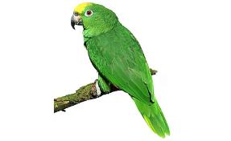


Rescue Update
Our rescue continues to be active. We have adopted to new homes two parrots, A Green Cheek Conure and a Quaker Parakeet.
All these birds went to their new homes with cages, food and toys. Thanks to all of you, our generous club members. It is because of your support and participation in our monthly club raffles and your donations that help to make our rescue the success that it is. Keep up the great work, our thanks to all of you.

A bird’s droppings can be an early indicator of illness

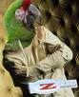
By Don J. Harris, DVM
Because birds are excellent at hiding illness, your bird’s dropping may be one of the early indicators that your bird is sick. There are three components to your bird’s droppings—the stool component, the urine component and the uric acid component. Changes in any of the three components should be taken seriously and may indicate your bird is sick. Any abnormal signs demand the immediate attention of your veterinarian.
1. The stool component
The stool comes from the gastrointestinal tract and is usually a greenish rope or blob. This portion of the bird’s droppings is highly influenced by the bird’s diet and can radically vary with a change in diet. For example, beets can make the stools red, while blueberries may turn the stools purple. Colorants in some commercial diets can also change the color of the stools. Color changes are often irrelevant, but bird owners should be concerned if the stools become black or have a
strong or unusual odor.
2. The urine component
The relatively clear, watery urine portion is produced by your bird’s kidneys. The amount of water in your bird’s droppings is directly influenced by the water content of the foods your bird eats. Wet stools, however, should become drier with dry foods. Large amounts of water persistently present in the droppings could be a sign of serious disease and you should consult your avian veterinarian.
3. The uric acid component
The white/cream colored uric acid portion of your bird’s droppings is a very important indicator of
health. This part of the droppings should without exception be white or near white in color. Changes to lime green, bright yellow, mustard brown, pale brown and brick red are common signs of very serious illness. Any change from normal should be investigated immediately. Establish a normal benchmark in your bird by observing and keeping a record of the number, volume, color and consistency of your bird’s droppings. This can be very helpful later if you notice a change.
This article reprinted with permission from Zupreem ®

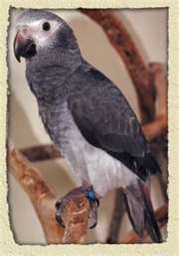

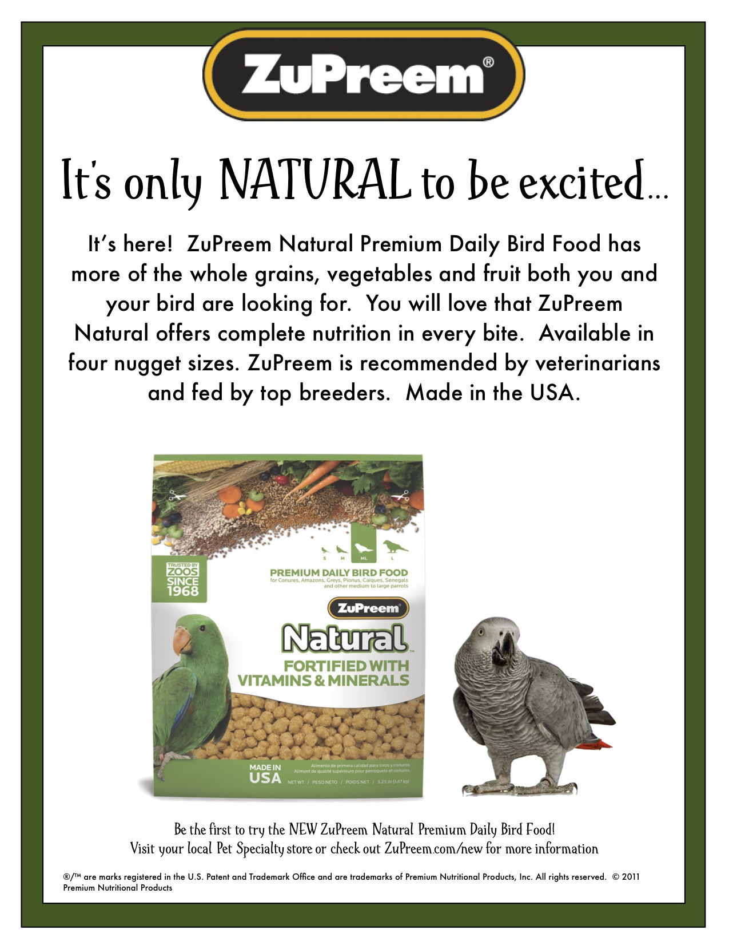

BIRDMAMA’S BIRD SITTING
SERVICE
Are you going out of town or on vacation? Do you have a feathered friend that needs to stay at home? Susan can help you. She will shower your bird(s) with TLC in her home.
For more information on rates and care specifics, contact by phone or e-mail
Susan Dixon
1-248-330-6938
susanhdixon@hotmail.com
References provided upon request

Free discount card Open 7-Days available to club members Ask about our birdie day spa treatment

DISCOUNT PET & SUPPLIES
Specializing in Exotic Birds & Cages
1623 Middlebelt Rd. Livonia, MI 48154
734-513-6060
http://www.discountpetbirdstore.com/

ROOSE ANIMAL HOSPITAL
Kevin Roose, D.V.M. * Karen Knight, D.V.M.
509 W. Ann Arbor Trail * Plymouth, MI 48170
734-451-2870

WARREN WOODS VETERINARY HOSPITAL
29157 Schoenherr * Warren, MI 48314
586-751-3350

SOUTHGATE ANIMAL HOSPITAL
Keith Cook, D.V.M. * Eileen Cook, D.V.M.
13697 Dix-Toledo Rd* Southgate, MI 48195
734-284-9122

ANIMAL EMERGENCY CENTER
24360 Novi Road * Novi, MI 48375
248-348-1788
265 E. 2nd St. * Rochester, MI 48307
248-651-1788
Both Locations are open 24 hours a Day
7 Days a Week
www.theanimalemergencycenter.com

OAKLAND VETERINARY EMERGENCY GROUP
1400 Telegraph Rd * Bloomfield Hills, MI 48302
248-334-6877

Parkway Small Animal & Exotic Hospital
39321 Garfield
Clinton Township, MI 48038
586-416-8800

Veterinary Care Specialists
205 Rowe Road
Milford, MI 48380
248-684-0468
Open 24 Hours A Day 7 Days A Week

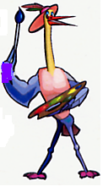
MURALS
AND OTHER
CREATIONS
BY MARY KAY PERVA
517-672-9528

SPECIALTY PET SUPPLIES, INC.
1449 W. Ann Arbor Road * Plymouth, MI 48170
734-453-6930
Fax: 734-453-7127
M-F 10-7:30 * Sat 10-6 * Sun 12-4

MUGSHOTS and MOUSE PADS
Species specific coffee mugs, mouse pads and other parrot
paraphernalia
Cheryl Hitter
734-422-2804
*Put your pet’s picture on a mug or mouse pad*

PRODUCTS FOR SALE

UV LIGHTING, HEATERS, VITIMINS AND OTHER SUPPLIES for your BIRDS, FISH and REPTILES

VISIT OUR WEBSITE AT
zoomed.com
Animal Crackers
1100 N. Old US 23 * Hartland, MI 48843

810-632-3344

NORTH BRANCH ANIMAL HOSPITAL
17630 Twelve Mile Road * Southfield, MI 48076
248-557-7773


Lafeber Company Customer Service
24981 N 1400 E Rd Cornell, Illinois 61319
800-842-6445 phone
815-358-2352 fax
cernst@lafebermail.com

FASHIONISTA WEAR
Custom Handmade Clothing, Hair and Body Jewelry
Anything Parrot-ly
Custom Parrot Accessories
Cage Covers, Shoulder Capes
or anything else you might think of
Text, Message or Call me and ask
If I can make it, I will
Lanah Harris
1- 734-502-3751



