 This newsletter
Devoted to pet bird
Enthusiasts is
Published monthly by
The Rainbow Feathers
Bird club of Michigan
A 501(c) (3) club

October 2015
Volume 18 Issue 10

Bird Droppings

UPCOMING MEETING DATES:
OCTOBER 25th – FOURTH SUNDAY
NOVEMBER-PET EXPO NO MEETING
DECEMBER 20th - THIRD SUNDAY

RAINBOW FEATHERS BIRD CLUB
Who we are and what we are about
- Non Profit club with members throughout the tri-county area, single bird owners, or just thinking of getting a bird, families, breeders, exhibitors, all are welcome.
- Support scholarships for avian vet students
- Yearly Bird Fair
- Club Library for members
- Grooming available
- Avian rescue/relocation programs
- Monthly meetings with programs of interest to members.
- Monthly newsletter
- Periodic Service projects
- Field Trips
- Educational Programs upon request
- Make-it-take-it workshops
Come join us and have your feathers preened by other Pet Bird Enthusiasts

Rainbow Feathers Bird Club Elected Officers: President – Dave Carol 734-422-5981
Email – sweettweeters@comcast.net
Vice President – Steve Plafchan 734-513-0030
Email – splafchan@twmi.rr.com

Secretary – Kathe Cote 313-728-2211
Email –gardenfrog1967@comcast.net
Treasurer and Membership Secretary – Tammy Carol 734-422-5981
Email – sweettweeters@comcast.net

Board of Trustees –
Susan Dixon 248-330-6938
Email- mailto:susanhdixon@hotmail.com
Mary Perva – 734-207-0489
Henry Jedrzejek-734-427-3187
Email – bigduke@comcast.net
ALL HEALTHY AND CLIPPED BIRDS ARE ALWAYS WELCOME TO ACCOMPANY THEIR HUMAN COMPANIONS TO THE MONTHLY MEETINGS. WE MEET AT THE UNITED METHODIST CHURCH, 6443 MERRIMAN ROAD BETWEEN FORD AND WARREN IN GARDEN CITY. MEETINGS START AT 2:00 PM.

Anyone interested in becoming a member please contact Tammy Carol @ 734-422-5981 or by e-mail sweettweeters@comcast.net

Steve Plafchan is now doing the newsletter. All ads and articles will be due the 1st of the month for publishing in the current month’s newsletter. Please send all items to him at 11021 Henry Ruff, Livonia, MI 48150 or email them to him at splafchan@twmi.rr.com

Everyone is encouraged to submit articles for the newsletter – this is YOUR newsletter.

Articles and/or pictures copied from other publications must be accompanied with written permission from original publication and author; this needs to be provided to the editor along with the article and/or picture.

Editor reserves the right to approve and/or edit any articles submitted prior to publication.

Ads will be run free for members having a one-time sale (baby birds, etc.). Those wishing to run ads multiple times or for a business must purchase a business membership.

BIRD CLUB ETIQUETTE

- Ask owner’s permission to handle/feed bird(s) and remember to return bird to the owner.
- Wash hands prior/after bird handling.
- When bringing companion birds to club meetings, only bring birds that you have had vet checked and in your possession for at least 30 days.
- Clean up after yourself and your bird(s) before you leave.

CLUB WELFARE

Please contact Jean Jedrzejek at 734-427-3187 or e-mail her at bigduke@comcast.net if you know of any club member who is in the hospital or has lost a loved one.

Monthly Potluck
Early last year, we stopped soliciting volunteers to bring food to our meetings. Instead, it was agreed that the format be a potluck venue. We ask that “Everyone”, please join in and contribute a main dish, veggie, salad, or dessert. Our meetings will be a potluck fair enjoyed by one and all.

From the prez:

Time sure does fly it seems like summer had just started and now we are fully into fall, where does the time go any way! It is now time to focus on our other big events. By the time you get this newsletter we will have already done the Guardians for Animals Pet Expo and will be looking toward the Novi Pet Expo a three day event of meet and greet, pictures and controlled mayhem but it is a blast to do. We need anyone who is planning to participate to please sign up so we can get the parking passes and your name on the list of club members who will be there so you get in. Remember no birds will be allowed through the front door all vendors and rescues must always use the back vendor/rescue entrance or you won’t get in. So please sign up and the parking passes will be mailed to you these are good all three days. Set-up is Thursday morning at 9 AM November 19th so meet us at the Suburban Collection Showplace if you want to help. Also we will have the discounted tickets for sale for anyone who is interested in them $8.00 instead of the full $10 for admission. I was pleased to have such a good turnout at the September meeting considering the weather was beautiful and those weekends are going to be harder to find so thanks for coming as always it was a lot of fun. So as we look toward the colder weather (sorry but this is Michigan) we will always have the taste of warmer exotic places with our birds around us. So keep that thought in your heads as the weather turns colder and the snow starts to fly it might help a little. So I look forward to the Novi Pet Expo and all the fun we will have and look forward to seeing you there, as always YOU GUYS ROCK!!!!!!
Until Next Time
Your Prez Dave


Voice of the Veep

We have two big events for our club in the near future and we are inviting everyone who wishes to assist to join us. The first event is the Guardians for Animals Pet Expo it is taking place at: Madison Place, 876 Horace Brown Drive, Madison Heights, MI 48071(this is the same hall that the Motor City Bird Club has their fair at). The Expo is a two day event Sat & Sun on October 17th & 18th. All the clubs participating will receive an equal portion of the donations from 50/50 raffle ticket sales and donations at the door. Or club is also assisting by providing birds for a souvenir photograph. We offered Guardians the option to allow them to have their photographer take photos of people with as many birds as they were willing to hold to bring in donations for the cause. This is why we need as many members to assist all day both days to facilitate handling our birds and staging the pictures. If Guardians manages to generate even a small portion of enthusiasm for pictures like we do at the Heritage Festival I know we will be a big success.
The next event is the Pet Expo in Novi this is a three day event Nov. 20th, 21st, & 22nd. We will be meeting at the church on the morning of Thurs. Nov.19th at 8:00 AM to load tables then head to Suburban Showcase to set up for the Expo. Anyone planning on attending the Expo needs to contact Tammy so she can order your parking passes also: (THIS IS IMPORTANT) is you intend on bringing a bird you must enter through the rear door then go to the desk to get a vendor wrist band. If you are just working our booth but are not bringing a bird you still must enter through the rear door and get a wrist band. If you enter through the front entrance you will have to pay for a full admission and you will not be able to bring a bird inside!
Both of these events are a lot of fun and I encourage everyone to join us for a lot of fun.
Your Veep
Steve

Avast ye Mates

CAPTAINS
CORNER

As you know last month this article got hijacked by Zoë a Moluccan Cockatoo who is relatively new to our flock but very astute in her observations, especially where Pookie’s pet human Steve is involved. She has noticed his anti-Cockatoo rants and how we need more Grays but this is just a cover-up! We have evidence that Mr. Steve is trying to divert our attention from some very disturbing evidence and that he is all talk. That evidence is pictures and they say a picture is worth a thousand words well these speak volumes. These pictures show Mr. Steve holding, GASP, not one but TWO Cockatoos. He is shown holding Zoë AND Tuna at the same time and he is smiling. Really you are always going on about how there has to be a limit put on Cockatoos and Macaws but not on Grays. Also he keeps calling Cockatoos, (Umbrellas and Moluccan) psychotic and makes so much noise when Cockatoos outnumber Grays at the meetings. Well he never says anything about the mental state of Macaws just their numbers need to be limited at the meetings. We now know this may be all for show because those pictures are very damaging to his Gray cred. I think he secretly likes Cockatoos but doesn’t want the world to know his true feelings about Toos so he blusters on and on about them. Well Mr. Steve we have the pictures and are posting them everywhere we can Squawker, Featherbook, Instabird and Snapchirp to let the world know. Welcome to the dark side Mr. Steve!!!!!
Cheers
Captain Morgan

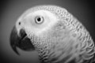
Out and About with Pookie

Contrary to many erroneous reports that have been circulating about inside the club Steve has not moved to the dark side. Oh, I admit that it was a close call, he was barely saved by the tips of our feathers; but saved he was!
Yes, all of us (the Grey’s in his home) banded together and performed a Cockatoorcisim on Steve before he became completely swallowed up by the dark side. It was close and for a short while we were afraid our efforts might have been in vain but in the end the good power of the Grey force prevailed. We started by pinning Steve in his favorite chair, holding his eyelids open and forcing him to watch videos of various Cockatoos. There were Umbrellas, Moluccans and Sulphur Crested Too’s all behaving in a cute and snuggly manner. Then at the peak of their perceived cuteness the incessant screaming would start, but we had Steve sufficiently pinned to his chair rendering him immobile and unable to respond. Although the evil darkness inside of him attempted to have him respond to this torture and have him cross to becoming a Cockatoo lover, we held our ground. Regardless of how much his head spun about on his shoulders or how much he struggled and screamed, we did not give in. We snuggled and cooed in his ears, gave him Grey kisses and hugs, assuring that small piece of the true Steve that we were on his side and we were going to save him. As the evil of the dark side seemed to reach the zenith of its influence all of us Greys bonded together wing tip to wing tip while repeating over and over to him; “Greys are good, Cockatoos can’t be trusted, Greys are awesome, Cockatoos are psychotic, I don’t trust Toos, I trust Greys, I trust Greys, I trust Greys.” With a sudden burst of emotion Steve sat up and blurted out “I’m a Grey lover.” With this sudden epiphany Steve suddenly bolted upright, the darkness in his eyes cleared and he smiled once again.
Yes, we were successful in pulling Steve out of his disillusioned state and returning him to normal; well normal is a relative term. We managed to return him to what we know as normal. To confirm that our task was complete we allowed him to hold and handle Cockatoo’s at the next bird show and there were no ill effects. The African Grey lover Steve is back with us, hale and healthy in all of his Grey loving glory.
Until next month
Chirps and Squawks
Pookie

PET EXPO
Here is tentative Pet Expo information; the hours are as follows:
Friday, November 20th, Noon - 8pm
Saturday, November 21st, 10am - 8pm Sunday, November 22nd, 11am-5pm
The Suburban Showcase has the operation of the pet expo again this year. Our club has been given the same generous space that we had last year and vendor badges will be available same as last year. We do know that no birds will be allowed through the front door; if your bird is going to attend we must get you a pass to enter in the rear doors. This can be accomplished in multiple ways; 1) Be sure to wear your club badge 2) Go to the vendor desk at the rear doors to either receive a vendor badge or to be allowed access to our booth to receive a badge. 3) Call Dave, Tammy or me on our cell phones to bring you a badge.

The club will be getting parking passes for you if you have signed up to work. If you are scheduled to work and have to pay an admission to enter or park your car keep your receipts and the club will refund your admission and parking fees. YOU MUST HAVE YOUR RECEIPTS! Entrance to the expo as a club member means you plan on working at least three hours at our booth. If you intend to shop and look around plan on arriving early or staying over after your scheduled work times please.
If you signed up to work and haven’t heard any details feel free to call Tammy 734-422-5981 or Steve 734-513-0030 for last minute information
For those of you who want to look around at the Expo, you can come early or stay after your scheduled time. The schedule will be as follows; Set-up is Thursday 9am-6pm, we will be arriving at the church to move tables into our vehicles about 7:45 AM then to Suburban Showcase at 9am to set up. Friday’s show schedule is: Noon-3pm, 3pm-6pm, 6pm-8pm, Saturday’s schedule is 11am – noon, noon-3pm, 3pm-6pm and 6pm to 8pm. Sunday’s schedule is 11am-1pm, 1-3pm and 3-5pm, and after the expo closes we will need help to clear out our space and return the tables to the church.
Tammy

!!!!IMPORANT NOTE!!!!

Please remember if you plan on working you have to sign up or let Tammy know. She needs to know as soon as possible to put your name on the list so you may enter through the rear door and she can get you a parking pass.



Well many times people will call and use language that is, well, different to put it mildly. Here are some of the things they think sound intelligent but when translated are really dumb, let’s see if you agree.
I want a bird that I have a VISUAL CONNECTION with. This means it’s got to be perfect not one feather missing!
Do you get any Umbrella Cockatoos that don’t have DECIBEL ISSUES? Meaning do you have any quiet Umbrella Cockatoos!
I would like a bird without BEHAVIORAL REASSIGNMENT ISSUES. They want a bird that is sweet cuddly and will never bite.
I want a bird that is HOUSEBROKEN! Uh, I am not sure about this one.
Many of the Grays I have seen are bald do you ever get any in without being FEATHER FIXATED. Simple pluckers not allowed!
We want a bird that will not become GENDER FIXATED. Another gimme, they want it to like both sexes.

My all time favorite so far is:
We don’t want a bird that will become SEXUALLY ENAMORED with one of us we have small children they will not understand! In other words they don’t want a male bird doing the wild thing on their hand, shoulder or anywhere on their body.
Of course none of these people would ever get a bird from us but they do keep the newsletter interesting. Oh and I am sure there will be more so you will see them!

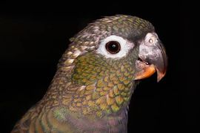

“Kiwi’s Castle”
Hello everyone! You all know me as Kiwi Iris. I own the humans Susan Jenison and Carolyn Hemmye. Today I am going to give an instructional guide on how to train your human in the technique of “Scritching”.
I want you all to know how flustered I am that it takes my humans multiple tries and a great deal of effort to finally get the technique down.
First off, all of us birdies know how great it feels for our human pets to scritch us the right way (^_^). We all know what it feels like to be scritched the wrong way (>_>).
Now I will finally start my instructional guide. The first step in getting your human to scritch you the right way, well, is they have to know that you want to be scritched. This is different depending on the species you happen to be. If you are a Cockatoo or Macaw, you may try squawking a little to let your human know that this is what you want them to do (this is after you have made several nice attempts to get what you want). If you are an African Grey (or a species I have not yet listed), you may try to play with an jewelry or glasses, or maybe even nibble on the ear if your human does not pay attention. This is because you are tired of your human’s shenanigans of being busy with things they actually think are more important than paying attention to you and noticing that you have put your head to be scritched multiple times. Finally, if you’re a Pionus like me you may do several things at once to alert your human pet of this. For instance, I like to purr as loud as I possibly can while ruffling my head feathers to let my human know I want to be scritched. Or I may just resort to doing what I said an African Grey might do. Now you all know the first step which is getting your human to notice.
The next step is to make sure your human knows how and where you want to be scritched. If my human does not do it right, I nibble on their fingers until they learn. I will usually start by tilting and pointing my head in the general direction of where I want to be scritched. When the human finally gets it right I am in paradise.
The last step is to enjoy the fact that your human pet is wrapped around your claws and sit back and enjoying the massage. After all, that’s what human pets are there for!
Kiwi

Quality by Mother Nature
Original Corn Bean Mix®: Noodles-n-Nuts®
Rainforest Rice Puddin®: Pollypasta®
Kung Fu Yum®
For Birds of all Sizes 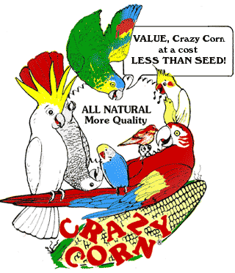
The Industry Pioneer of Quality Broad Natural Low Fat Nutrition®
All at a Cost Less than Seed
Because Crazy Corn® expands and seed is 60% waste! We’ve made it easy to prevent the most common cause of bird death- malnutrition from a seed diet. Cook ahead monthly, freeze baggies, keep some in the fridge to serve instantly. Superior breeding, lustrous feathering. Self-weans chicks. Shining health. Generous chunky fruits, veggies, whole grains, exciting herbs, pastas, beans, legumes, melon seeds, nuts, and more! Ecstatic birds! 1-800-BIRD YUM
in California (818) 503-4YUM. Fax (818) 765-4895
SPECIAL BREEDER PRICING

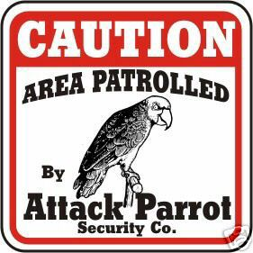



An E-mail from the AARP Show

To all the Rainbow Feathers Bird Club volunteers - Thank you for the wonderful show today at our AARP Chapter meeting. Everyone was thoroughly amazed to see all the birds. The narrative on each bird made it very interesting. We applaud your group for the volunteer and rescue work that you do. Having a bird is a longtime commitment, which many people do not understand. Keep up the good work and thanks again for sharing your time and knowledge with us.
Sincerely, Adrienne
the Chapter Secretary.

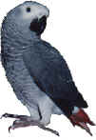


                                 
RESCUE RANGERS




This month’s adventure takes us to Hartland (no not the heartland of the United States) but Hartland Michigan to help out another rescuer in need. It seems that when people hear you do animal rescue you will take ANY type of animal. The Rangers have been offered everything from Hamsters, Gerbils, Turtles, Bunnies, Dogs, Cats and even a Pig, so when this woman called she was in a bit of a pickle. It seems that because she was involved in dog rescue and occasionally did some pet sitting she would be the perfect candidate to dump a Cockatiel on. When she tried to refuse out came the old guilt trip and this moron of a person did the, if you don’t take him I’ll just open the door and let him go! Being an animal lover she couldn’t bear the thought of this happening so she took the bird in. Well now she was concerned about the safety of this poor little bird with large rescue dogs around so she called the Rangers for help. In a flash they headed out to Hartland to rescue him. When they arrived they were greeted by two beautiful Greyhounds very sweet but overly curious about this small feathered play toy and the bird was not happy. Well as it turns out the him was actually a her, a beautiful sweet little girl a cinnamon pearl to be exact and to the Rangers amazement was as sweet as she said. The woman was so grateful to the Rangers for taking her because not only was the bird stressed but so was the woman that had her but now both could relax for this poor Cockatiel was now going to a true bird place, minus the dogs. She would not stay long because of her sweet disposition she found a home quickly and would live happily ever after in the right home. The Rangers were thankful to this woman for taking the bird in and thankful she called them to find her the proper home. Another happy ending but their job was not done for more sooner than later another call would come in and another bird would need their assistance but they would be ready for they are THE RESCUE RANGERS!!!!!!!!!!!!!

Stay tuned for our next exciting adventure Craziness in Highland!!!

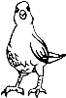


RESCUE UPDATE

The adoption side of the rescue saw a lot of activity last month. We adopted four birds to new homes; A Cockatiel named Norma, a Parrotlett named Neia, a Blue & Gold Macaw named Gilligan and a Sever Macaw named Buddy went to new forever homes. They all went to their new homes with cages, toys and food.
Again we want to extend our “THANKS” to you, our club members for your generous donations and participation in our monthly raffles. It is your generosity that makes our rescue the success that it is. Thank You!



Guardians for Animals Pet Expo Raffle Tickets
The Guardians for Animals Pet Expo is fast approaching on October 17th and 18th and the way our rescue benefits from this event is from raffle ticket sales. All the rescues receive an equal cut of the total raffle ticket sales with the rescue that sells the most tickets receiving an extra cut.
Tammy has received our club’s first box of 500 tickets to sell; the price of the tickets is $1.00 each or six for $5.00 we could sure use everyone’s help selling and buying tickets over the next couple of months. We will have tickets available at all of the upcoming events or you can call Tammy for arrangements to obtain some.
Talk to your friends and neighbors and ask if they would be interested in helping our rescue out. Let’s all do our best to sell all of our tickets!

Odds and ends
- The gifts for our Christmas exchange should have a $5 maximum. Now’s when the bargains are if you want to start looking around for items.
- Start asking businesses for donations for our raffle tables for the bird fair. They do not need to be bird related.



BIRTHDAY GREETINGS:
To

NANCY KEENAN NOV. 1
RIDGE BOUGENOY NOV. 2
PATRICIA TREGURTHA NOV. 8
SHERYL DEGREGORIO NOV. 9
MARY ANN KENNE NOV. 9
BOB GRUSZCZYNSKI NOV. 12
JONI GRUSZCZYNSKI NOV. 13
JOE LYNCH NOV. 13
RACHEL PLAGENS NOV. 15
STEPHAN SULLIVAN NOV. 15
JACOB PASEK NOV. 17
JANET ONDERCHANIN NOV. 19
FRED GORLITZ NOV. 20
JOHANNA SEIBLEY NOV. 21
DIANE ARQUETTE NOV. 22
ROBERT GONZALEZ JR NOV. 24
ARIANA PASEK NOV. 25
DORTHY MUELLER NOV. 28
KATHY WAGNER NOV. 30

Bits from Baby

Howdy all my feathered and non-feathered members, I’m back with the latest news. I contacted Sparky and J. B. by Birdygram but they missed the meeting also. My main man Duke filled me in on all the news from the September’s meeting.
We had forty-six people in attendance of which forty-three were members and three were guests who joined our flock. There were thirty-one feathered members with nine Macaws, seven Cockatoos, two African grays plus thirteen other types of parrots.
October is almost a carbine copy of last month with all the programs and shows we are doing. I’ve said it once and I’ll say it again; it’s nice we are very lucky to have such GREAT NON-FEATHERED CLUB MEMBERS, who work so hard to keep things running so smoothly for us. P.S. Steve will be back at our programs again!
Now next month we have the greatest show on earth at Novi, it’s the Pet Expo. I look forward to this one all year long and will be there with my best feathers on.
Well that's all for now.

Till next we meet in October at the Meeting,
Your friend Baby, >< >< >< >< ><>< >< >< >< ><>< >< ><

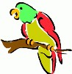
UP COMING
EVENTS
As of
October 13th 2015

Oct 13th Senior Show
American House East I
17255 Common Rd.
Roseville, MI 48066
1:00 PM Set-up
2:00 PM Start

Oct 14th Senior Show
American House Livonia
11525 Farmington Rd.
Livonia, MI 48150
1:00 PM Set-up
2:00 PM Start

Oct 17th & 18th
Guardians for Animals
Pet Expo
Madison Place
876 Horace Brown Drive
Madison Heights, MI 48071
Sat Times 10 AM to 5 PM
Sun Times 11 AM to 4 PM
We hopefully will be setting up on Friday like last year

Oct 19th Senior Show
Waltonwoods at University
Independent Living
3250 Walton Blvd.
Rochester Hills MI 48309
12:00 PM Set-up
1:00 PM Start

Oct 23rd Senior Show
American House Carpenter
3470 Carpenter Rd.
Ypsilanti, MI 48197
1:30 PM Set-up
2:30 PM Start

Oct 27th Senior Show
Brookdale (was Clarebridge)
750 West Eisenhower Rd.
Ann Arbor, MI 48103
12:00PM Set-up
1:00PM Show

Nov. 3rd Senior Show
Cartel Inns of Brighton
1014 E. Grand River
Brighton MI 48116
1:30 PM Set-up
2:30 PM Start

Nov.11th Bird Show
The Oaks Adult Day Care
(Located in the Church of Christ)
2500 S. Main St.
Ann Arbor, MI 48103
12:00 set-up
1:00 Show

Nov. 13th Senior Show
American House Westland
39201 Joy Rd.
Westland MI 48185
1:00 PM Set-up
2:00 PM Start

PET EXPO
Nov. 20th Noon to 8pm
Nov. 21st 10am to 8pm
Nov. 22nd 11am to 5pm
Suburban Collection Showplace
46100 Grand River
Novi, MI 48374
We will be setting up on Thursday Nov. 19th most likely around 9:00 am. Please remember no birds will be allowed through the front door.

Dec 1st Senior Show
Henry Ford Village
Main Lobby
15051 Ford Rd.
Dearborn, MI 48126
1:30 PM Set-up
2:30 PM Start
********2016*******2016********

March 1st Senior Show
American House Troy
2300 Grand Haven Drive
Troy, MI 48083
2:00 PM Set-up
3:00 PM Start

***NOTE******NOTE******NOTE***
There has been some confusion from the loyal readers of Bird Droppings as to which events they are allowed to bring their own bird(s) to. As a point of reference and for future information please we want everyone to be aware that when you see the line:
***Our Club Has a Booth at This Event***
following or “Educational Show” preceding an event listing it means we are attending the event in an official capacity representing our club and rescue. At these events all club members are welcomed to bring their feathered companions with them. Also please note that our space is very limited at some of these events but don’t let this stop you from joining us, we will find a way for you and your birdie buddy to fit in and enjoy the fun.


Five methods for converting your bird to a healthier diet.
By ZuPreem Staff

For years, companion birds have been fed a diet comprised primarily of seeds. However, new research shows a diet with a high percentage of seeds does not provide even the minimum nutrient levels your bird requires. Because seeds are not consistent in nutrient levels, many seeds are deficient in calcium and have excess levels of fat. A diet high in seeds may lead to obesity and other nutritionally related diseases. Avian nutritionists recommend a diet like ZuPreem® Avian Maintenance™ should make up at least 85 percent of an adult Bird’s meal. If your bird currently eats primarily seeds, you may want to consider switching to a diet that ensures the proper consumption of nutrients and will promote a healthier longer life for your bird.
Which method is best for you and your bird?
There are many methods for converting your bird to a new diet, and your avian veterinarian can help you decide which method may work best for you and your bird.

1. Interval feeding
For 20-30 minutes three times a day, offer 50% seeds along with 50% new diet in the same bowl. The bowl should only be 1/4 full using this method. Remove all uneaten food from the cage after each feeding and check to see how much of the old and the new diet the bird is eating. If the bird is eating some of the new diet, reduce the amount of seed and increase the amount of the new diet at each feeding until you are feeding only the new diet. This method assures your bird will not starve, but should still be hungry enough to begin experimenting with the new food. This process may take several days or several weeks, depending on your bird.
2.Ten-day gradual method
Over a 10-day period, fill the food dish 1/4 full several times a day maintaining the following proportions of the old and the new diet.
3. Remove seeds until later in the day
Starting at bedtime, remove all seeds. In the morning, put fresh portions of the new diet in the cup. Leave the new diet in the cage until mid- to late afternoon. Then feed the bird’s previous diet for the rest of the day. Repeat this process for several days or until the bird is consuming the new diet. Then offer only the new diet at all feedings.
4. Back and forth method
Starting at night, remove all food from the cage. In the morning, put the new diet in the food cup. Let the bird experiment with the new food, perhaps sampling one or two nuggets. Then after an hour, remove the nuggets and feed the old diet. Repeat the process throughout the day—new food for an hour, then the old diet. During the next 4-5 days, repeat the process but lengthen the time the new diet is in the cage, before offering the old diet. During the following week, keep extending the time the new diet is in the food cup, until you eliminate the old diet altogether.
5.Total new diet
In the wild, birds often do not have options. They eat seeds one season, fruits the next, consuming what is available. Many authorities believe that
some birds are able to make an abrupt transition because they recognize the new unfamiliar shapes as food and adapt relatively easily. Great care should be taken to confirm that your bird is eating enough of the new diet to maintain weight.
Day Old Diet New Diet
Day 1 90% 10%
Day 2 80% 20%
Day 3 70% 30%
Day 4 60% 40%
Day 5 50% 50%
Day 6 40% 60%
Day 7 30% 70%
Day 8 20% 80%
Day 9 10% 90%
Day 10 00% 100%
This article reprinted with permission from Zupreem®

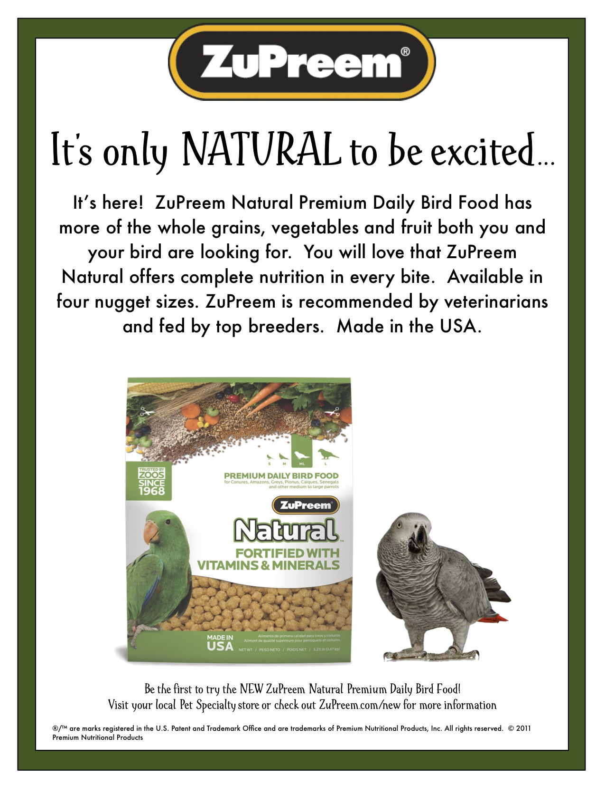

BIRDMAMA’S BIRD SITTING
SERVICE
Are you going out of town or on vacation? Do you have a feathered friend that needs to stay at home? Susan can help you. She will shower your bird(s) with TLC in her home.
For more information on rates and care specifics, contact by phone or e-mail
Susan Dixon
1-248-330-6938
susanhdixon@hotmail.com
References provided upon request

Free discount card Open 7-Days available to club members Ask about our birdie day spa treatment

DISCOUNT PET & SUPPLIES
Specializing in Exotic Birds & Cages
1623 Middlebelt Rd. Livonia, MI 48154
734-513-6060
http://www.discountpetbirdstore.com/

FASHIONISTA WEAR
Custom Handmade Clothing, Hair and Body Jewelry
Anything Parrot-ty
Custom Parrot Accessories
Cage Covers, Shoulder Capes
or anything else you might think of
Text, Message or Call me and ask
If I can make it I will
Lanah Harris
1- 734-502-3751

ROOSE ANIMAL HOSPITAL
Kevin Roose, D.V.M. * Karen Knight, D.V.M.
509 W. Ann Arbor Trail * Plymouth, MI 48170
734-451-2870

WARREN WOODS VETERINARY HOSPITAL
29157 Schoenherr * Warren, MI 48314
586-751-3350

SOUTHGATE ANIMAL HOSPITAL
Keith Cook, D.V.M. * Elieen Cook, D.V.M.
13697 Dix-Toledo Rd* Southgate, MI 48195
734-284-9122

ANIMAL EMERGENCY CENTER
24360 Novi Road * Novi, MI 48375
248-348-1788
265 E. 2nd St. * Rochester, MI 48307
248-651-1788
Both Locations are open 24 hours a Day
7 Days a Week
www.theanimalemergencycenter.com

OAKLAND VETERINARY EMERGENCY GROUP
1400 Telegraph Rd * Bloomfield Hills, MI 48302
248-334-6877

Parkway Small Animal & Exotic Hospital
39321 Garfield
Clinton Township, MI 48038
586-416-8800

Veterinary Care Specialists
205 Rowe Road
Milford, MI 48380
248-684-0468
Open 24 Hours A Day 7 Days A Week

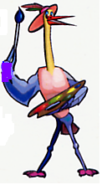
MURALS
AND OTHER
CREATIONS
BY MARY KAY PERVA
734-207-0489

SPECIALTY PET SUPPLIES, INC.
1449 W. Ann Arbor Road * Plymouth, MI 48170
734-453-6930
Fax: 734-453-7127
M-F 10-7:30 * Sat 10-6 * Sun 12-4

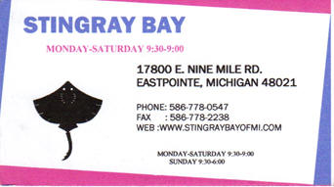

MUGSHOTS and MOUSE PADS
Species specific coffee mugs, mouse pads and other parrot
paraphernalia
Cheryl Hitter
734-422-2804
*Put your pet’s picture on a mug or mouse pad*

PRODUCTS FOR SALE

UV LIGHTING, HEATERS, VITIMINS AND OTHER SUPPLIES for your BIRDS, FISH and REPTILES

VISIT OUR WEBSITE AT
zoomed.com

Animal Crackers
1100 N. Old US 23 * Hartland, MI 48843

810-632-3344

NORTH BRANCH ANIMAL HOSPITAL
17630 Twelve Mile Road * Southfield, MI 48076
248-557-7773

For Birds of all Sizes
The Industry Pioneer of Quality Broad Natural Low Fat Nutrition®
All at a Cost Less than Seed
Because Crazy Corn® expands and seed is 60% waste! We’ve made it easy to prevent the most common cause of bird death- malnutrition from a seed diet. Cook ahead monthly, freeze baggies, keep some in the fridge to serve instantly. Superior breeding, lustrous feathering. Self-weans chicks. Shining health. Generous chunky fruits, veggies, whole grains, exciting herbs, pastas, beans, legumes, melon seeds, nuts, and more! Ecstatic birds! 1-800-BIRD YUM
in California (818) 503-4YUM. Fax (818) 765-4895
SPECIAL BREEDER PRICING

