This newsletter
Devoted to pet bird
Enthusiasts is
Published monthly by
The Rainbow Feathers
Bird club of Michigan
A 501(c) (3) club

October 2012
Volume 15 Issue 10

Bird Droppings

UPCOMING MEETING DATES:
OCTOBER 28th – FOURTH SUNDAY
NOVEMBER 18th- THIRD SUNDAY
DECEMBER 16th - FOURTH SUNDAY

RAINBOW FEATHERS BIRD CLUB
Who we are and what we are about
- Non Profit club with members throughout the tri-county area, single bird owners, or just thinking of getting a bird, families, breeders, exhibitors, all are welcome.
- Support scholarships for avian vet students
- Yearly Bird Fair
- Club Library for members
- Grooming available
- Avian rescue/relocation programs
- Monthly meetings with programs of interest to members.
- Monthly newsletter
- Periodic Service projects
- Field Trips
- Educational Programs upon request
- Make-it-take-it workshops
- Non-perishable food contributions to local soup kitchens
And more…….
Come join us and have your feathers preened by other Pet Bird Enthusiasts

Rainbow Feathers Bird Club Elected Officers: President – Dave Carol 734-422-5981
email – sweettweeters@comcast.net
Vice President – Steve Plafchan 734-513-0030
Email – splafchan@twmi.rr.com

Secretary – Marie Keehl 734-262-2098
Email –lanahh@comcast.net
Treasurer and Membership Secretary – Tammy Carol 734-422-5981
Email – sweettweeters@comcast.net

Board of Trustees –
Stan Johnson 248-746-0520
Email- mailto:mmisterjay@comcast.net
Mary Perva – 734-207-0489
Henry Jedrzejek-734-427-3187
Email – bigduke@comcast.net
ALL HEALTHY AND CLIPPED BIRDS ARE ALWAYS WELCOME TO ACCOMPANY THEIR HUMAN COMPANIONS TO THE MONTHLY MEETINGS. WE MEET AT THE UNITED METHODIST CHURCH, 6443 MERRIMAN ROAD BETWEEN FORD AND WARREN IN GARDEN CITY. MEETINGS START AT 2:00 PM.

Anyone interested in becoming a member please contact Tammy Carol @ 734-422-5981 or by e-mail sweettweeters@comcast.net

Steve Plafchan is now doing the newsletter. All ads and articles will be due the 1st of the month for publishing in the current month’s newsletter. Please send all items to him at 11021 Henry Ruff, Livonia, MI 48150 or email them to him at splafchan@twmi.rr.com

Everyone is encouraged to submit articles for the newsletter – this is YOUR newsletter.

Articles and/or pictures copied from other publications must be accompanied with written permission from original publication and author; this needs to be provided to the editor along with the article and/or picture.

Editor reserves the right to approve and/or edit any articles submitted prior to publication.

Ads will be run free for members having a one-time sale (baby birds, etc.). Those wishing to run ads multiple times or for a business must purchase a business membership.

BIRD CLUB ETIQUETTE

- Ask owner’s permission to handle/feed bird(s) and remember to return bird to the owner.
- Wash hands prior/after bird handling.
- When bringing companion birds to club meetings, only bring birds that you have had vet checked and in your possession for at least 30 days.
- Clean up after yourself and your bird(s) before you leave.

CLUB WELFARE

Please contact Jean Jedrzejek at 734-427-3187 or e-mail her at bigduke@comcast.net if you know of any club member who is in the hospital or has lost a loved one.
Member update

Monthly snack list
We have decided to stop soliciting for snack volunteers for our meetings and make the format a potluck venue. The reasoning for this is twofold; there have been very few members signing up for snacks and many members just bring dishes and desserts without signing up. So from now on our meetings will be a potluck fair, YUM!!



Crossing
The Rainbow Bridge

Sadly it must be reported that our club lost two feathered members last month. Pixi a Parrotlett that truly owned Beverly Sholar and Cecil a Timneh African Gray that owned Sandra Kempisty crossed over the rainbow bridge last month.
Pixi was rescued many years ago and was an absolute joy in Beverly’s life. She enjoyed snuggling in Beverly’s hair and following her around the house from room to room. Although Pixi was only three inches long she had the personality of a parrot the size of a Macaw. Pixi, you will be forever remembered and missed by all of us that knew you. Cecil was loved dearly by Sandra for over thirty years. The loss of his familiar whistles and spunky personality will leave a hole in Sandra and Ed’s hearts. There are no words that can be offered that will help their human companions cope with the pain.
To both Pixi and Cecil we say “soar forever and free on the far side of the rainbow bridge. You will never be forgotten.” To Beverly, Sandra and Ed we dedicate the following verse.


The Rainbow Bridge

Just this side of heaven is a place called
Rainbow Bridge.
When and animal dies that has been especially close to someone here, that pet goes to
Rainbow Bridge.
There are meadows and hills for all our special friends so they can run and play together. There is plenty of food and water and sunshine, and our friends are warm and comfortable.
All of the animals that have been ill and old are restored to health and vigor, those who were hurt or maimed are made whole and strong again, just as we remember in our dreams of days and times gone bye. The animals are happy and content, except for one small thing;
They miss someone very special to them who had to be left behind. They all run and play together, but the day comes when one suddenly stops and looks into the distance,…
The bright eyes are intent; the eager body quivers. suddenly she begins to break away from the group, flying over the green grass,
her wings carrying her faster and faster YOU ~
have just been spotted, and when you and your special friend meet, you cling together in joyous reunion ~
never to be parted again. The sweet sounds of happy tweets play your ears; your hands again
caress the beloved’s head, and you look once more into the trusting eyes of your pet,
so long gone from your life but never absent from your heart ~
Then you cross~…the
Rainbow Bridge together !

From the prez:

Well I am still basking in the afterglow of the pet expo and it was absolutely fantastic!!! We had such a turnout of club members manning the booth that I am still amazed. The one picture that Bev took shows just how many members were there; it is on her Facebook page and I am sure you will be impressed. We also made a big impression with the attending public they were awed, amazed and left speechless at the ability to not only see these magnificent creatures up close but being able to hold them as well. Even the organizer of the event and his staff received great reports about our club from the attending public. Also three cheers to our very own Celeste for being the runaway winner of the pet look-a-like contest. Hey I got twenty-nine votes and Brent got twelve so let’s hear it for the birdbrains. Also to the set-up crew Bev, Henry, Steve, Ken and Brent (yes I was there too) our booth was the best decorated and most impressive in the whole expo, just don’t ask Bev, Steve and me to blow up an inflatable palm tree, (it gets a little goofy, I’ll just leave it at that). Also thanking Tammy for ordering additional decorations and having them shipped overnight to make our booth a standout. All in all it was an exhilarating, crazy, busy, exhausting but well worth the effort and so much fun three days. So thank you to all who were there to help us out and to those that couldn’t but supported the club and our presence there in other ways it all comes together to make one memorable event so once again thank you.
Speaking of events do you realize that we have not had a free weekend since the beginning of August? It’s true! We have been at some event or function and the last will happen as this newsletter goes to print the I Geek program at Highland Library the last one for a while. So as I continue to try to recover from the pet expo thank you to everyone who makes it possible for us to do these events without the clubs support (and I mean that in every way possible) we could not do these things. So to the best club members in the whole universe YOU GUYS TRULY ROCK!!!!!!!!!!!!

Until Next Time
Your Prez Dave


Voice of the Veep
This past summer has been our busiest in my memory. A brief recap of the summer from June 1st until September 30th shows that our club was involved in thirty different events. This includes educational shows, fairs, festivals and adoption events for a total of thirty-five days. That is just an astounding amount of events to be involved in and it could not have been accomplished without the support of all of you, our members. The support of our members was most evident at the pet expo this year; we had many first time participants and I’m sure they had a great time. The one detail I don’t have is what our club received in the form of donations for doing all of these events but I am sure it’s substantial. The events haven’t ended just because summer is over, I know we have booked at least eight more Senior Programs in the months of October and November. So to everybody that has joined us I say thank you and to anyone who hasn’t I say you should consider joining us at an event; it’s a blast.
On a separate note and totally different subject; I have a huge problem. My house is out of control, I’ve lost any semblance of order and balance with my birds. JB and Calvin have become a pair of delinquents who have taken over my kitchen and will not allow me to eat a meal in peace. Pookie has discovered a hiding spot somewhere in a back room and I can’t find it. It seems that whenever I have to be someplace at a specific time she can’t be found. Being at such a loss for solutions I attended a seminar in Ann Arbor dealing with avian health and behavior with the hopes I could solve the issues I have at home. What I did learn was quite interesting and somewhat depressing at the same time. Quite simply put: I’m the one being trained. Pookie, JB and Calvin have complete and total control over my life. They are influencing what I eat, when I eat, what I do, when I can leave the house, when I have to be home and how long I can leave for. This probably doesn’t come as a big surprise to most of you. All of us with companion parrots know our birdie buddies rule the roost!

Your Veep
Steve

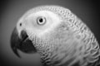
Out and About with Pookie

Steve recently returned home after attending a one day seminar provided by a local rescue group. There were two main speakers one was an avian veterinarian who is also a specialist in nutrition and diseases; the second was a behaviorist who specialized in modifying undesired behavior issues. There is only one comment I have to make on these subjects. “Thank goodness Steve is not the sharpest pencil in the box.”
After spending an eight hour day listening to the “human” avian experts giving advice on what he should do to alter our diet and behavior he returned home. His poor little companion human brain was so full of great advice about altering our diet and behavior he was unable to comprehend what was actually occurring. He never realized that he was living with seven true avian behaviorists and nutritionists. The main difference is we are parrots and in case some of you haven’t noticed parrots are members of the avian species. This has enabled me, Sparky, Tyler, Calvin, Misimo, Squeak and JB to continue with Steve’s training. The beauty of this situation is quite simple, Steve returned home thinking he was the trainer when in actuality he was the trainee.
I have had wonderful success in altering many of Steve’s undesirable dietary habits; please note that the following examples are only a small portion of my successes. Carry out food such as pizza; he no longer orders pizza with icky things like mushrooms, onions and peppers but orders pizza with extra spicy pepperoni. Burgers and fries he now purchases an extra-large fry and shares with us before he serves himself. He has also learned that foraging is beneficial to his greater wellbeing and mental attitude. He has learned that searching throughout the house for us when he is in a hurry to be somewhere is good for him and his health. Rather than having us sit on top of our cages and being easy to find we now hide in different spots allowing Steve to accelerate his heart rate and exercise his legs and body as well as his mind. Hiding under beds and dressers as well as going down the basement stairs and blending in with the dirty laundry has given Steve the enjoyment of foraging and the stimulation of discovery.
He didn’t need to attend a seminar staged by human avian specialists; he lives in a house with a flock of true avian behavioral modification experts. Fear not Steve, I will continue to modify your diet and behavior to enrich all of our lives.
☺
Until next month
Chirps and Squawks

Pookie

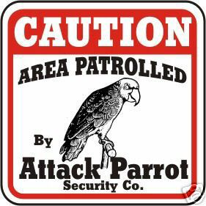

Quality by Mother Nature
Original Corn Bean Mix®: Noodles-n-Nuts®
Rainforest Rice Puddin®: Pollypasta®
Kung Fu Yum®
For Birds of all Sizes 
The Industry Pioneer of Quality Broad Natural Low Fat Nutrition®
All at a Cost Less than Seed
Because Crazy Corn® expands and seed is 60% waste! We’ve made it easy to prevent the most common cause of bird death- malnutrition from a seed diet. Cook ahead monthly, freeze baggies, keep some in the fridge to serve instantly. Superior breeding, lustrous feathering. Self-weans chicks. Shining health. Generous chunky fruits, veggies, whole grains, exciting herbs, pastas, beans, legumes, melon seeds, nuts, and more! Ecstatic birds! 1-800-BIRD YUM
in California (818) 503-4YUM. Fax (818) 765-4895
SPECIAL BREEDER PRICING


BLAH, BLAH, BLAH……..
Yes once again it is time again for those wonderful yearly gems that come so freely at the pet expo. So as long as people keep talking I will keep on writing. Here they are!!!!

- I am sooo disappointed I thought there would be some parrots here. All there is are birds here. (Ok did I miss something I thought we had parrots I, I’m confused!!!)
- Honey, don’t get too close to that bird it will eat your face off! (Well Maybe part of your face Sparky or Ruby could never eat a whole one.)
- You’re the smallest guy here but you have the biggest bird. Oh, that came out totally wrong I didn’t mean how that sounded. (Why I thank you.)
- Go real slow or they will attack you. (I might attack you for going so slow!)
- What would he do if I put my finger in his mouth (referring to Captain). (Well gosh I don’t know maybe give you a little something to remember him by.)
- Those African Grays sure look evil. (Well I’m sure you don’t look to good to them either.)
- So you went to Africa and got all these birds. (Sure on my last safari.)
- Finally my personal favorite; so you are the bird club people? Yes we are. You all look so normal! (I don’t know what she meant but I can assure her looks can sure be deceiving.)
So another pet expo has come and gone but there will always be these gems at every function we do. Stay tuned for more in the future.
.


                                 
RESCUE RANGERS



Well they say that good things come in threes but not when it comes to bird rescues and this would be the third and final strike. The Rangers found themselves going to Canton Michigan. Now this really doesn’t really seem odd for they had gone there a number of times on rescue runs but this one would be different very different. What made this one so very different is they had been to this residence not once but twice before. This one would make it three (cue the eerie music). What? No budget for eerie music OK well then hum it to yourselves. Anyway back to our story. This time it would be two Cockatiels and a Budgie. As they pulled up to the house a resounding “this place again” echoed through the Rescue Mobile (hey it’s a big vehicle). Yes it was that place again but now they would get the cage that was strange empty their first visit and simple gone the second plus the Cockatiels and the Budgie (Parakeet). The Rangers serendipitously (ten dollar word) looked and listened for any more birds hoping to stop a fourth visit in its tracks. Happy day they accomplished their mission and the house was now bird free, dog free well that not our jurisdiction but birds are so off they went to their foster home. Well they wouldn’t stay in foster care long and soon they were happily going to there forever home. This moment of bliss would only be a fleeting moment for there are other birds to rescue and they would not stop until every bird has been rescued and found its new forever home for they are the RESCUE RANGERS !!!!!!

Stay glued to whatever you are glued to for our next sensational story The Gift that Stopped Giving.


RESCUE UPDATE
The rescue was slower this month both in rescues and adoptions. There was only one adoption last month; Mooch a Double Yellow Head Amazon. He went to his new home with cage, toys and food.
Again we want to extend our “THANKS” to you, our club members for your generous donations and participation in our monthly raffles. It is your generosity that makes our rescue the success that it is. Thank You!

Odds and ends
- The gifts for our Christmas exchange should have a $5 maximum. Now’s when the bargains are if you want to start looking around for items.
- Start asking businesses for donations for our raffle tables for the bird fair. They do not need to be bird related.

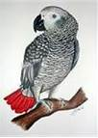
TALES OF BUSTER BROWN

Buster and I had our first Pet Expo experience. It was such an enjoyable afternoon. I was amazed at the interest of people who do not have birds and the young children who were interested in holding a bird. The awe in their little faces was a pleasure to behold. Proud parents took many cell-phone pictures. I also enjoyed how people were so open about their experiences with their birds. They had some great stories. I brought Buster because he needs socialization. I have been his only handler. I think that all the people and loud music from the dog show next-door stressed-out Buster. He sat so close at my elbow. He had a look on his face as if to say “how could you do this to me” or “what kind of torture is this”? He did spook once and fluttered to the ground. Tammy was right there to pick him up. He stepped up on many other members without biting. Thanks to the members, I think that he has really improved. After about an hour or so, Pookie, Sparky and JB let Buster use their perch in the back. I thought he would settle down, but he looked like he was watching a tennis match. Buster was out in the crowds a great deal and I think overall he did very well. I introduced Buster to pretty Sparky but he just turned away. I guess that she was too old for him. I decided that 3 ½ hours was enough so we headed home. Once there, Buster went on his perch, stuck his head on his back and slept for over 3 hours. I guess he was totally worn out. All and all, it was a great time!

Linda Brown



BIRTHDAY GREETINGS:
to

NANCY KEENAN NOV. 1
CODY EASTEP NOV. 7
SHERYL DEGREGORIO NOV. 9
MARY ANN KENNE NOV. 9
BOB GRUSZCZYNSKI NOV. 12
RICHARD DEKEYSER NOV. 13
JONI GRUSZCZYNSKI NOV. 13
JOE LYNCH NOV. 13
JACOB PASEK NOV. 17
JANET ONDERCHANIN NOV.19
ARINA PASEK NOV.25
CRYSTAL BARNETT NOV. 25
DORTHY MUELLER NOV. 28
KATHY WAGNER NOV.30



Bits from Baby

Howdy all my feathered and non-feathered friends. Well the Pet Expo came and went but it was more fun than a barrel of monkeys. The area we had was the largest we have ever had it was a fifty foot by fifty foot space; where all of the feathered members had room to stretch their wings and visit with one another. I only went on Saturday when Duke was there. He told me of all the fun all the members had visiting with all the people, mostly the young ones. People were coming and going all three days that it was impossible to get a good count but we were busy all the time. I can’t wait till next year.
We started off October with a bang. On Oct.6th we did the (What Do You Geek?) at the Highland Township Public Library in Highland. There were other groups and people showing off their interests, hobbies and passions. Again our gang showed what a great club we have and how much fun we have doing these programs. Then Oct. 14th there was the education program at The Eisenhower center in Ann Arbor. Then we were off and running with three programs in four days. We started with Oct.21st American House Regent Street in West Bloomfield, Oct. 22nd American House on Eureka in Taylor, and Oct.24th American House on Common Rd. in Roseville. Some of these are repeats. Our members both feathered and non-feathered must be doing a great job for us to be invited back over and over. Oct. 27th the day before our October meeting we will be in Canton for a program.
The feathered and non-featheedr members always do a GREAT JOB AT EVERY EVENT THEY DO.

Till next we meet in October at the Meeting,
Your friend Baby, >< >< >< >< ><>< >< >< >< ><>< >< ><

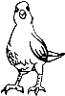


WORD OF WARNING!!!!!

I have received at least five phone calls asking if I had LARGE BIRDS. One person even went as far to ask how many, what kind of large birds I had and how old. Never give out this information this is how thieves target your home to steal them. Many larger parrots need to be at least five to eight years old to breed and these people are looking for birds to sell to unsuspecting breeders for profit or just to sell as pets. So to keep yourself safe do not give out any information about your guys. Two of these people were so bold as to ask who else in the club had large birds once again they got no information from me. So keep yourself and your birds safe, silence in this case is more than golden.

Dave


Upcoming Events

Oct. 21st Senior Educational Program
American House Regent Street
4460 Orchard Lake Rd.
West Bloomfield, MI 48323
2:00 PM Set-up
3:00 PM Show

Oct. 24th Senior Educational Program
American House East 1
17255 Common Rd.
Roseville, MI 48066
12:30 PM Set-up
1:30 PM Show

Oct.27th Educational Show
Community Indoor Picnic
Winds Club House
41280 Southwind
Canton, MI 48188
1:00 PM Set-up
2:00 PM Show

Oct. 22nd Senior Educational Program
American House
25250 Eureka Rd.
Taylor, MI 48180
1:30 PM Set-up
2:00 PM Show

Nov. 7th Senior Educational Program
Waldenwoods at University
3280 Walton Blvd.
Rochester Hills, MI 48309
2:00 PM Set-up
3:00 PM Show

Nov.13th Senior Educational Program
American House East 2
18760 13 Mile Road
Roseville, MI 48606
12:30 PM Set-up
1:30 PM Show

*****NOTE******NOTE******NOTE*****
There has been some confusion from the loyal readers of Bird Droppings as to which events they are allowed to bring their own bird(s) to. As a point of reference and for future information please we want everyone to be aware that when you see the line:
*****Our Club Has a Booth at This Event*****
following or “Educational Show” preceding an event listing it means we are attending the event in an official capacity representing our club and rescue. At these events all club members are welcomed to bring their feathered companions with them. Also please note that our space is very limited at some of these events but don’t let this stop you from joining us, we will find a way for you and your birdie buddy to fit in and enjoy the fun.

*****NOTE******NOTE******NOTE*****

*CANCELATION CONFUSION *

A few of our scheduled events have been canceled at the last minute by the group staging the event. If you do not regularly participate in the shows but plan on attending please call Steve (734-513-0030) to make sure the event is still a go. Recent cancellations that have occurred at the last minute are: the Fall for Novi Pet Adoption Fair, and the Allen Park Animal Shelter Pet Adoption

Avast ye Mates

CAPTAINS
CORNER

Well another pet expo has come and gone and we were a hit as always. Now I know that our pet humans will forever take the credit away from us but who do they come to see US that’s who. I will give them credit our booth looked amazing and the candy was flowing like water and Celeste did kinda resemble Ricky but who really had it going on well Ricky won hands down. I do realize that my hair challenged pet human (the Egghead as I call him) did his best but there was only so much he could do with his condition. He should have found a Mexican hairless it would have been a closer match then he might have taken the pet look-alike crown away from Celeste. Better luck next year. I do love the pet expo because it gives me a chance to catch up with all my friends and have them spill the goods on their pet humans. Careful or all of you will end up in my novel, I know things lots of things, and you have been warned. Anyway it was a spectacular weekend that left all of us feathered and non-feathered completely worn out. It was a weekend of French fries, pizza and cashews, meeting and greeting, having my picture taken a gazillion times but most of all having fun. Plus we introduced the newest member of the parrot patrol to you Charlie the Moluccan Cockatoo who did us parrots proud. Way to go Charlie!!! So in closing as we bask in the afterglow of another successful pet expo I must say good show everybody. Now it is time for a long nap. ZZZZZZZZZZZZZZZZZZ!!!!!!

Cheers
Captain Morgan


Five methods for converting your bird to a healthier diet.
By ZuPreem Staff

For years, companion birds have been fed a diet comprised primarily of seeds. However, new research shows a diet with a high percentage of seeds does not provide even the minimum nutrient levels your bird requires. Because seeds are not consistent in nutrient levels, many seeds are deficient in calcium and have excess levels of fat. A diet high in seeds may lead to obesity and other nutritionally related diseases. Avian nutritionists recommend a diet like ZuPreem® Avian Maintenance™ should make up at least 85 percent of an adult Bird’s meal. If your bird currently eats primarily seeds, you may want to consider switching to a diet that ensures the proper consumption of nutrients and will promote a healthier longer life for your bird.
Which method is best for you and your bird?
There are many methods for converting your bird to a new diet, and your avian veterinarian can help you decide which method may work best for you and your bird.
1. Interval feeding
For 20-30 minutes three times a day, offer 50% seeds along with 50% new diet in the same bowl. The bowl should only be 1/4 full using this method. Remove all uneaten food from the cage after each feeding and check to see how much of the old and the new diet the bird is eating. If the bird is eating some of the new diet, reduce the amount of seed and increase the amount of the new diet at each feeding until you are feeding only the new diet. This method assures your bird will not starve, but should still be hungry enough to begin experimenting with the new food. This process may take several days or several weeks, depending on your bird.
2.Ten-day gradual method
Over a 10-day period, fill the food dish 1/4 full several times a day maintaining the following proportions of the old and the new diet.
3. Remove seeds until later in the day
Starting at bedtime, remove all seeds. In the morning, put fresh portions of the new diet in the cup. Leave the new diet in the cage until mid- to late afternoon. Then feed the bird’s previous diet for the rest of the day. Repeat this process for several days or until the bird is consuming the new diet. Then offer only the new diet at all feedings.
4. Back and forth method
Starting at night, remove all food from the cage. In the morning, put the new diet in the food cup. Let the bird experiment with the new food, perhaps sampling one or two nuggets. Then after an hour, remove the nuggets and feed the old diet. Repeat the process throughout the day—new food for an hour, then the old diet. During the next 4-5 days, repeat the process but lengthen the time the new diet is in the cage, before offering the old diet. During the following week, keep extending the time the new diet is in the food cup, until you eliminate the old diet altogether.
5.Total new diet
In the wild, birds often do not have options. They eat seeds one season, fruits the next, consuming what is available. Many authorities believe that
some birds are able to make an abrupt transition because they recognize the new unfamiliar shapes as food and adapt relatively easily. Great care should be taken to confirm that your bird is eating enough of the new diet to maintain weight.
Day Old Diet New Diet
Day 1 90% 10%
Day 2 80% 20%
Day 3 70% 30%
Day 4 60% 40%
Day 5 50% 50%
Day 6 40% 60%
Day 7 30% 70%
Day 8 20% 80%
Day 9 10% 90%
Day 10 00% 100%
This article reprinted with permission from Zupreem®

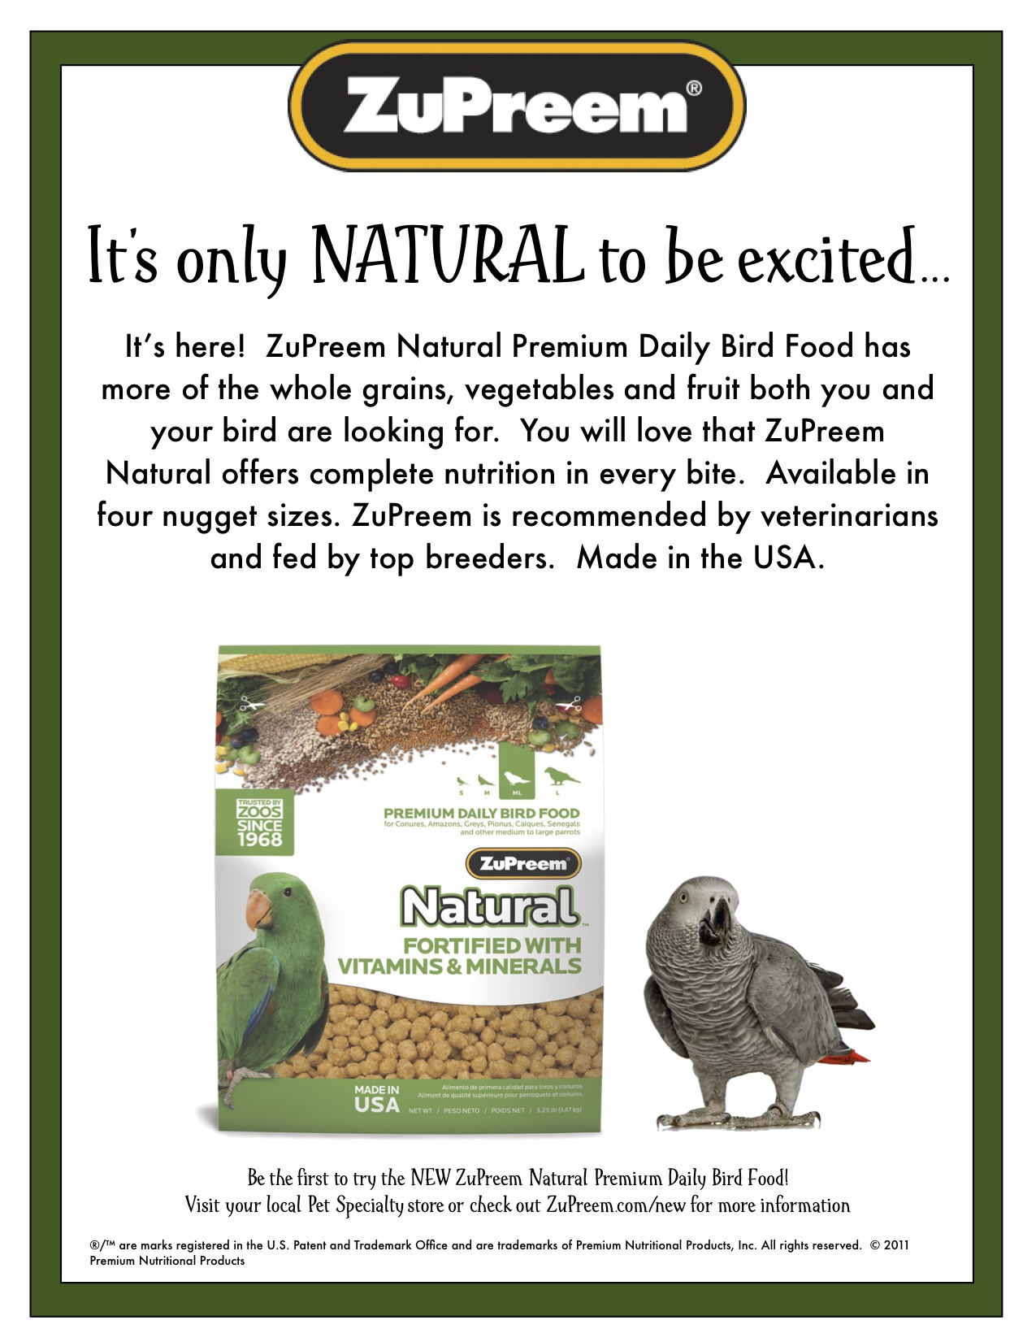

BITE ME BIRD TOYS
Tony & Edie Riojas
4593 Howell Rd, Otter Lake, MI 48464
1-810-793-2093
bitemebirdtoys.com

NORTH BRANCH ANIMAL HOSPITAL
Frederick B. Shulak, D.V.M.
17630 Twelve Mile Road * Southfield, MI 48076
248-557-7773

ROOSE ANIMAL HOSPITAL
Kevin Roose, D.V.M. * Karen Knight, D.V.M.
509 W. Ann Arbor Trail * Plymouth, MI 48170
734-451-2870

SPECIALTY PET SUPPLIES, INC.
1449 W. Ann Arbor Road * Plymouth, MI 48170
734-453-6930
Fax: 734-453-7127
M-F 10-7:30 * Sat 10-6 * Sun 12-4

WARREN WOODS VETERINARY HOSPITAL
29157 Schoenherr * Warren, MI 48314
586-751-3350

OAKLAND VETERINARY EMERGENCY GROUP
1400 Telegraph Rd * Bloomfield Hills, MI 48302
248-334-6877

Free discount card Open 7-Days available to club members Ask about our birdie day spa treatment

DISCOUNT PET & SUPPLIES
Specializing in Exotic Birds & Cages
1623 Middlebelt Rd. Livonia, MI 48154
734-513-6060
http://www.discountpetandsupplies.com/

SOUTHGATE ANIMAL HOSPITAL
Keith Cook, D.V.M. * Elieen Cook, D.V.M.
13697 Dix-Toledo Rd* Southgate, MI 48195
734-284-9122

ANIMAL EMERGENCY CENTER
24360 Novi Road * Novi, MI 48375
248-348-1788
265 E. 2nd St. * Rochester, MI 48307
248-651-1788
Both Locations are open 24 hours a Day
7 Days a Week
www.theanimalemergencycenter.com

MUGSHOTS and MOUSE PADS
Species specific coffee mugs, mouse pads and other parrot
paraphernalia
Cheryl Hitter
734-422-2804
*Put your pet’s picture on a mug or mouse pad*

Custom sizes up to 25” x 38” •
Square or Rectangle cuts
PayPal plus Shipping available • Priced for 100 sheets
White cover weight paper • Fresh clean cage everyday
Call or email us for your custom size
248.438.6572
littlemancageliners@yahoo.com
Visit us on
Facebook and Blogger!
little-man-cage-liners.blogspot.com

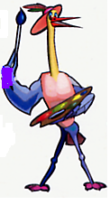
MURALS
AND OTHER
CREATIONS
BY MARY KAY PERVA
734-207-0489

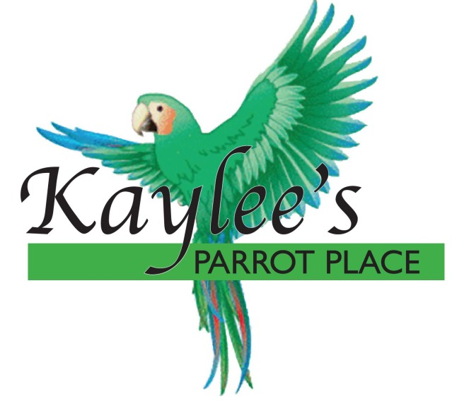
“Baby Parrots Raised in a Home for a Home”
Specializing in Macaws, Greys,
Amazons, and others.
Cages and Food at reasonable prices.
Contact Kaylee at 734-301-0486
www.kayleesparrotplace.com

UV LIGHTING, HEATERS, VITIMINS AND OTHER SUPPLIES for your BIRDS, FISH and REPTILES

VISIT OUR WEBSITE AT
zoomed.com

Veterinary Care Specialists
205 Rowe Road
Milford, MI 48380
248-684-0468
Open 24 Hours A Day 7 Days A Week

