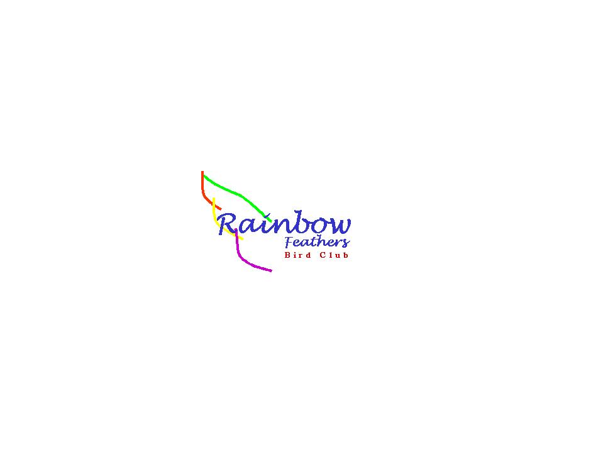 This newsletter
devoted to pet bird
enthusiasts is
published monthly by
Rainbow Feathers
Bird Club of Michigan
A 501(c) (3) club

January 2016
Volume 19 Issue 1

Bird Droppings

UPCOMING MEETING DATES:
JANUARY 24th ---– FOURTH SUNDAY
FEBRUARY 28th – FOURTH SUNDAY
MARCH 20th -----– THIRD SUNDAY

RAINBOW FEATHERS BIRD CLUB
Who we are and what we are about
- Non Profit club with members throughout the tri-county area, single bird owners, or just thinking of getting a bird, families, breeders, exhibitors, all are welcome.
- Support scholarships for avian vet students
- Yearly Bird Fair
- Club Library for members
- Grooming available
- Avian rescue/relocation programs
- Monthly meetings with programs of interest to members.
- Monthly newsletter
- Periodic Service projects
- Field Trips
- Educational Programs upon request
- Save molted feathers for craft projects
- Make-it-take-it workshops
And more…….

Come join us and have your feathers preened by other Pet Bird Enthusiasts

Rainbow Feathers Bird Club Elected Officers: President – Dave Carol 734-422-5981
email – sweettweeters@comcast.net
Vice President – Steve Plafchan 734-513-0030
Email – splafchan@twmi.rr.com

Secretary – Kathe Cote 313-728-2211

Email –gardenfrog1967@comcast.net
Treasurer and Membership Secretary – Tammy Carol 734-422-5981
Email – sweettweeters@comcast.net

Board of Trustees –
Susan Dixon 248-330-6938
Email – susanhdixon@hotmail.com
Henry Jedrzejek-734-427-3187
Email – bigduke@comcast.net
Mary Perva – 517-672-9528
Email-maryperva@rocketmail.com

ALL HEALTHY AND CLIPPED BIRDS ARE ALWAYS WELCOME TO ACCOMPANY THEIR HUMAN COMPANIONS TO THE MONTHLY MEETINGS. WE MEET AT THE UNITED METHODIST CHURCH, 6443 MERRIMAN ROAD BETWEEN FORD AND WARREN IN GARDEN CITY. MEETINGS START AT 2:00 PM.

Anyone interested in becoming a member please contact Tammy Carol @ 734-422-5981 or by e-mail sweettweeters@comcast.net

Steve Plafchan is doing the newsletter. All ads and articles will be due the 1st of the month for publishing in the current month’s newsletter. Please send all items to him at 11021 Henry Ruff, Livonia MI 48150 or email to splafchan@twmi.rr.com.

Everyone is encouraged to submit articles for the newsletter – this is YOUR newsletter.

Articles and/or pictures copied from other publications must be accompanied with written permission from original publication and author; this needs to be provided to the editor along with the article and/or picture.

Editor reserves the right to approve and/or edit any articles submitted prior to publication.

Ads will be run free for members having a one-time sale (baby birds, etc.). Those wishing to run ads multiple times or for a business must purchase a business membership.

BIRD CLUB ETIQUETTE

- Ask owner’s permission to handle/feed bird(s) and remember to return bird to the owner.
- Wash hands prior/after bird handling.
- When bringing companion birds to club meetings, only bring birds that you have had vet checked and in your possession for at least 30 days.
- Clean up after yourself and your bird(s) before you leave.

CLUB WELFARE
Please contact Jean Jedrzejek at 734-427-3187 or e-mail her at bigduke@comcast.net if you know of any club member who is in the hospital or has lost a loved one.

Monthly snack list

We have decided to stop soliciting for snack volunteers for our meetings and make the format a potluck venue. The reasoning for this is twofold; there have been very few members signing up for snacks and many members just bringing dishes and desserts without signing up. So from now on our meetings will be a potluck fair, YUM!!



OVER THE RAINBOW BRIDGE
Sadly we must report the passing of yet two more feathered members of our club.
Susan Jenison lost her two Parakeets last month, Bluebonnet and Leprechaun. We offer our sympathies to her and bid a sad farewell to Bluebonnet and Leprechaun. May you always fly free on the far side of the rainbow bridge.
Birds come into our lives to
teach us about love. They depart
to teach us about loss. A new bird never replaces an old bird; it merely expands the heart. If you have loved many birds, your heart is very big.
(Author unknown)
The above poem was submitted by club member Jim Lamb.

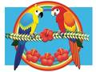

From the prez:

Well I am typing this on New Year’s Eve and I can’t help but think of all the things that we did as a club it just boggles my mind. We did several events like the Ypsilanti Heritage Festival, the Novi Pet Expo and a new one the Garden City Flea Circus (the flea circus we will be doing again). We were a HUGE hit at them all. Also all the programs we did and we continue to get new ones all the time. Plus all of our regular things we do bag-it-bingo, the picnic and our Christmas meeting which was a lot of fun. The other amazing thing is our flock keeps growing and we keep adding new members to the roster. It is truly you the members that make this club the incredible thing it is, you have taken our philosophy that this is your club to heart and have truly made it just that. From your many ideas to your work at the programs and events it shows through. In fact it shows so much that the public notices what a “together” group we are and this is from an actual comment made at the pet expo. They see us not only working our tail feathers off but see us having fun doing it. Whether it be a certain crazy person dressing up like a pirate or one of our members making beautiful and delicious bird cookies to the picture staging and our interaction with the people something special always comes out. The best example was at the pet expo when a man in a wheel chair with his caretaker came to our booth and we went and let him hold the birds (he needed help to steady his hands) his caretaker actually started to cry. I ask her if she was alright and she said that everywhere they go he is treated like what is wrong with him is it contagious and people back away from him. We just went right to him and without any fear took his hands and let him hold the birds and we got him to smile and that meant so much to her. That comment says volumes about our group and makes me proud to be part of it. So as we go into 2016 I see nothing but good things for our club because we keep going in the right direction and that is up! So to all of the members of Rainbow Feathers Bird Club and Rescue a very happy, healthy and prosperous New Year and I know that next one will be even better because YOU GUYS ROCK!!!!!!!
Your Prez
Dave
P.S. It is also election time so if you want to nominate someone for an office you can do it at the next meeting.
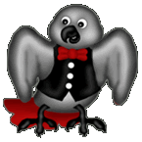
Voice of the Veep

Thank you everyone for your concerns and well wishes. To anybody who didn’t know why I didn’t participate in December’s newsletter it’s because I was in the hospital with a case of shingles on the left side of my face. It started on the week before Thanksgiving and put me in the hospital the weekend after. I spent a week in isolation in the hospital then continued my recovery at home. Yes, I did receive a Shingles vaccination over a year ago. All the doctors told me it was a good thing that I had done so because my affliction was milder that it would have been had I not received it? Milder? It put me in the hospital for a week and I still have nerve damage on my face that may last a long time.
The Christmas meeting last month was fabulous from the delicious food to the annual Christmas raffle it was tons of fun. I want to thank everybody in the club for their participation in our Christmas raffle and all the meeting raffles throughout the year. This is the most generous way you can help support our rescue and assist our club in paying vet bills and all of you have succeeded in accomplishing this in a big way. Thank you to everyone for the support. Another way we generate monies for supporting the rescue is to stage senior programs at nursing homes, assisted living and independent living facilities throughout the year. The year 2015 was the busiest year for shows and events we have ever had; however that being said, this year 2016 could very easily exceed last year. I encourage everyone to join us at a show, even if you don’t bring your own bird, they are a lot of fun and we can always use the help. Check the Up-coming Events page on the website or in the newsletter to see the dates and times of the show schedule. If you have any questions about attending an event please feel free to call me (Steve) at 734-513-0030 for more information.
This month is when we hold our annual elections; there is a description of all the offices and the duties of each office holder included in this edition of the newsletter. If you’re interested in running or wish to nominate someone feel free to do so. Our annual dues are also payable this month; if you joined the club within the last six months your dues are good for another year. Please check with Tammy if you’re not sure what your dues are or if you owe some.
I’ll see you at the meeting
Your Veep

Avast ye Mates
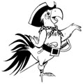
CAPTAINS CORNER

Well hello everyone I am fresh from that New Years Eve party that Pookie, Sparky and J.B. throw every year and it was epic. Those knock out drops J.B. gave Steve his pet human really did the trick although he did wake up to find out someone (or shall I say bird) gave him a makeover! The Smokey eye look is not for him, not at all. Anyway, the music was pumpin’ and we all got up to dance to Uptown Funk and I even taught everybody to do the Macawrena. Corky and Piccolo really amazed us with some incredible hip-hop moves but not to be out done Lola, Georgia and Ruby pulled off some sweet moves themselves. New best friends Tuna and Zoe were just having a ball as they watched all the goings on. It was Rambo who really got things into high gear when he spiked the punch then everybody was rockin. I am glad we set up designated flyers to get everybody home safe before the punch got spiked! Yes everyone was having a blast Mr. Finnegan and Zoe the Meyers Parrot (gets confusing when there are two birds with the same name) sang an amazing duet of Ain’t No Mountain High Enough followed by Merlin, Max and me singing Proud Mary. And at midnight we all sang that Auld Lang something song. All good things have to come to an end and it was time to call it a night (besides the knockout drops would be wearing off soon) so we had to bid adieu until next year. So to all my feathered and non-feathered friends a very Happy New Year may all your wishes come true!
Cheers
Captain Morgan

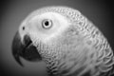
Out and About with Pookie

First I must offer my apologies for not submitting my article last month even though my reasons for missing the deadline are quite legitimate.
As all of you may recall we Greys in this household have been very concerned about Steve and his growing tendencies to accept and cavort with various Cockatoos. At first we thought it was because he had been possessed by the evil spirit of a Cockatoo so we performed a “Cockatooism” (similar to an exorcism); obviously this didn’t work. We then consulted a specialist and realized that he had been bitten by an afflicted Cockatoo and had contracted a rare illness that is transmitted by the Cockamaw germ. Most companion humans are immune to this affliction and simply develop affections for Cockatoos and Macaws. There is however a rare and sometimes violent reaction to this germ by African Grey lovers; which is what occurred with Steve.
It started in November about a week prior to Thanksgiving, Steve developed a minor rash on the left side of his nose. Rapidly expanding from a small spot the rash encroached across the left side of his face and into his teeth. Then it spread down his nose to his chin and across his left eye to the temple above his ear. The effects of his love of Greys with this evil Cockamaw bug were absolutely devastating. The rash began blistering and oozing a sickening yellow gook and his face started to swell up. When his eye swelled shut the other companion humans around him decided to take him to a hospital. We tried to convince the humans that a sufficient dose of Grey love and affection had been administered and would take about a week to cure him. However to the emergency room Steve was taken where they rapidly diagnosed that he had some fictional ailment called “shingles”. I didn’t even try to correct or inform the humans that shingles are found on the roofs of houses. I’m sure all of you know how stubborn humans can be, so we Greys simply kept our beaks shut and let the human doctors think they solved the problem.
Well, making a long story short Steve spent a week in the hospital and since he has returned he’s better but still suffering a few residual effects from his bout with Cockamaw birdamiteus. The worst of which is he seems to be gaining a tolerance of Cockatoos and the willingness to accept an Umbrella Cockatoo into our home to visit and even made an offer for one to stay here with us. YEACH! We’re actively trying to dissuade him of this awful idea but only time will tell.
See you at the meeting
Chirps and Squawks
Pookie

Hi Everyone,
I work to help people establish the kind of connection with the natural world I have. I work through birds. I also volunteer to help financially disadvantaged clients. I have been an IAATE member for several years, and last year I attended the annual conference. It was very constructive, and it has affected my outreach both in how I work with birds and with people. I hope to get even better by attending the 2016 conference. The cost remaining for the four days is $700. With some major unexpected expenses, I will not be able to make it without some help, though I will be paying the lion’s share on my own. Every little bit helps. It seems as though everyone has a tight budget these days, so if you cannot contribute anything, please consider sharing this post with friends on Facebook. The URL link to my FundMe.com page is
https://www.fundme.com/en/projects/22490-Helping-Share-the-Magic-in-Nature-Through-Birds
Thanks.
Craig Perdue
734-262-0998

A REMINDER
Our dues are due by January 31st. Checks should be made out to RAINBOW FEATHERS BIRD CLUB. Please pay them at the January meeting or by mail to Tammy Carol at Rainbow Feathers Bird Club, PO Box 1587, Garden City MI 48135.

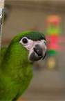
Rambling with Rambo
Well all my feathered, and non-feathered friends, it has certainly been a month to remember. The Novi Pet Expo was wonderful. Though, it was a little stressful being behind those big dogs. The first day I was really chilling. The next two, seems like all us birds were worked up.
Most of the excitement happened on Saturday. This was the day Captain Jack Sparrow (Dave Carol) visited us. This was great entertainment for everyone. Dave will have to do this more often. His costume was Great.
The real excitement (according to me) was first thing in the morning. See before Michael first opened my travel box, I could hear them dogs again. So I was a little worked up already. Wouldn’t you know it! Upon leaving my box, Michael walked past the tables, out to see everyone. Who do you think crosses behind us? Yup my favorite person, Miss Tammy. Now she was just out of reach. I had to release my frustration somehow. I grabbed onto and slid over the back of Daddy’s neck. My beak has become really sharp again. I cut him good. I gave him a nice bloody cut. But he still loves me. Those crazy humans.
Then at hour, or so, later, we had the Zoe’ attack. This was actually funny, if you were not in the middle of it. See I was on Michael’s left shoulder. Well, Miss Tammy asked Daddy to take Corky, and Ruby to the picture station. I did not get upset then. Funny thing, I like when Michael has other birds on him.
So there we are, 3 birds on Michael. It seems Ruby was in a mood. She ran up Daddy’s arm, across his back right towards me. This did not bother me. Everyone knows Macaws are superior fighters. Back off Ruby. Michael freaked out. He already had a big cut on his neck. He did not want a bird battle back there.
So Michael is putting Corky on someone. Corky does not want to go. What is it with these Ekkies today? As Daddy gets Corky down, he is reaching across his back, keeping myself, and Ruby apart. Then it happened. His right forearm went in front of Zoe. Yup, Zoe grabbed and chomped. However, he only got a small piece of skin. He was really chewing, but Michael’s sleeve was loose. Zoe let go. There was a better target. Yup Daddy’s finger. Zoe struck and crunched. Michael said, “I could feel Cockatoo beak touching both sides of my finger bone. Zoe was hanging on, and grinding for all he was worth.” Luckily, our own Cockatoo Whisperer was there to save the finger. That was exciting.
Here is the last item about the Expo I want to tell you about. You remember when I reported on the Ypsilanti Heritage Event. I told you there was a romance blossoming. Well it has happened. Yup the happy couple were wearing matching I’m His, and I’m Hers, bright neon yellow/green shirts. They looked happy together. That is it for this all for now friends.

So as always,
Be Good, Have Fun
Remember
Macaws rule,
Rambo.

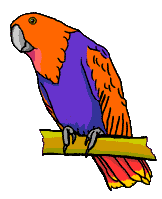

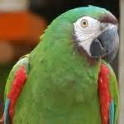
Pondering With Packo:

Well fans, as you know I’m still having trust issues, with Michael picking me up. Well, the issue is leaving my cage. This is my house, my kingdom, and special place. I don’t want to leave it. Appears to me every time someone takes me out of here, I end up going to the Vet’s office. And you know what that means? Yeah! It means that person in the white coat sticks a needle in my leg, them cuts my nails. Oh I hate when that happens. Doing my nails does not hurt. It’s just the indignity of this procedure. Then I have to sharpen them up again.
Rambo was telling me all about the excitement at the Novi Pet Expo. He told me the noise of the dogs had all the birds worked up. Rambo told me he had a hard time behaving. I for sure would have been too upset to stay there.
Daddy really tried to get Mommy to bring me out for only one hour. Daddy told her he would put me in my travel box for her. She would not have to touch me. I can leave my travel box, and climb into my cage by myself. After all us Macaws excel at climbing. She still would not do this for me.
So since I don’t get around, I have to entertain myself. However, with a superior Macaw brain, that is no problem. After all Michael keeps me in treats, and toys. What more could a birdy want. And both Mommy, and Daddy, are always telling me how pretty, and good I am.
Michael has been really trying to get me to come out of my cage on command. Excuse me. Nobody can command a bird (especially a Macaw) to do anything. If a Macaw does not want to do something, they are not going to do it.
When he tries to get me out with his hand, I respond with a warning bite; well usually. I do sometimes show him I mean real business with this beak of mine. And he knows when a serious bite is coming. Then he does not push me.
I have let him get me up on that rope thing once. But I was too slick for him. I let him get me almost out of the cage. I jumped and grabbed the cage door. No getting me out this time.
This morning I was outside (my cage) yelling and running around. I’m tired now. Think I have come up with a tag line for my column.
Life is good when you have a pet human. Enjoy it my friends.
Packo.
That is about all for now.
Packo


BIRTHDAY GREETINGS to:

ALICIA GONZALEZ FEB. 2
CINDY BOLTON FEB. 17
DAN ERNST FEB. 19
DEBBIE JAMIESON FEB. 20
JIM LAMB FEB. 22
CHRISTINA FECKO FEB. 23
DIANE SILAS FEB. 24
NANCY SULLIVAN FEB. 25


Annual elections
The annual elections will be held at our January meeting. We will be voting on a President, Vice President, Secretary, Treasurer, and Trustee. Any member in good standing is eligible to fill any one of these offices. To help you decide who you think would best fill these offices, the following is a brief guide to their duties:
PRESIDENT: The President shall preside at all meetings of the Club, see that the bylaws are enforced, call such meetings as are needed, and be responsible for the execution of all motions passed by the members. The President shall also be public relations administrator and liaison between the Club and all other groups.
VICE PRESIDENT: The Vice President shall assume the President’s responsibilities in the absence or disability of the President, keep constantly informed of Club activities, and shall be responsible for special programs and social events.
SECRETARY: The Secretary is responsible for minutes at all general membership and board meetings, reads minutes of previous meetings when requested, keeps a file of all minutes, shall provide copies of minutes for each board member upon request, is responsible for all member notices, and is responsible for all correspondence, both incoming and outgoing.
TREASURER: The Treasurer collects all dues and records all moneys belonging to the Club, disburses same under the direction of the President, deposits the funds of the Club in the name of the Club in such bank or banks as may be designated by the Executive Committee, and submits a statement of accounts at each meeting. The books and accounts shall at all reasonable times be open to inspection by any member. The Treasurer shall be responsible for disbursement of moneys for bird bands.
TRUSTEE: One Trustee is elected each year to serve a three year term. A person serving as Trustee is ineligible for other elected office. Duties shall be to serve as coordinators of the Club, assuring a meeting place, acting as assistants to the President, and serve as a grievance committee. They shall conduct an annual audit of all Club records, Treasurer’s and Secretary’s books, etc. The Trustees whose terms of office have not expired shall serve as the election committee and shall conduct the annual elections. The Trustees shall review all absences of officers and shall fill any vacant office by either appointment or special election with the membership.
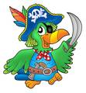
2015 in review
2015 was quite a year and here are some of the things that made it so very interesting.
We had 58 calls looking for birds that had escaped including 2 Blue and Gold Macaws, 3 Sun Conures, 5 Umbrella Cockatoos, 2 Goffin Cockatoos and several other parrots.
We adopted several birds that seemed destine to be in the rescue a long time and some that had.
We adopted many Parakeets and Cockatiels to senior facilities.
We became a feature at the Novi Pet Expo.
We did a new adoption event The Garden City Flea Circus.
We broke a record for donations at the Novi Pet Expo.
We did several new programs last year.
At the Guardians for Animals Pet Expo a bird (Tuna) won the pet trick contest.
Steve put us all on Santa’s nice list by giving him a free picture at the Novi Pet Expo.
We broke down our set-up at the Heritage Festival in record time as severe storms rolled in (and nothing got but us).

Most important, we welcomed many new members to our flock so our bird club family just keeps growing. I know we REALLY LIKE that!!!
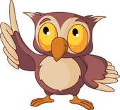

It is so beautiful to see a bird in flight in the wild but at a club meeting not so much. There are way too many hazards that could injure and even kill our feathered members. Hazards such as all the Crockpot’s that contain very hot food or the trays of hot food that get brought to the meetings could severely burn a birds feet should they land in it or even on the hot lids. Also there are many birds that do attend the meeting with their pet humans and do not tolerate the sudden invasion of their space when a bird flies onto their pet human. Macaws and Cockatoos can cause some major damage to a smaller bird that decides to fly and land within chomping distance. There is also the issue of the kitchen, birds must stay out of the kitchen due to health department regulations and if our club got caught by the church with a bird, no matter how it got there, in the kitchen they could ask us to meet somewhere else. So please keep all flighted birds in their carriers even those waiting for a wing clipping or harnessed, this is mainly for the bird’s safety. Plus you never know what the reaction of a person or another bird might be when getting that sudden uninvited guest on their shoulder or play stand. So only clipped or harnessed birds are allowed at the meetings, thank you for your understanding and remember this is for the bird’s safety.

Attention Kroger and Amazon Shoppers
We have registered our rescue in the KROGER COMMUNITY REWARDS PROGRAM and the AMAZON SMILE PROGRAM. These programs will donate a portion of the proceeds from registered shoppers to our non-profit rescue every time they purchase something. We are encouraging everybody who shops at Kroger® and/or Amazon to do so. Here is what you have to do.
Kroger Shoppers:
You must have a “Kroger Plus” card. If you don’t have one, they are available free by asking for one at your neighborhood Kroger store service desk.
You then have to register for the program by going on-line to Kroger.com and create an account or sign onto your account if you have been to this site before.
Once you have an account you click on the “EDIT KROGER COMMUNITY REWARDS” tab and select Rainbow Feathers Bird Club and Rescue or our club’s NPO number “52206”. Once you have successfully registered you will see: Rainbow Feathers Bird Club and Rescue on the right side of the information page. When you shop at Kroger your support will also show at the bottom of your cash register receipts.
If you have been using your phone number when shopping at Kroger and don’t know your “Kroger Plus” card number you can call 877-576-7587 to get your card number.
Amazon.com Shoppers:
Instead of going to amazon.com go to smile.amazon.com this is a mirror website and it will have your shopping history, wish list and all account information. Under your account tab you will be able to change or select your charity. Select RAINBOW FEATHERS BIRD CLUB for our rescue to reap the benefits. Remember to bookmark smile.amazon.com and always use this site for shopping on Amazon for our rescue to receive the donations.

REMEMBER WE VOTE THIS MONTH!

Quality by Mother Nature
Original Corn Bean Mix®: Noodles-n-Nuts®
Rainforest Rice Puddin®: Pollypasta®
Kung Fu Yum®
For Birds of all Sizes 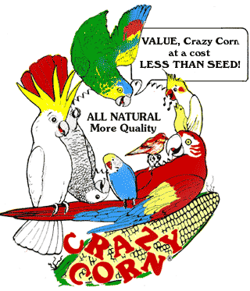
The Industry Pioneer of Quality Broad Natural Low Fat Nutrition®
All at a Cost Less than Seed
Because Crazy Corn® expands and seed is 60% waste! We’ve made it easy to prevent the most common cause of bird death- malnutrition from a seed diet. Cook ahead monthly, freeze baggies, keep some in the fridge to serve instantly. Superior breeding, lustrous feathering. Self-weans chicks. Shining health. Generous chunky fruits, veggies, whole grains, exciting herbs, pastas, beans, legumes, melon seeds, nuts, and more! Ecstatic birds! 1-800-BIRD YUM
in California (818) 503-4YUM. Fax (818) 765-4895
SPECIAL BREEDER PRICING

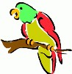
UP COMING
EVENTS
As of
January 9th 2016

February 27th Society of Canary and Finch
Breeders
Bird Fair
$3.00 Adm. 9AM to 3 PM
Livonia Elks Lodge #2246
31117 Plymouth Rd.
Livonia, MI 48150
**Our Club Has a Booth at This Event**

March 11th Senior Show
American House Troy
2300 Grand Haven Drive
Troy, MI 48083
2:00 PM Set-up
3:00 PM Start

July 7th Bird Show
Farmington Community Library
23500 Liberty Street
Farmington, MI 48335
1:00 PM Set-up
2:00 PM Show

****NOTE*****NOTE*****NOTE****
There has been some confusion from the loyal readers of Bird Droppings as to which events they are allowed to bring their own bird(s) to. As a point of reference and for future information please we want everyone to be aware that when you see the line:
***Our Club Has a Booth at This Event***
following or “Educational Show” preceding an event listing it means we are attending the event in an official capacity representing our club and rescue. At these events all club members are welcomed to bring their feathered companions with them. Also please note that our space is very limited at some of these events but don’t let this stop you from joining us, we will find a way for you and your birdie buddy to fit in and enjoy the fun.

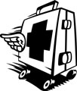

Rescue Update

Our rangers have been working overtime on rescue runs. Foster homes have also been doing extra duty with fostering and adoptions. In short it has been a busy, busy month!
Here is a brief recap of our latest adoptions:
Rita: a B&G Macaw and 3 Parakeets were adopted last month.
All of these adopted birds went to their new homes with cages, food and toys. We are able to do this because of all of you, our members. It is your generosity and participation in our monthly raffles that has allowed us to be so successful. Thank you, thank you! Every one of you should be proud of the great job you’ve done. We couldn’t do it without your support.
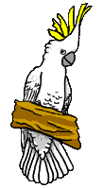
Bits from Baby

HAPPY 2016 EVERYONE!!

HAPPY NEW YEAR to all my feathered and non-feathered members, this is your roving reporter Baby with the latest and greatest news.
The December meeting was a great Christmas party for all who attended. We all had a fun time together as always. There were fifty-three people that attended of which forty-six were members and seven guests. Four of the guests joined our flock. We must be doing something right do you think?
We had twenty-four feathered members of which there were six African Greys, three Cockatoos and three Macaws, plus twelve other parrots in attendance.
Last year was another busy year for the club between programs and events there had to be over forty I think. I’d like to thank everyone who helped out to make it a wonderful year. We already have some programs set for this year when the weather gets a little warmer. For now we can take a break for a couple of months.

See you all at the January meeting,
God Bless.
Your friend Baby,
>< >< >< >< ><>< >< >< >< ><


                           
RESCUE RANGERS
         


The story you are about to read is one that is all too familiar and it always ends with the same outcome and still people never learn. This day has the Rangers heading out to Taylor Michigan to rescue two very sad Parakeets (Budgies to us bird savvy people). It seems that these birds were bought as a gift for two youngsters who really, really wanted them and promised to do all the work of feeding, cleaning and basically taking care of the birds. The parents thought that this would be a great tool to teach them responsibility so off to the big box pet store for two Parakeets and all the fixin’s. Fast forward two years and the shine has gone out of having these birds; the kids are now getting involved in other things, (that’s what happens as kids get older) and now the birds were more of a hassle and just in the way. The Parakeet’s soon were put into an upstairs bedroom being just fed and watered but little else. That is when the Rangers were called to rescue these poor little guys from their solitary life. They arrived and the birds were brought down from the room probably for the first time in a long time and they were fortunately two males (yay, no eggs or oops babies). Then the real reason comes out for the removal of the birds, the kids wanted a puppy and could not get one until the birds went somewhere else. The kicker was they originally tried to sell these two birds unsuccessfully and a rescue was their last resort. First the birds and now a puppy some people never learn. So with the birds all safely in the carrier and all the stuff that came with them loaded up they were off to a better place. It wasn’t long before they found a home together being very pretty little birds made it that much easier. This kind of thing happens way too often especially at Christmas time no thought is made to whether the animal is truly wanted just bought out of desperation for lack of a better idea for a gift (hey gift cards are a much better desperation gift). So with the New Year upon us we will see more of this kind of thing but they will be ready to rescue these poor unwanted gifts for they are the RESCUE RANGERS!!!!

The Ranger would like to take this opportunity to whish all of their fans a Happy New Year and invite you to come along with them on their next adventure Small Parrot Huge Attitude!
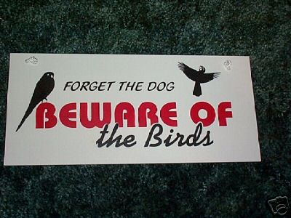

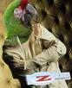
How do you know if your bird is getting the nutrition he needs for a long and healthy life?
By ZuPreem Staff

What’s the best diet for your bird?
The best diet for your bird is one that provides a reliable consistent source of balanced nutrition. It’s also a diet that your bird likes to eat and gives him an enjoyable eating experience, while preventing obesity and other nutritionally related diseases.
Feeding a variety of foods does not guarantee good nutrition
Bird owners feed their birds a wide variety of foods ranging from seeds to home-prepared foods to commercial diets. Unfortunately, feeding a variety of foods does not always prevent nutritional imbalances. Many of these diets lack important nutrients birds need to maintain their health. Often they are not balanced, providing too much of this vitamin or nutrient, or not enough of another.
Seed diets can lead to obesity
Seeds are high in fat and deficient in important nutrients. Even if you supplement a seed diet with a nutritionally complete extruded diet or with fruits and vegetables, your bird will often choose the seeds, leaving behind the more nutritious foods. The simple fact is your bird likes seeds, just as you might like high-calorie, high-fat snacks. Okay for an occasional treat, but a steady diet over time can lead to vitamin deficiencies, obesity-related diseases and possible early death.
Home prepared diets are not necessarily healthy
As a labor of love, some bird owners chop, cook and mix special foods for their birds. Not only is this time-consuming, it is impossible to make sure your bird is getting the correct balance of nutrients. Too much iron, too little calcium, improper levels of Vitamins A, D, E and K. How do you know?
Supplement sparingly with fruits and vegetables
If your bird enjoys fruits and vegetables, go ahead and serve them, but they should not make up more than 15% of your bird’s daily diet. Fruits and vegetables do not offer all the nutrients your bird needs, and some are high in sugar and fiber, curbing your bird’s appetite for a more nutritious food.
ZuPreem® Avian Diets take the guesswork out of your bird’s nutrition
When you feed ZuPreem Life-stage Avian Diets, you know your bird is getting complete and balanced nutrition. From Embrace™ Hand-Feeding Formulas to AvianWeaning™ Diet to adult Avian-Maintenance™ FruitBlend™ Flavor and Natural Flavor Diets, your bird will get the precise nutrition he needs for each stage of his life. Backed by more than 30 years of nutrition research, ZuPreem diets have high-quality fresh ingredients that result in highly digestible and very palatable foods. Food your bird will like to eat and you will feel good about feeding him. Food that will provide all the nutrition he needs for a long and healthy life.
This Article Reprinted with Permission by Zupreem®

NORTH BRANCH ANIMAL HOSPITAL
17630 Twelve Mile Road * Southfield, MI 48076
248-557-7773

FASHIONISTA WEAR
Custom Handmade Clothing, Hair and Body Jewelry
Anything Parrot-ly
Custom Parrot Accessories
Cage Covers, Shoulder Capes
or anything else you might think of
Text, Message or Call me and ask
If I can make it I will
Lanah Harris
1- 734-502-3751

ROOSE ANIMAL HOSPITAL
Kevin Roose, D.V.M. * Karen Knight, D.V.M.
509 W. Ann Arbor Trail * Plymouth, MI 48170
734-451-2870

BIRDMAMA’S BIRD SITTING
SERVICE
Are you going out of town or on vacation? Do you have a feathered friend that is staying at home? Susan can help you with your problem she will birdie sit your bird(s) at her house.
For more information on rates and care specifics contact by phone or e-mail

Susan Dixon
1-248-330-6938
susanhdixon@hotmail.com

SPECIALTY PET SUPPLIES, INC.
1449 W. Ann Arbor Road * Plymouth, MI 48170
734-453-6930
Fax: 734-453-7127
M-F 10-7:30 * Sat 10-6 * Sun 12-4

WARREN WOODS VETERINARY HOSPITAL
29157 Schoenherr * Warren, MI 48314
586-751-3350

OAKLAND VETERINARY EMERGENCY GROUP
1400 Telegraph Rd * Bloomfield Hills, MI 48302
248-334-6877

Free discount card Open 7-Days available to club members Ask about our birdie day spa treatment

DISCOUNT PET & SUPPLIES
Specializing in Exotic Birds & Cages
1623 Middlebelt Rd. Livonia, MI 48154
734-513-6060
http://www.discountpetbirdstore.com/

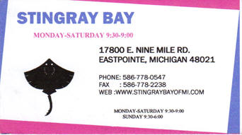

SOUTHGATE ANIMAL HOSPITAL
Keith Cook, D.V.M. * Elieen Cook, D.V.M.
13697 Dix-Toledo Rd* Southgate, MI 48195
734-284-9122

ANIMAL EMERGENCY CENTER
24360 Novi Road * Novi, MI 48375
248-348-1788
265 E. 2nd St. * Rochester, MI 48307
248-651-1788
Both Locations are open 24 hours a Day
7 Days a Week
www.theanimalemergencycenter.com

MUGSHOTS and MOUSE PADS
Species specific coffee mugs, mouse pads and other parrot
paraphernalia
Cheryl Hitter
734-422-2804
*Put your pet’s picture on a mug or mouse pad*

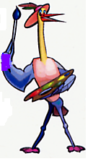
MURALS
AND OTHER
CREATIONS
BY MARY KAY PERVA
517-672-9528

Parkway Small Animal & Exotic Hospital
39321 Garfield
Clinton Township, MI 48038
586-416-8800

UV LIGHTING, HEATERS, VITIMINS AND OTHER SUPPLIES for your BIRDS, FISH and REPTILES

VISIT OUR WEBSITE AT
zoomed.com

Veterinary Care Specialists
205 Rowe Road
Milford, MI 48380
248-684-0468
Open 24 Hours A Day 7 Days A Week

ANIMAL CRACKERS
1100 N. OLD US 23
HARTLAND, MI 48843
810-632-3344

