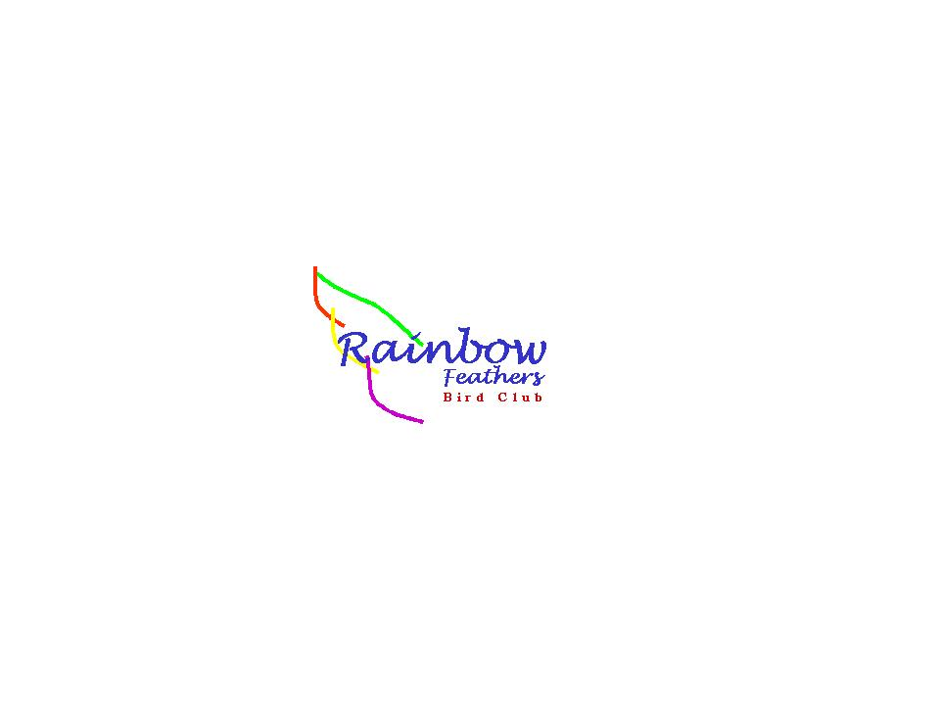 This newsletter
devoted to pet bird
enthusiasts is
published monthly by
Rainbow Feathers
Bird Club of Michigan
A 501(c) (3) club

January 2015
Volume 18 Issue 1

Bird Droppings

UPCOMING MEETING DATES:
JANUARY 25th ---– FOURTH SUNDAY
FEBRUARY 22nd – FOURTH SUNDAY
MARCH 22nd -----– FOURTH SUNDAY

RAINBOW FEATHERS BIRD CLUB
Who we are and what we are about
- Non Profit club with members throughout the tri-county area, single bird owners, or just thinking of getting a bird, families, breeders, exhibitors, all are welcome.
- Support scholarships for avian vet students
- Yearly Bird Fair
- Club Library for members
- Grooming available
- Avian rescue/relocation programs
- Monthly meetings with programs of interest to members.
- Monthly newsletter
- Periodic Service projects
- Field Trips
- Educational Programs upon request
- Save molted feathers for craft projects
- Make-it-take-it workshops
And more…….

Come join us and have your feathers preened by other Pet Bird Enthusiasts

Rainbow Feathers Bird Club Elected Officers: President – Dave Carol 734-422-5981
email – sweettweeters@comcast.net
Vice President – Steve Plafchan 734-513-0030
Email – splafchan@twmi.rr.com

Secretary – Beverly Sholar 313-492-5700
Email –basholar@yahoo.com
Treasurer and Membership Secretary – Tammy Carol 734-422-5981
Email – sweettweeters@comcast.net

Board of Trustees –
Susan Dixon 248-330-6938
Email – susanhdixon@hotmail.com
Henry Jedrzejek-734-427-3187
Email – bigduke@comcast.net
Mary Perva – 734-207-0489

ALL HEALTHY AND CLIPPED BIRDS ARE ALWAYS WELCOME TO ACCOMPANY THEIR HUMAN COMPANIONS TO THE MONTHLY MEETINGS. WE MEET AT THE UNITED METHODIST CHURCH, 6443 MERRIMAN ROAD BETWEEN FORD AND WARREN IN GARDEN CITY. MEETINGS START AT 2:00 PM.

Anyone interested in becoming a member please contact Tammy Carol @ 734-422-5981 or by e-mail sweettweeters@comcast.net

Steve Plafchan is doing the newsletter. All ads and articles will be due the 1st of the month for publishing in the current month’s newsletter. Please send all items to him at 11021 Henry Ruff, Livonia MI 48150 or email to splafchan@twmi.rr.com.

Everyone is encouraged to submit articles for the newsletter – this is YOUR newsletter.

Articles and/or pictures copied from other publications must be accompanied with written permission from original publication and author; this needs to be provided to the editor along with the article and/or picture.

Editor reserves the right to approve and/or edit any articles submitted prior to publication.

Ads will be run free for members having a one-time sale (baby birds, etc.). Those wishing to run ads multiple times or for a business must purchase a business membership.

BIRD CLUB ETIQUETTE

- Ask owner’s permission to handle/feed bird(s) and remember to return bird to the owner.
- Wash hands prior/after bird handling.
- When bringing companion birds to club meetings, only bring birds that you have had vet checked and in your possession for at least 30 days.
- Clean up after yourself and your bird(s) before you leave.

CLUB WELFARE
Please contact Jean Jedrzejek at 734-427-3187 or e-mail her at bigduke@comcast.net if you know of any club member who is in the hospital or has lost a loved one.

Monthly snack list

We have decided to stop soliciting for snack volunteers for our meetings and make the format a potluck venue. The reasoning for this is twofold; there have been very few members signing up for snacks and many members just bring dishes and desserts without signing up. So from now on our meetings will be a potluck fair, YUM!!



OVER THE RAINBOW BRIDGE
Sadly we must report the passing of yet two more feathered members of our club.
Winston, a Senegal parrot who owned Tammy crossed over the rainbow bridge last month. Those of you that were regulars at our bird shows would remember Winston from his feisty attitude. A necropsy revealed that he had a cancerous tumor which took him quite suddenly. Winston will be missed by all of us.
Layla, an Umbrella Cockatoo who owned Lanah Bogard also crossed over the rainbow bridge early in January. Although Layla was a handful and a typical Umbrella Cockatoo she was dearly loved and her playful antics will forever be missed and remembered.
To Winston and Layla we say “soar high and free on the far side of the rainbow bridge, you will always be remembered and loved.” The following verse is dedicated to both of their memories and our sympathies are given to both Tammy and Lanah.


The Rainbow Bridge

Just this side of heaven is a place called
Rainbow Bridge.
When and animal dies that has been especially close to someone here, that pet goes to
Rainbow Bridge.
There are meadows and hills for all our special friends so they can run and play together. There is plenty of food and water and sunshine, and our friends are warm and comfortable.
All of the animals that have been ill and old are restored to health and vigor, those who were hurt or maimed are made whole and strong again, just as we remember in our dreams of days and times gone bye. The animals are happy and content, except for one small thing;
They miss someone very special to them who had to be left behind. They all run and play together, but the day comes when one suddenly stops and looks into the distance,…
The bright eyes are intent; the eager body quivers. suddenly she begins to break away from the group, flying over the green grass,
her wings carrying her faster and faster YOU ~
have just been spotted, and when you and your special friend meet, you cling together in joyous reunion ~
never to be parted again. The sweet sounds of happy tweets play your ears; your hands again
caress the beloved’s head, and you look once more into the trusting eyes of your pet,
so long gone from your life but never absent from your heart ~
Then you cross~…the
Rainbow Bridge together !


From the prez:

Wow a new year is upon us I just would like to know where the time went. As a club we were so busy doing things like the Heritage Festival, Walled Lake Pet awareness, the Summer Fling in Whitmore Lake, Critter Care in Redford Guardians for Animals and the Novi Pet Expo it is no wonder the time flew. We also did many educational programs 47 to be exact plus we got involved in an art photo shoot with real models a professional artistic photographer and J.B., Sparky, Max and Tuna can now be called professional models as well, who knew?. It was a very cool experience to be a part of the whole process of creating true pieces of photographic art. Not to mention the thousands of people we impressed with our feathered wonders and I do mean thousands! It just boggles the mind. Looking back at 2014 it was a year of firsts, heartbreaking losses, and the joys of adopting what many would consider unadoptable. This year proved that when we band together as a truly united club there is no obstacle we cannot overcome, be it weather, closed freeways, some very interesting people or wowing the public we can do it with the sky being the limit. So as we look toward 2015 I hope you can see what I see just great things for the club new flock members and many more successful adoptions. So let’s look back at 2014 and smile at all we accomplished the great times we had and go fearlessly into 2015 knowing there are great things to come, new experiences to have, new friends to be made and we can face any NEW events with the knowledge that together we can do anything!! I’ve said this time and time again but it is so true YOU GUYS ROCK!!!!!!
Your Prez
Dave
P.S. It is also election time so if you want to nominate someone for an office you can do it at the next meeting.

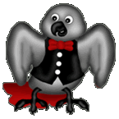
Voice of the Veep

The Christmas meeting last month was fabulous from the delicious food to the annual Christmas raffle it was tons of fun. I want to thank everybody in the club for their participation in our Christmas raffle and all the meeting raffles throughout the year. This is the most generous way you can help support our rescue and assist our club in paying vet bills and all of you have succeeded in accomplishing this in a big way. Thank you to everyone for the support. Another way we generate monies for supporting the rescue is to stage senior programs at nursing homes, assisted living and independent living facilities throughout the year. The year 2014 was the busiest year for shows and events we have ever had; however that being said, this year 2015 could very easily exceed last year. I encourage everyone to join us at a show, even if you don’t bring your own bird, they are a lot of fun and we can always use the help. Check the Up-coming Events page on the website or in the newsletter to see the dates and times of the show schedule. If you have any questions about attending an event please feel free to call me (Steve) at 734-513-0030 for more information.
My house is totally out of control; JB, Calvin and Pookie have conspired to prevent me from sleeping at night. I incurred a minor problem with the smoke detectors in my home during the middle of the night one day last month. They are all hard wired together (per code) with battery back-ups. I however have a generator on my house so I never changed the 9V batteries. What I discovered quite rudely at 3:00 AM was when a battery gets too low it triggers an alarm causing all the detectors to sound off! When five detectors sound off they trigger five parrots to think, that was pretty neat. Now all my feathered friends are imitating smoke alarms nightly between 2:00AM and 4:00 AM much to my chagrin. ☹
This month is when we hold our annual elections; there is a description of all the offices and the duties of each office holder included in this edition of the newsletter. If you’re interested in running or wish to nominate someone feel free to do so. Our annual dues are also payable this month; if you joined the club within the last six months your dues are good for another year. Please check with Tammy if you’re not sure what your dues are or if you owe some.
I’ll see you at the meeting
Your Veep
Steve

Avast ye Mates

CAPTAINS CORNER

YEEEEEEHAAAAAW!!!!! HAPPY NEW YEAR!!!!! I can say that Pookie throws the best New Years Eve parties anywhere in the world. All the glitz and pizzazz that New Years Eve should be is at one of Pookies parties. All the nog was flowing (can’t say egg nog it makes some of the attendees a little nauseous) and it made some of the more uptight bird attendees a whole lot looser. I would have never guessed that Kiwi the Pionus could twerk like that she even made Bo the Blue headed Pionus blush through his blue head. Then there was Tuna the cockatoo with Ricky, Winnie, Boogie and Doodles doing some amazing moves on the dance floor. Naturally Mr. Finnegan and Ruby almost melted the place with moves that could have got us raided. Buttons proved to be the grand master a spinning the jams and Rambo and Pablo were very impressive bartenders. I can’t even name all who were there but I did see Lucy, Apollo, Max, Phoenix, Picasso, Sparky, Marley and Sam there. Sidney the Blue and Gold made an appearance as did many others. It was a night to remember and the perfect way to ring in the New Year. At the stroke of midnight we dropped the human to count down to 2015 and there was a whole lot of kissing going on. Oh what about Steve you ask? Well he should be coming around from the Mickey we slipped him and all will be fine until he sees the Masterbird charge card bill (of course we took it out in his name) for the party. It was a great time and we all plan to do it again next year. So to all my friends a blessed and great big
Cheers
Captain Morgan

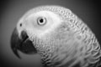
Out and About with Pookie

I know I mentioned in passing last month about a brilliant new exercise program for Steve but I simply didn’t have the space to expound on the program. This new discovery of ours is spectacular in its simplicity and effectiveness; what is it you may ask, sound effects! Steve himself was the one who demonstrated how awesome these sound effects work but there is one caveat to employing their usage. They are only effective to a maximum when implemented during the middle of the night.
We wait until 2:00AM or 3:00AM in the morning and all of us start imitating the various smoke alarms in our house. I make sounds like the closest alarm, Sparky and Tyler copy the alarms that are in our room and out in the hallway. JB and Calvin chime in and repeat alarms both near and far from our room. In almost an instant we hear Steve hop out of bed, walk into our room and turn on the light. We know that he appreciates what we are doing for him because he stands in the doorway smiling. The house alarm ruse is also beneficial during daylight hours when properly deployed. We have been doing this in a number of different ways. The most effective use of the sound is when we’re roaming around the house when Steve is loafing on the couch or in his chair. JB and Calvin go into the kitchen and imitate alarm sounds and Sparky and I will sneak up by his chair and imitate the beep as loud as we can. He lurches up and sits up almost instantly every time we do these things.
Although I was unable to attend the meeting last month that doesn’t mean we here at the Bird Droppings news and information department we always have members present just in case something monumental occurs. Well, last month was one of those months; Baby who is in charge of taking the monthly feathered member census was unable to attend. Generally he has Duke or Tammy perform this critical duty; Duke had to leave the meeting due to an emergency and Tammy was totally preoccupied helping to perform wing and nail clippings. Ergo, when JB contacted me via “Tweeter” I told him it was our duty to perform the feathered head count and report it to me. So for everyone who is interested here is the feathered member head count for December: There were oodles and oodles of African Gray parrots, a Macaw or two, a couple of Cockatoos, some Conures and Pionus parrots also.
See you at the meeting
Chirps and Squawks
Pookie

A REMINDER
Our dues are due by January 31st. Checks should be made out to RAINBOW FEATHERS BIRD CLUB. Please pay them at the January meeting or by mail to Tammy Carol at Rainbow Feathers Bird Club, PO Box 1587, Garden City MI 48135.

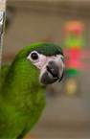
Rambling with Rambo

Greeting all my friends. I had a very good December. How was yours?
I want to thank all my friends for making this the best year of both Rambo, and Michael’s life.
In December, we don’t get out as much, because of the cold. Our humans have to think of creative ways to entertain us. My pet human takes me a few interesting places, like the various restaurants, and the mall. There are some new places that want Michael to bring me in to visit. But I don’t make it easy for him. Since we don’t have many shows this time of year, I’m not used to jumping into my box at a moment’s notice. In November, we had lots of shows. I was able to make every one of them. Back then, anytime Daddy said, “Get in your box.” I was ready to go. Now I give him a really hard time. I either run inside my house, or I clamp on tight to my cage. Of course, he won’t pull hard, or try to lift off my toes. He doesn’t want to hurt me. But in December, we get new toys. And we get to go visit friends, at their homes. There we get new foods, and we get to play with other birds.
This reminds me of our Christmas party. It was wonderful. We had lots of humans there. Naturally, we birds were the stars of the event. I’m very proud to say we Macaws were the most popular ones there. I think the Cockatoos were next. It was great to see so many birds, and Humans together. We even had a new bird there. He was a Severe Macaw. He is a beautiful, friendly, boy.
Michael really wants to adopt him. But Mommy is giving him a hard time.
At the party, there were some humans I’ve not seen in some time. They have been very sick. I’m glad they were feeling better. There are some of our friends that were not at our party. How about giving them a call.
Michael always has pictures of all our events. On Christmas day, Daddy goes around the neighborhood giving out Mommy’s cookies. They are delicious. She gives me treats of them. So while he delivers these, he shows everyone the pictures of the year’s events. We had a busy year. Wow, 47 indoor events.
This year was the most fun I ever had, since becoming a Rainbow Feather Member. There was too much fun to describe.
There are a couple of interesting things to tell you.
Michael has a friend in Finland. She said there are no bird clubs over there. Following the Rainbow Feathers example, she arranged her own educational show at the local pet shop, with her 6 Kaks.
The other thing happening is this. There is a new bird club in Flint Michigan. The person starting this has asked Michael about how Rainbow Feathers does things. We should feel honored that Rainbow Feathers has inspired others to bring the education of Birds to others. So friends feel proud of yourself. Our work is widely noticed by others.
And lastly I want to wish all of you a great new year. Let’s get out there. There are new people to teach, places to visit, new friends to make, and as always there are many, many homeless birds we need to find homes for. Isn’t amazing how many of them never leave us, and become our flock mates, and friends? And, we birdies love that part.
Remember (Try to) Be Good, Have Fun, and Never forget, Macaws Rule. Rambo.

So as always,
Be Good, Have Fun
Remember
Macaws rule,
Rambo.


BIRTHDAY GREETINGS to:

CINDY BOLTON FEB. 17
DAN ERNST FEB. 19
DEBBIE JAMIESON FEB. 20
CHRISTINA FECKO FEB. 23
DIANE SILAS FEB. 24
NANCY SULLIVAN FEB. 25

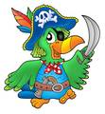


Annual elections
The annual elections will be held at our January meeting. We will be voting on a President, Vice President, Secretary, Treasurer, and Trustee. Any member in good standing is eligible to fill any one of these offices. To help you decide who you think would best fill these offices, the following is a brief guide to their duties:
PRESIDENT: The President shall preside at all meetings of the Club, see that the bylaws are enforced, call such meetings as are needed, and be responsible for the execution of all motions passed by the members. The President shall also be public relations administrator and liaison between the Club and all other groups.
VICE PRESIDENT: The Vice President shall assume the President’s responsibilities in the absence or disability of the President, keep constantly informed of Club activities, and shall be responsible for special programs and social events.
SECRETARY: The Secretary is responsible for minutes at all general membership and board meetings, reads minutes of previous meetings when requested, keeps a file of all minutes, shall provide copies of minutes for each board member upon request, is responsible for all member notices, and is responsible for all correspondence, both incoming and outgoing.
TREASURER: The Treasurer collects all dues and records all moneys belonging to the Club, disburses same under the direction of the President, deposits the funds of the Club in the name of the Club in such bank or banks as may be designated by the Executive Committee, and submits a statement of accounts at each meeting. The books and accounts shall at all reasonable times be open to inspection by any member. The Treasurer shall be responsible for disbursement of moneys for bird bands.
TRUSTEE: One Trustee is elected each year to serve a three year term. A person serving as Trustee is ineligible for other elected office. Duties shall be to serve as coordinators of the Club, assuring a meeting place, acting as assistants to the President, and serve as a grievance committee. They shall conduct an annual audit of all Club records, Treasurer’s and Secretary’s books, etc. The Trustees whose terms of office have not expired shall serve as the election committee and shall conduct the annual elections. The Trustees shall review all absences of officers and shall fill any vacant office by either appointment or special election with the membership.

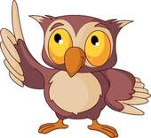

It is so beautiful to see a bird in flight in the wild but at a club meeting not so much. There are way too many hazards that could injure and even kill our feathered members. Hazards such as all the Crockpot’s that contain very hot food or the trays of hot food that get brought to the meetings could severely burn a birds feet should they land in it or even on the hot lids. Also there are many birds that do attend the meeting with their pet humans and do not tolerate the sudden invasion of their space when a bird flies onto their pet human. Macaws and Cockatoos can cause some major damage to a smaller bird that decides to fly and land within chomping distance. There is also the issue of the kitchen, birds must stay out of the kitchen due to health department regulations and if our club got caught by the church with a bird, no matter how it got there, in the kitchen they could ask us to meet somewhere else. So please keep all flighted birds in their carriers even those waiting for a wing clipping or harnessed, this is mainly for the bird’s safety. Plus you never know what the reaction of a person or another bird might be when getting that sudden uninvited guest on their shoulder or play stand. So only clipped or harnessed birds are allowed at the meetings, thank you for your understanding and remember this is for the bird’s safety.


Attention Kroger and Amazon Shoppers
We have registered our rescue in the KROGER COMMUNITY REWARDS PROGRAM and the AMAZON SMILE PROGRAM. These programs will donate a portion of the proceeds from registered shoppers to our non-profit rescue every time they purchase something. We are encouraging everybody who shops at Kroger® and/or Amazon to do so. Here is what you have to do.
Kroger Shoppers:
You must have a “Kroger Plus” card. If you don’t have one, they are available free by asking for one at your neighborhood Kroger store service desk.
You then have to register for the program by going on-line to Kroger.com and create an account or sign onto your account if you have been to this site before.
Once you have an account you click on the “EDIT KROGER COMMUNITY REWARDS” tab and select Rainbow Feathers Bird Club and Rescue or our club’s NPO number “52206”. Once you have successfully registered you will see: Rainbow Feathers Bird Club and Rescue on the right side of the information page. When you shop at Kroger your support will also show at the bottom of your cash register receipts.
If you have been using your phone number when shopping at Kroger and don’t know your “Kroger Plus” card number you can call 877-576-7587 to get your card number.
Amazon.com Shoppers:

Instead of going to amazon.com go to smile.amazon.com this is a mirror website and it will have your shopping history, wish list and all account information. Under your account tab you will be able to change or select your charity. Select RAINBOW FEATHERS BIRD CLUB for our rescue to reap the benefits. Remember to bookmark smile.amazon.com and always use this site for shopping on Amazon for our rescue to receive the donations.

REMEMBER WE VOTE THIS MONTH!



2014 Was year to remember and so were these gems said innocently by our adoring public.
You’re a bird person, I was expecting someone wimpier! (I think it was a compliment, I think)
Oh those must be fancy Pigeons they have red tails. (Hey at least you guys have graduated to fancy)
How do birds procreate? (It was an earnest question by a gentleman at a senior program and yes I did tell him)
Which one of these birds are parrots? (Said at the Novi Pet Expo)
So is that a Parakeet? (Pointing to Captain Morgan)
Oh look at the beautiful Canary! (Said about Princess the Female Indian Ringneck Parakeet)
Aren’t you worried about a snake eating one of your birds? (Not really one of your children would be more filling. Said at the Novi Pet Expo)
Do you take these back to the zoo when you are done with them? (Well kind of our houses can get a little like a zoo at time, or is it a circus, I forget)
Look a pink African Grey! (Looking at Aurora the Rose Breasted Cockatoo)
Finally on Captain Morgan’s screaming at the Novi Pet Expo, I am glad he is far away from the cat show his screaming would disturb the cats! (I have seen the way some of you dress for the cat show that should disturb the cats)
Now it is 2015 a New Year and a new set of gems for the newsletter!

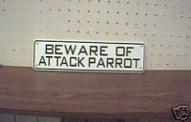

Quality by Mother Nature
Original Corn Bean Mix®: Noodles-n-Nuts®
Rainforest Rice Puddin®: Pollypasta®
Kung Fu Yum®
For Birds of all Sizes 
The Industry Pioneer of Quality Broad Natural Low Fat Nutrition®
All at a Cost Less than Seed
Because Crazy Corn® expands and seed is 60% waste! We’ve made it easy to prevent the most common cause of bird death- malnutrition from a seed diet. Cook ahead monthly, freeze baggies, keep some in the fridge to serve instantly. Superior breeding, lustrous feathering. Self-weans chicks. Shining health. Generous chunky fruits, veggies, whole grains, exciting herbs, pastas, beans, legumes, melon seeds, nuts, and more! Ecstatic birds! 1-800-BIRD YUM
in California (818) 503-4YUM. Fax (818) 765-4895
SPECIAL BREEDER PRICING

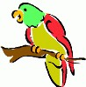
UP COMING
EVENTS
As of
Jan.10th 2014

*****2015*****

March 11th Senior Show
American House
39201 Joy Road
Westland, MI 48185
5:30 PM Set-up
6:30 PM Show

March 24th Senior Show
American House Westland
Hunter Senior Living
35700 Hunter Ave.
Westland, MI 48185
1:00 PM Set-up
2:00 PM Show

April 27th Senior Show
Caretel Inns of Brighton
1014 East Grand River
Brighton, MI 48116
2:00 Set-up
3:00 Show

May 5th Educational Show
AARP Meeting at Wayne County
Community College
in the Ray Mix Room
21000 Northline
Taylor, MI 48180
11:30 AM Set-up
12:30 PM Show
May 12th Senior Show
Village Care Center
22600 W. Main St.
Armada, MI 48005
1:00 PM set-up
2:00 PM show

****NOTE******NOTE******NOTE****
There has been some confusion from the loyal readers of Bird Droppings as to which events they are allowed to bring their own bird(s) to. As a point of reference and for future information please we want everyone to be aware that when you see the line:
*****Our Club Has a Booth at This Event*****
following or “Educational Show” preceding an event listing it means we are attending the event in an official capacity representing our club and rescue. At these events all club members are welcomed to bring their feathered companions with them. Also please note that our space is very limited at some of these events but don’t let this stop you from joining us, we will find a way for you and your birdie buddy to fit in and enjoy the fun.

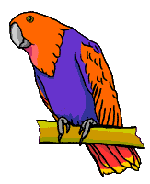



Rescue Update

Our rangers have been working overtime on rescue runs. Foster homes have also been doing extra duty with fostering and adoptions. In short it has been a busy, busy month!
Here is a brief recap of our latest adoptions:
Sarge: a Quaker Parrot
Cookie, Baby and Honeyboy all Cockatiels went to three different homes.
All of these adopted birds went to their new homes with cages, food and toys. We are able to do this because of all of you, our members. It is your generosity and participation in our monthly raffles that has allowed us to be so successful. Thank you, thank you! Every one of you should be proud of the great job you’ve done. We couldn’t do it without your support.


Bits from Baby

HAPPY 2014 EVERYONE!!

Howdy all of my Rainbow Feathered friends, this is your roving reporter Baby with the latest and greatest club news.
December's meeting was a great big party. There were sixty-four people of which fifty-eight were club members and six guests, two of the guests joined our flock.
I did not have time to count the number of feathered members that were at the party this month, but there sure were a lot of us enjoying all that good food that was there.
I’d like to wish everyone a Happy New Year.

See you all at the January meeting,
God Bless.
Your friend Baby,
>< >< >< >< ><>< >< >< >< ><


                           
RESCUE RANGERS
         


It never ceases to amaze the Rangers that some people can have a bird for years and never know what kind of bird they have. What? You ask yourself in disbelief how can that be? Well if we had the answer to that question we could come up with a concept to achieve world peace and win the Nobel Prize. It’s not going to happen anytime soon. Anyway, the Rangers were called to the burg of Taylor to pick up a green Conure. They speculated on what was meant by a green Conure, could it be a Blue Crown Conure they’re mostly green, a Cherry Headed Conure how about a Mitred Conure , well it could be any of a number of green Conures so they would find out when they got there. They pulled up to the house still wondering what kind of “green Conure” it could be rang the doorbell and entered. As they entered they saw a large green bird with red and yellow on its head. Ranger Steve looked at this bird kind of puzzled but Ranger Dave knew what kind of bird that was and it was no Conure. It was a Barraband Parakeet a larger Australian grass parakeet so this was definitely not the Conure. Their attention was directed to the cage beside this bird on the other side of a small table. Ranger Steve let out a “that’s the Green Conure!” It’s a mutant Conure. Well it was a Conure, and it certainly was no mutant Ranger Dave had seen these guys before and knew right away it was a Patagonian Conure the largest of the Conure Family. So Ranger Dave had to call Rangerette Tammy and inform her that we were getting a “mutant Conure” to foster. They did get one thing right it was somewhat green but it was also something they did not expect. So with the mutant (real name Kiwi) in tow they were off. It seems that Kiwi took a liking to Ranger Dave (no accounting for taste) and she is still raising cane at the humble abode of Ranger Dave and Rangerette Tammy. They could see why the wanted Kiwi gone she is very loud but compared to a Cockatoo she is a mime so it all balances out. So Kiwi got a good home Steve saw his first mutant Conure and Kiwi joined the troupe of educational program birds, (and Ranger Dave really likes her)! A happy ending all around but the call still goes on to rescue unwanted birds (no mutants please) and they will never stop for they are the RESCUE RANGERS!!!!!!!

Stay riveted to your mailbox for our next exciting adventure Winston and the Plastic people!!!!!

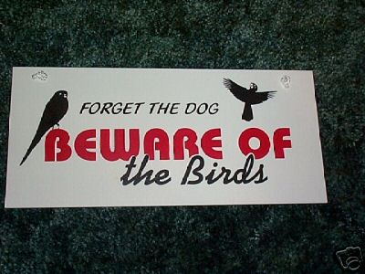


How do you know if your bird is getting the nutrition he needs for a long and healthy life?
By ZuPreem Staff

What’s the best diet for your bird?
The best diet for your bird is one that provides a reliable consistent source of balanced nutrition. It’s also a diet that your bird likes to eat and gives him an enjoyable eating experience, while preventing obesity and other nutritionally related diseases.
Feeding a variety of foods does not guarantee good nutrition
Bird owners feed their birds a wide variety of foods ranging from seeds to home-prepared foods to commercial diets. Unfortunately, feeding a variety of foods does not always prevent nutritional imbalances. Many of these diets lack important nutrients birds need to maintain their health. Often they are not balanced, providing too much of this vitamin or nutrient, or not enough of another.
Seed diets can lead to obesity
Seeds are high in fat and deficient in important nutrients. Even if you supplement a seed diet with a nutritionally complete extruded diet or with fruits and vegetables, your bird will often choose the seeds, leaving behind the more nutritious foods. The simple fact is your bird likes seeds, just as you might like high-calorie, high-fat snacks. Okay for an occasional treat, but a steady diet over time can lead to vitamin deficiencies, obesity-related diseases and possible early death.
Home prepared diets are not necessarily healthy
As a labor of love, some bird owners chop, cook and mix special foods for their birds. Not only is this time-consuming, it is impossible to make sure your bird is getting the correct balance of nutrients. Too much iron, too little calcium, improper levels of Vitamins A, D, E and K. How do you know?
Supplement sparingly with fruits and vegetables
If your bird enjoys fruits and vegetables, go ahead and serve them, but they should not make up more than 15% of your bird’s daily diet. Fruits and vegetables do not offer all the nutrients your bird needs, and some are high in sugar and fiber, curbing your bird’s appetite for a more nutritious food.
ZuPreem® Avian Diets take the guesswork out of your bird’s nutrition
When you feed ZuPreem Life-stage Avian Diets, you know your bird is getting complete and balanced nutrition. From Embrace™ Hand-Feeding Formulas to AvianWeaning™ Diet to adult Avian-Maintenance™ FruitBlend™ Flavor and Natural Flavor Diets, your bird will get the precise nutrition he needs for each stage of his life. Backed by more than 30 years of nutrition research, ZuPreem diets have high-quality fresh ingredients that result in highly digestible and very palatable foods. Food your bird will like to eat and you will feel good about feeding him. Food that will provide all the nutrition he needs for a long and healthy life.
This Article Reprinted with Permission by Zupreem®

NORTH BRANCH ANIMAL HOSPITAL
17630 Twelve Mile Road * Southfield, MI 48076
248-557-7773

FASHIONISTA WEAR
Custom Handmade Clothing, Hair and Body Jewelry
Anything Parrot-ly
Custom Parrot Accessories
Cage Covers, Shoulder Capes
or anything else you might think of
Text, Message or Call me and ask
If I can make it I will
Lanah Harris
1- 734-502-3751

ROOSE ANIMAL HOSPITAL
Kevin Roose, D.V.M. * Karen Knight, D.V.M.
509 W. Ann Arbor Trail * Plymouth, MI 48170
734-451-2870

BIRDMAMA’S BIRD SITTING
SERVICE
Are you going out of town or on vacation? Do you have a feathered friend that is staying at home? Susan can help you with your problem she will birdie sit your bird(s) at her house.
For more information on rates and care specifics contact by phone or e-mail

Susan Dixon
1-248-330-6938
susanhdixon@hotmail.com

SPECIALTY PET SUPPLIES, INC.
1449 W. Ann Arbor Road * Plymouth, MI 48170
734-453-6930
Fax: 734-453-7127
M-F 10-7:30 * Sat 10-6 * Sun 12-4

WARREN WOODS VETERINARY HOSPITAL
29157 Schoenherr * Warren, MI 48314
586-751-3350

OAKLAND VETERINARY EMERGENCY GROUP
1400 Telegraph Rd * Bloomfield Hills, MI 48302
248-334-6877

Free discount card Open 7-Days available to club members Ask about our birdie day spa treatment

DISCOUNT PET & SUPPLIES
Specializing in Exotic Birds & Cages
1623 Middlebelt Rd. Livonia, MI 48154
734-513-6060
http://www.discountpetbirdstore.com/

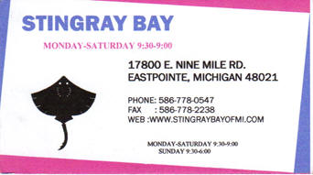

SOUTHGATE ANIMAL HOSPITAL
Keith Cook, D.V.M. * Elieen Cook, D.V.M.
13697 Dix-Toledo Rd* Southgate, MI 48195
734-284-9122

ANIMAL EMERGENCY CENTER
24360 Novi Road * Novi, MI 48375
248-348-1788
265 E. 2nd St. * Rochester, MI 48307
248-651-1788
Both Locations are open 24 hours a Day
7 Days a Week
www.theanimalemergencycenter.com

MUGSHOTS and MOUSE PADS
Species specific coffee mugs, mouse pads and other parrot
paraphernalia
Cheryl Hitter
734-422-2804
*Put your pet’s picture on a mug or mouse pad*

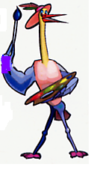
MURALS
AND OTHER
CREATIONS
BY MARY KAY PERVA
734-207-0489

UV LIGHTING, HEATERS, VITIMINS AND OTHER SUPPLIES for your BIRDS, FISH and REPTILES

VISIT OUR WEBSITE AT
zoomed.com

Veterinary Care Specialists
205 Rowe Road
Milford, MI 48380
248-684-0468
Open 24 Hours A Day 7 Days A Week

